WORKS CITED

Fesliyan Studios, Steve Oxen, 12 May 2021, https://www.fesliyanstudios.com/royalty-free-music/download/the-little-cafe/1959. Accessed 20 Nov. 2023.

“Learn to Code.” W3Schools Online Web Tutorials, Refsnes Data, www.w3schools.com/. Accessed 28 Nov. 2023.

For all images on the website, I used the free trial on iStock by Getty Images.
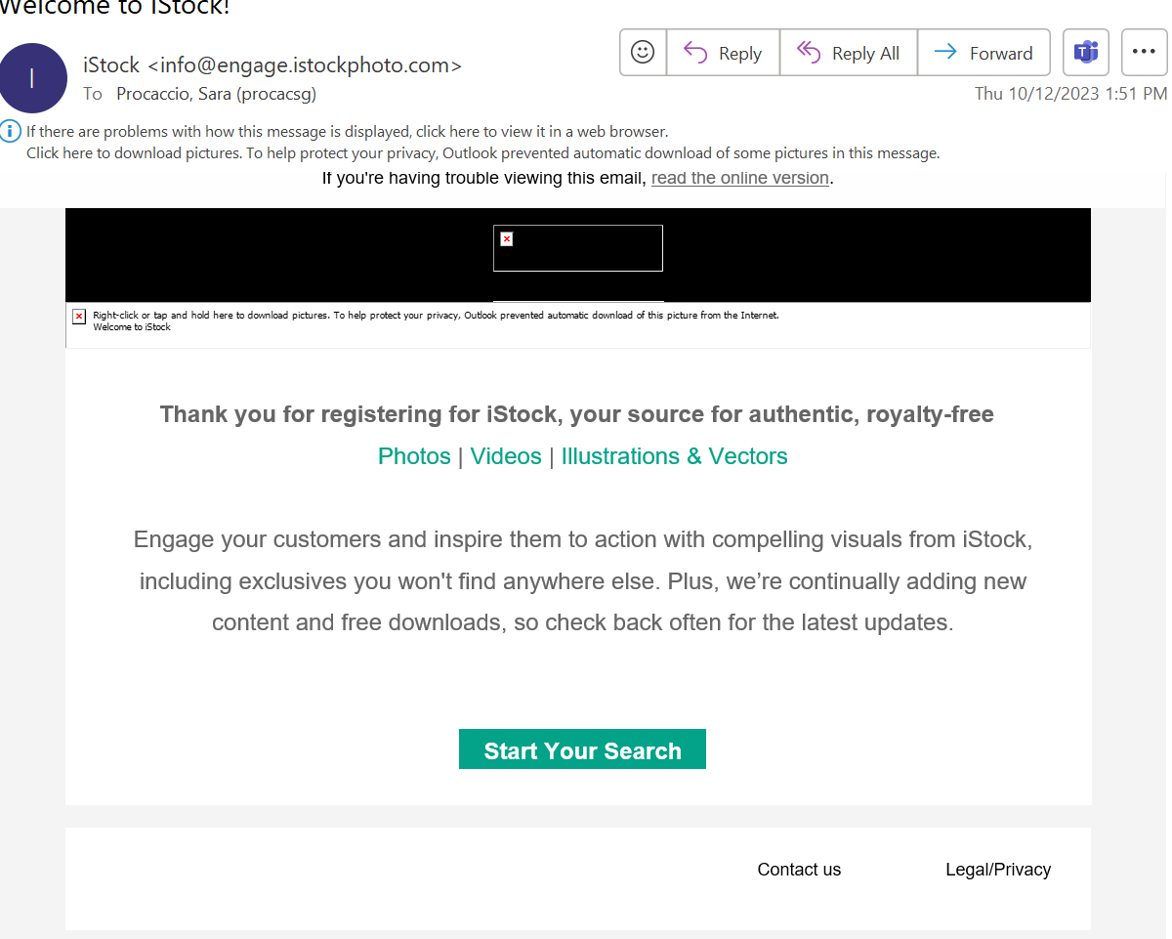
(proof of free trial for Getty images)

