Red Task of Lab4 of EECE3093 (Software Engineering), Spring 2015

This description is about Red task.

- The Red task asks you to implement your solution within a single project named GreenAndRed.

- The feature (requirement) to be traced for the Red task within the GreenAndRed project is:

Index source code at the method level

- Relevant materials can be found in “Course Website Labs Lab4 Red”

Task Red asks you to:

- Identify the requirements traceability matrix (RTM) of the “Index source code at the method level” feature within the project GreenAndRed. Document the RTM by using a WORD file.

- Extend the feature so that the HEADER COMMENT of each method is included as a single line in the indexing output. In the following figure, (a) shows a sample input with the header comment highlighted, and (b) shows the sample output where the header comment is displayed in one single line in the indexing result.

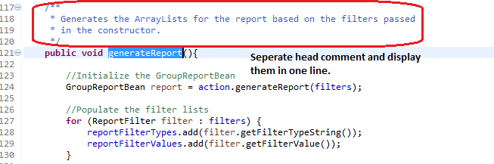
(a)

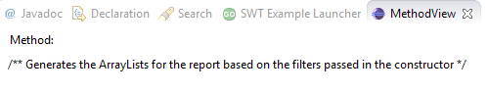
(b)

- Demo your code and then submit your RTM and code (two files) to Blackboard.

