Purple Task of Lab4 of EECE3093 (Software Engineering), Spring 2015

This description is about Purple task.

- The Purple task asks you to reuse the implementation of “Index source code at the method level” of the GreenAndRed project and implement your solution inside a different project named BlueAndPurple.

- The feature (requirement) to be traced for the Purple task within the GreenAndRed project is:

Index source code at the method level

- Relevant materials can be found in “Course Website Labs Lab4 Purple”

Task Purple asks you to:

- Identify the requirements traceability matrix (RTM) of the “Index source code at the method level” feature within the project GreenAndRed. Document the RTM by using a WORD file.

- Reuse the methods from GreenAndRed to implement inside BlueAndPurple a new feature to: read file “README.TXT”, use information in this file to fill grids in a tabular form. The following figure illustrates a sample output of the Purple task.

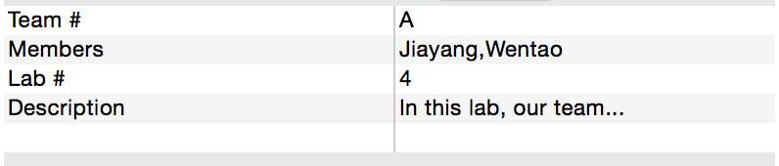

- Demo your code and then submit your RTM and code (two files) to Blackboard.

