Green Task of Lab4 of EECE3093 (Software Engineering), Spring 2015

This description is about Green task.

- The Green task asks you to implement your solution within a single project named GreenAndRed.

- The feature (requirement) to be traced for the Green task within the GreenAndRed project is:

Display file names in a dropdown box

- Relevant materials can be found in “Course Website Labs Lab4 Green”

Task Green asks you to:

- Identify the requirements traceability matrix (RTM) of the “Display file names in a dropdown box” feature within the project GreenAndRed. Document the RTM by using a WORD file.

- Extend the feature so that the folder can be RECURSIVELY parsed and displayed. In the following figure, (a) shows the current implementation, and (b) shows the extension that Green task requests.

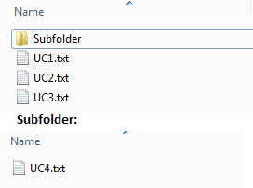 NEED A NEW (b) HERE SHOWING RECURSIVE!!!
- (b)

- Demo your code and then submit your RTM and code (two files) to Blackboard.

