1. Immersive sharing (Desktop)
Create a more personal and engaging experience as you present by immersing your video directly into you shared screen or application. In the Share Content menu, there’s a new option: Show me in front of presentation. Select the check box and your video is embedded into what you’re sharing.
By default, your video is shown in the lower right, but you have full control to resize and position your video anywhere you want during your presentation.
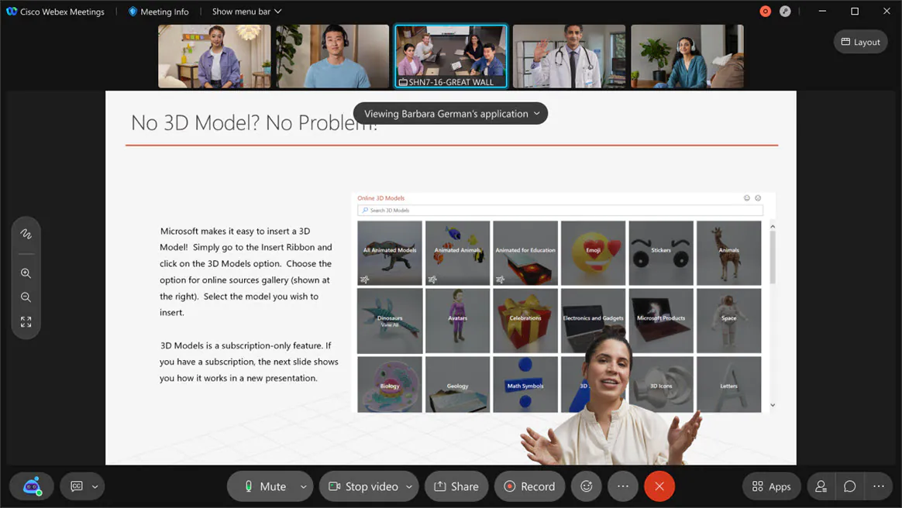

2. Immersive Sharing as an Attendee (Mobile)

iOS and Android app users can view immersive share as an attendee. Currently, mobile app users can’t choose immersive share when presenting.

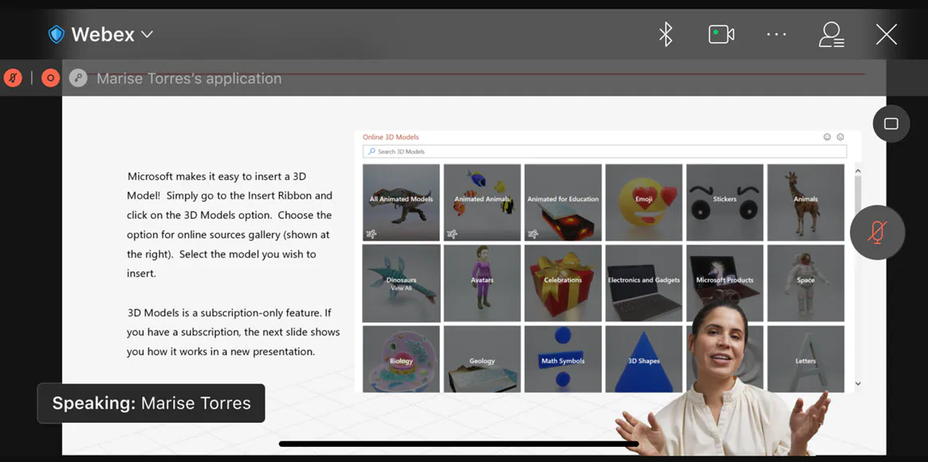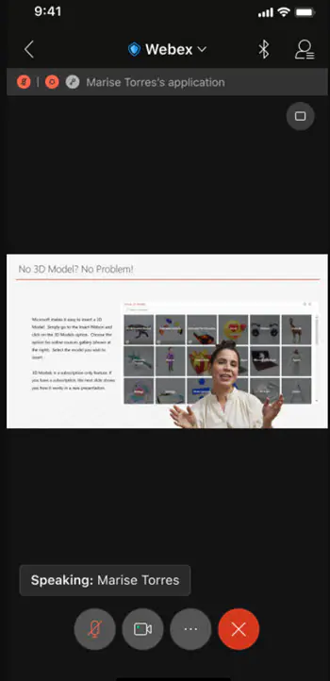

3. Video layout improvement for tablet and iPad
iPad Pro and higher end Android tablets can now enjoy enhanced video stage layouts during their meetings. Currently, the stage view only supports four to five videos. With this update, users can view eight to nine videos depending on the stage layout:
- Nine videos in stage view when content is shared.
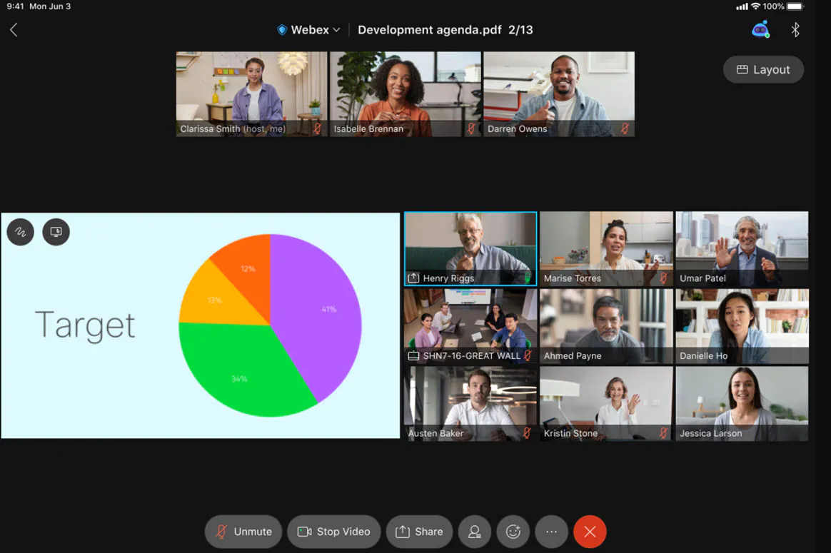
- Eight videos in stage view when content isn’t shared.
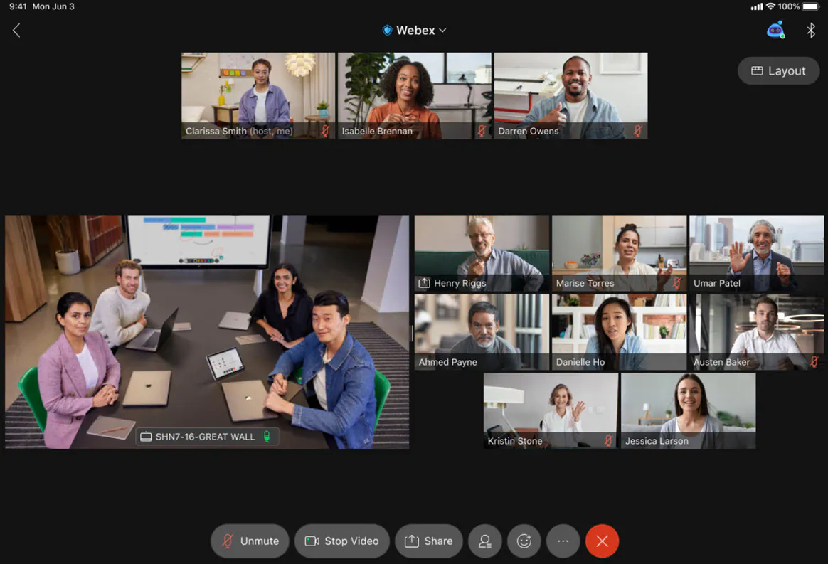

4. Add Webex Events to Microsoft 365 and Google Calendar

The host and invitees can now download the ics information of the event from the events detail window. The invitees can also add the event to their Google Calendar and Microsoft 365 Calendar from the invitation emails.
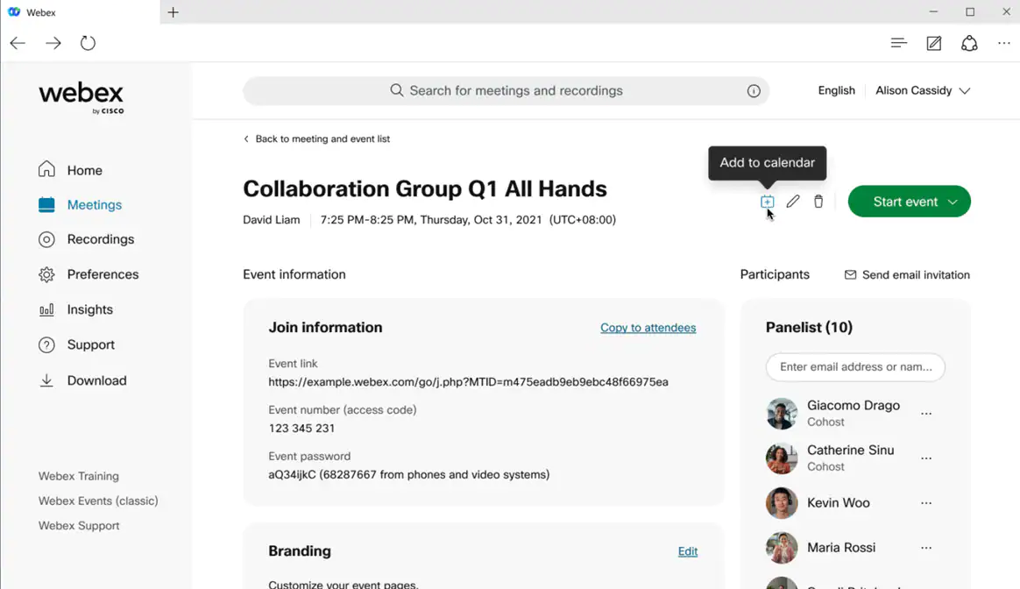

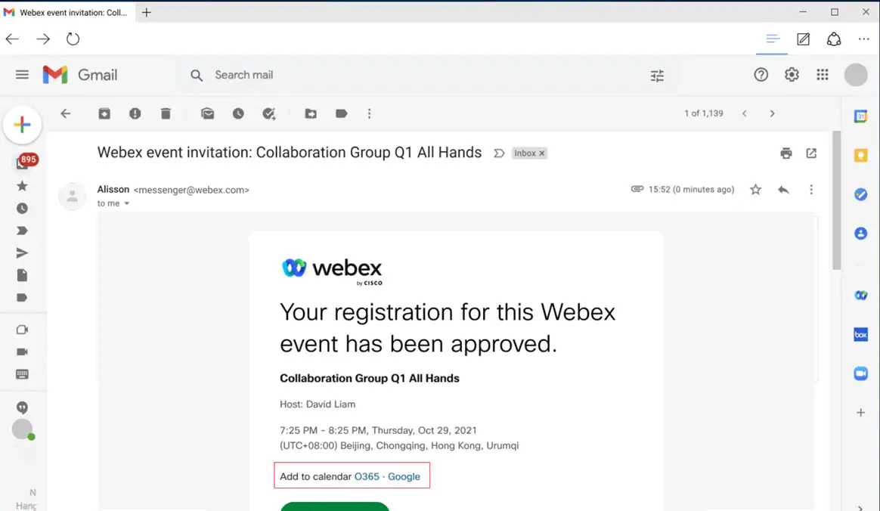

5. Improved leave flow to prevent cohosts from ending the meeting accidentally

We've improved the flow when cohosts leave a meeting to reduce instances of them ending the meeting by mistake. Now, if a cohost chooses End meeting for all from the leave menu when a host is still actively in the meeting, they will be given a prompt warning them that the host is still in the meeting, asking them to confirm if they really want to end the meeting for everyone, or cancel and leave the meeting instead. This secondary confirmation dialog is supported for Webex Meetings, Webex Events (new and classic).

6. Webex Video Mesh private meetings
The Private Meeting feature enhances the security of your meeting by terminating the media on your premises. When you schedule a private meeting, the media always terminates on the Video Mesh nodes inside your corporate network with no cloud cascade. Unlike normal meetings, if the local nodes are full, the media doesn’t cascade to the Cisco Webex cloud.
All participants in a private meeting must belong to your organization. They can join using the Webex App or an authenticated video system. Participants with VPN or MRA access to your network can join a private meeting. But nobody can join a private meeting from outside your network.

7. Video Mesh GDM

Video Mesh uses the globally distributed media (GDM) capabilities of Webex to achieve better media routing. To achieve optimal connectivity, Webex selects the nearest cloud media node to your enterprise when performing Video Mesh cascades to Webex. Traffic then passes through the Webex backbone to interact with the Webex microservices for the meeting. This routing minimizes latency and keeps most of the traffic on the Webex backbone and off the internet.

8. Optimize Your Voice (41.9.1)
You can filter out background voices and noises that would normally be picked up by your mic from your voice to create a better and more engaging experience during your meetings and events.

Ignored features from the above list:
- Slido Integration in Webinar Webex Events
- Additional Windows keyboard shortcuts
- Tooltips now include keyboard shortcuts
- Use the Tab key to navigate anywhere in the meeting window (Mac)
- Raise hand in breakout sessions (just like in the main session)
- Microsoft Teams Integration: Starting and scheduling meetings from message extension
- Meetings RESTful API to support automatic lock setting in create, update, and delete meeting
- Events to Support up to 5K Users (the feature is now available in Webex for Government)

