1. Enhanced meeting security with Auto Admit
We are excited to introduce Auto Admit that is designed to make your life easier as a meeting host while increasing the security of your meeting.
This new default behavior allows invitees who are signed into Webex to join a scheduled meeting directly without having to wait in the lobby. No more admitting people in the lobby when they were supposed to be in the meeting anyways.
No passwords or PIN numbers required. Even Webex Room systems that you add to your meeting invite can join the meeting directly.
Remind your invitees to sign into Webex to be able to take advantage of this amazing new usability improvement.
For users who aren't signed into Webex and those that aren't on the invite, they continue to wait in the lobby until you or a cohost admits them.

2. Share mobile camera view as content
We’re introducing an industry first ability to share the camera view from your mobile device or iOS and Android users. During a Webex Meeting, mobile app users can start sharing their mobile camera view with all the meeting participants. Meeting participants can view shared mobile camera content in full screen mode on their computers, devices, and phones.
To use this feature, select Start or Join a meeting, then … more > Share Content > Camera icon.
Capabilities while sharing mobile camera:
- Zoom in or zoom out when sharing mobile camera and attendees see the updated view.
- Annotate with shared mobile camera content.
- User can share either front camera or back camera.
- If you’ve turned on self-video on your meetings mobile app, it is turned off when sharing mobile camera as content.

3. Lobby chime in Meetings
To help hosts and cohosts manage attendees in a meeting we have added sound notifications for when a person joins the lobby. In addition to the current visual notification, hosts and cohosts can now turn on an audio notification. This option is found in Meeting Setting -> Notifications. People can choose which sound they hear. Sound is only audible for hosts or cohosts. If multiple people join lobby at same time only one sound plays. After 10 seconds then sound plays again if a new person joins the lobby.

4. Host can grant access to the meeting reports to their administrators
This feature empowers the scheduling delegates, typically the executive administrators, to access the meeting content that includes recordings, transcripts, highlights, and attendance reports. Thereby, removing the burden from executives of download this information and manually sending them to their administrators for any further analysis or processing.
When the meeting ends, the delegate, in addition to the host, gets an email with the link to the page where the meeting content is available. Delegate can also sign-in into the Webex site page, select the Calendar option in the left menu, go to the Completed tab and select where I am a delegate in the drop-down menu. The delegate can see and access the completed meeting list and meeting content by clicking any of the meetings.
Only a user marked as delegate can access the meetings content when the meetings end. Moreover, a Webex user has an option to assign if a delegate has access to meeting content or not.

5. Simultaneous interpretation original (floor) audio pass through
When interpreters aren’t speaking in a language channel, participants subscribed to that channel automatically hear 100% original (floor) audio. Once an interpreter speaks in the channel, the user hears the volume balance of an interpreter or the original audio according to what has been set (by default, it is 80% interpreter, 20% original audio, but the user can change it according to their preference). This feature does not change the user interface.

6. Email template improvement
In this update, webinar supports three new email templates:
- Webinar invitation emails for panelists
- Cancellation emails for panelists who are removed in the webinar
- Absentee follow up emails for people who registered for but didn’t join the webinar
Certain email templates are optional, and hosts can decide if they want them to be sent out.
There is also improved support for variables in the email templates, making customization easier for the host.
Also, there's improved support for variables in the email templates, which makes the customization easier on the host.
Support to customize logos for all the email templates.

7. Breakout session attendee report
Breakout session attendance report is added to the meeting attendee report. This includes breakout session names along with the attendee join and leave time.

8. Attendance report now sortable on web (Apple)
This report was previously static and not sortable. Now it is sortable by last name directly in the browser without having to download it.
Only non-beta customers can’t see this feature.

9. New look for site administration management
We're changing the look and feel of your meeting site management pages in Control Hub. We’re making your experience of managing your site consistent with how you manage other services in Control Hub.
The current site management pages use IFrames to pull the site management settings from Webex Site Administration into Control Hub. This interface refresh removes the IFrames and ports most of the site management settings on Control Hub pages. Meanwhile, all administrative activities are audited in Control Hub audit log. We provide a capability for the customers to revert to the old site administration tool in that time, and the administrator can also switch to a new site administration experience. (In this phase, we completed the relevant functions relating to Webex Meetings and Webinar meetings.) For more information, see New look for site management.
[Overview]
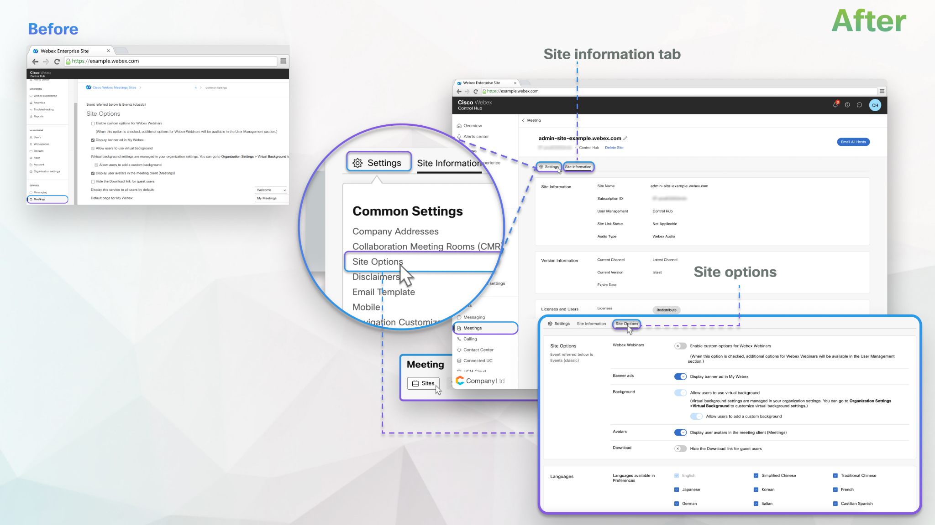

10. Update SSO auto-account creation in Site conversion tool
Site administrator sites with auto account creation can now be updated from Site administration to Control Hub.
Administrators should configure their Control Hub ORG with Auto account creation and auto license templates before updating their site to Control Hub to avoid loss of functionality.
[from https://help.webex.com/en-us/article/dowv6t/Update-Webex-Meetings-site-management-from-Site-Administration-to-Control-Hub ]
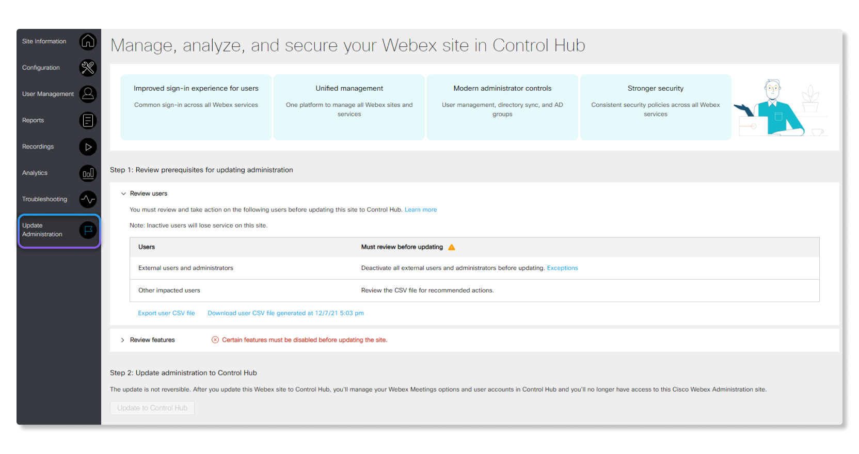

11. Ability to disable broadcast message
Administrators can disable Broadcast Message using Control Hub templates for Meetings and Webinars. The controls to disable this feature are available at the user or group or org level.
When the administrator has this disabled for the user, then the user as an attendee to a webinar or meeting can't receive broadcast messages. For a user that has the broadcast message turned OFF, they aren't able to use this feature in the meeting and appropriate client message is provided to them. If the user is a host, then the entire meeting doesn't have the broadcast message capability.

Ignored features from the above list:
- Support M2 chipset on Mac Webex Meetings is now fully supported on Mac operating system with M2 chipset.
- Embedded apps third-party SSO support When you select an app in the App Gallery, you can view the App Info along with the app descriptions, screenshots, and videos that app developers have provided for their app. You can also select Don't show me this page again if you don't want to view app information.
- PWA for Chrome OS: meeting calendar You can now access your upcoming meetings directly in the Meetings Progressive Web App (PWA) for Chrome operating system. Browse meetings by date and click to view meeting details. When it's time to join, the Join button is displayed automatically.
- Slido experience
  - Drag and drop polls in Webex You can now drag and drop polls and change their order directly in the Webex sidebar.
  - Multiple answers in open text by default Have you ever been approaching administrators to allow multiple answers in open text poll? Not only you, but we’ve also heard it as feedback from our users and experienced it on our own.
More than 50% of our used open text polls have enabled multiple answers in poll settings. So, it means, on more than 50% of open text polls our users had to do one additional click.
In future in all applications you have this poll setting that is enabled by default.
  - Typing indicator in a survey and ranking poll You can now see an indicator depicting the number of participants responding.

Webex Meetings to support Apple Continuity Camera Apple Continuity Camera lets you replace Mac's built-in web camera using the iPhone camera. You can use the rear-facing, wide-angle camera of an iPhone to support high-quality photo and video capture in Webex Meetings. It also enables the Mac Desk View app, which works like an overhead camera setup to show the desk area in front of the Mac without any additional equipment.

Requirements for Apple Continuity Camera feature:

Needs iOS 16 beta (or later) and MacOS Ventura beta (or later).

Wi-Fi and Bluetooth are on for both your Mac and iPhone.

Mac and iPhone are signed in with the same Apple ID and using 2FA.

