1. Simultaneous Interpretation
Hosts invite interpreters and assign them to the appropriate language channel as needed. Hosts can create audio channels at the beginning of the meeting.
Multiple language channels can be created and when participants join, they can select the appropriate audio channel. As soon as they join, they can hear their selected language.
This solution supports meetings and large events (webinars), multiple interpreters per channel, relay interpretation, and bi-directional interpretation.
The Manage interpreters feature is currently unavailable and will come in a later update.
Simultaneous Interpretation is available in Webex Meeting desktop app, Webex Events (new), Web app, and Mobile.
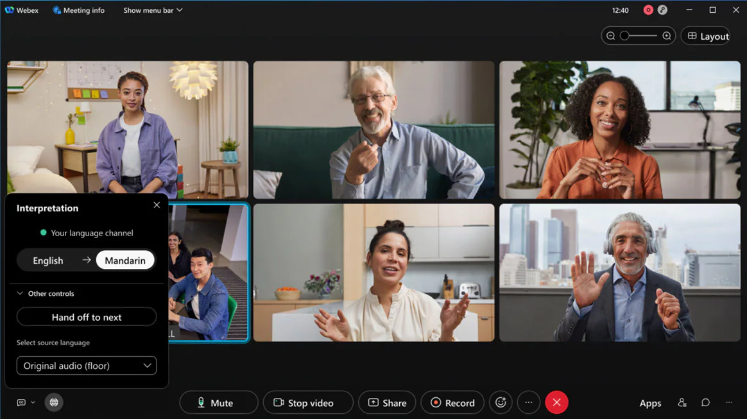

iOS
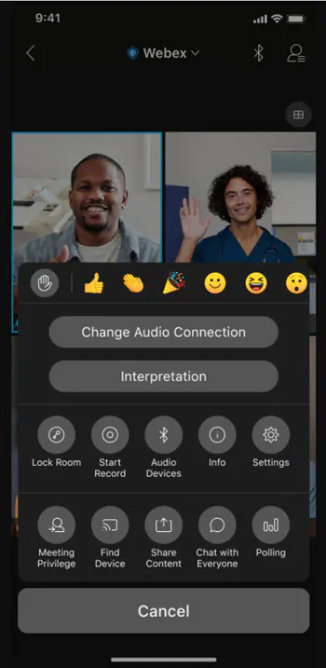

Android
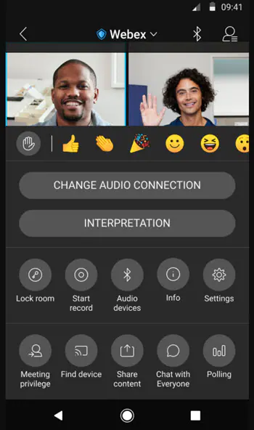

2. Webcast attendee view customization

The Webex event host can customize the look and feel of the attendee view in a webcast. They can also customize the logo, theme, and color of accent view.
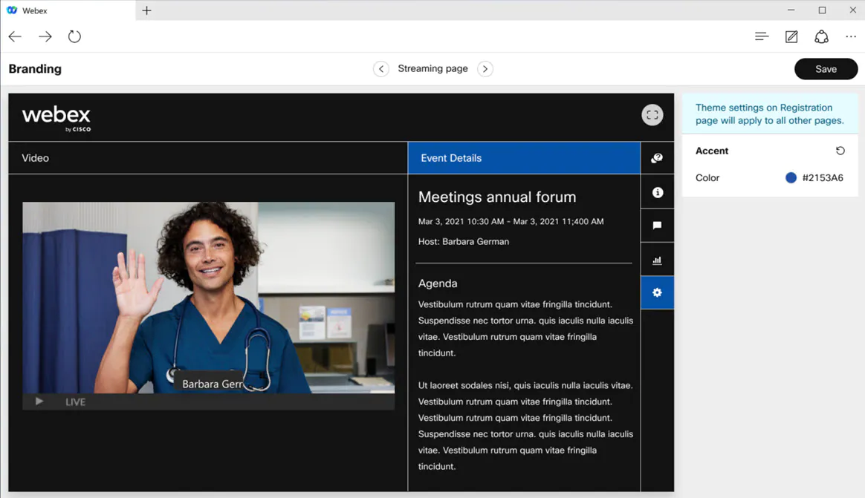

3. Accessibility settings: Manage screen reader notifications and chat font size
In this update, we've added a new item under the Help > Accessibility Settings Here, a user can:
- Manage their screen reader notifications announcements—For users who use assistive screen reader applications (like JAWS and VoiceOver), it may become overwhelming if the screen reader is announcing every single notification in a meeting. For example, if people are constantly coming in and out of the meeting, this may distract from being able to hear the conversation in the meeting. Now, users can manage which notifications they would like their screenreader to announce.
- Adjust the font size in the Chat panel—You can now increase the size of the font in the Chat panel, directly from the meeting. Particularly useful if you don’t want to adjust your font or display settings at the system level.

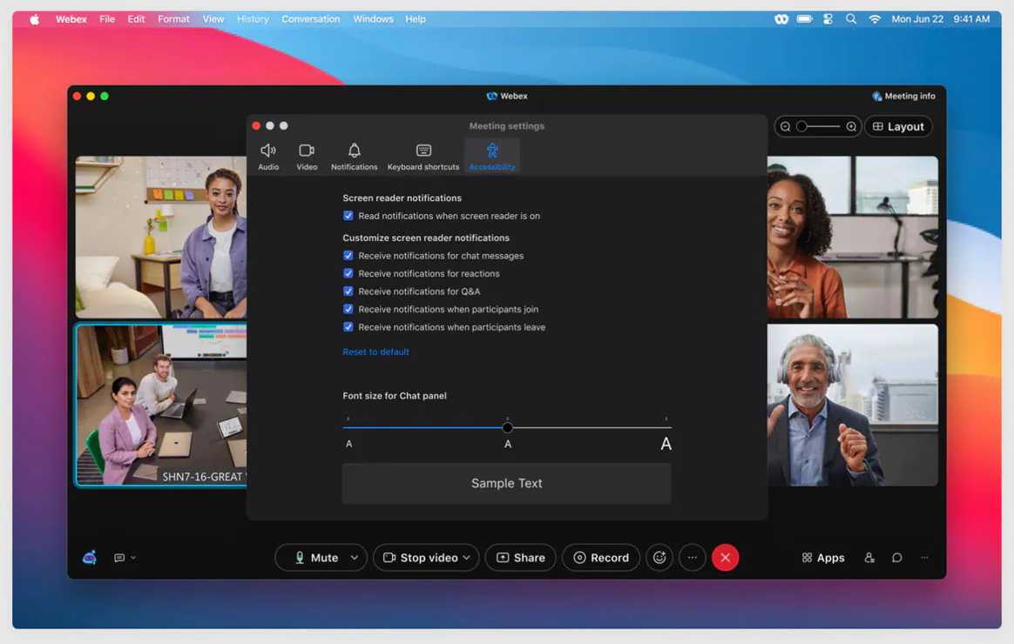

4. Layout menu: Optimized look and feel

We've optimized the look and feel of the Layout menu, making it easy to find the settings you're looking for.

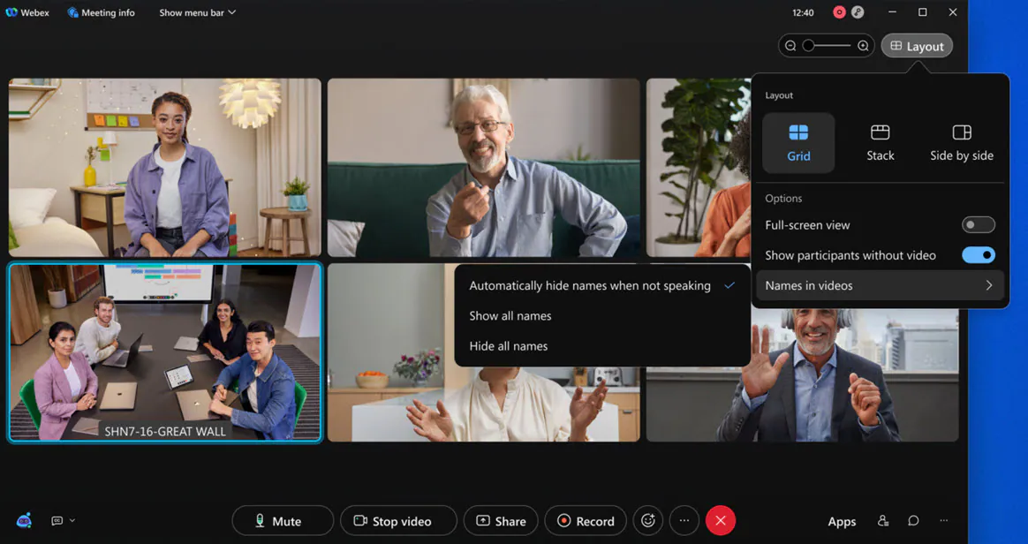

5. Support for new languages
In this update, we’re introducing support for four additional languages in Webex Meetings, Webex Events (new), Web app, Mobile app, and Audio Experience: Norwegian, Bulgarian, Serbian, Croatian. All audio prompts selections are played in the selected language to the audio users.

6. Unified meeting preferences
We've made it easier to keep your meeting settings organized by unifying them into a single Preferences interface. This also aligns with the preferences you can find outside of the meeting in the Webex app.
There's no change to the settings themselves (same capabilities you know and love), however, starting in this update, you’ll notice accessing any of the following will now open the unified dialog:
- Audio Options
- Video Options
- “Notification” Preferences
- Keyboard Shortcuts
- Accessibility Settings
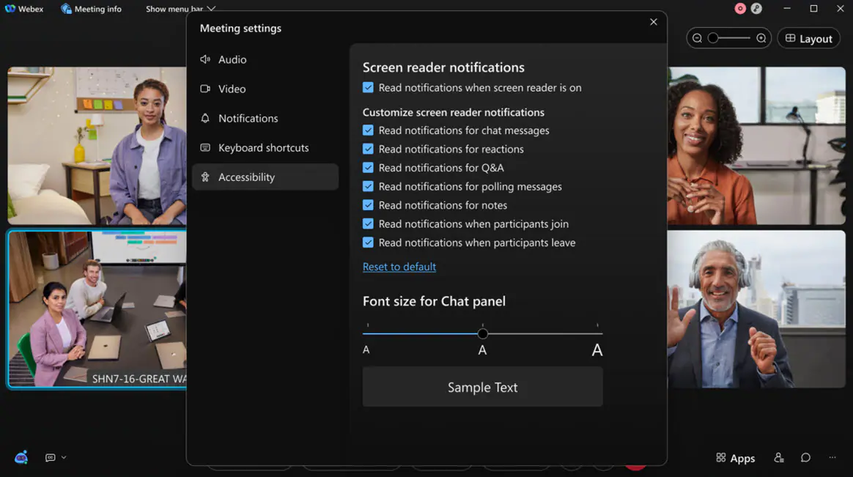

7. Host report for webcasts
The host can now see the same attendee report in a Webex Events (new) webcast as in a webinar. After the webcast ends, Webex generates a report, and the host can find them in the Completed Meetings tab.
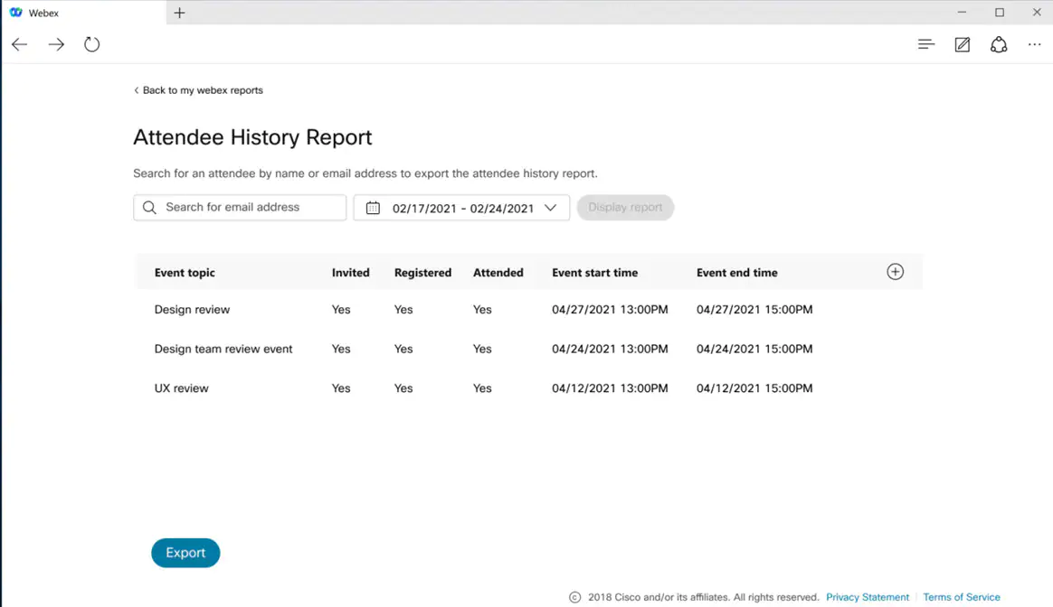

This feature isn’t supported for Webex for Government.

8. Attendance and registration reports
As a host you have access to meetings and events attendance and registration reports in one place to better understand a meeting or event’s turnout. In the Registration report view, you can look up someone’s registration. You can choose to view individual registration by clicking on the registrant’s name and export reports to a CSV formatted file that is available for both reports.
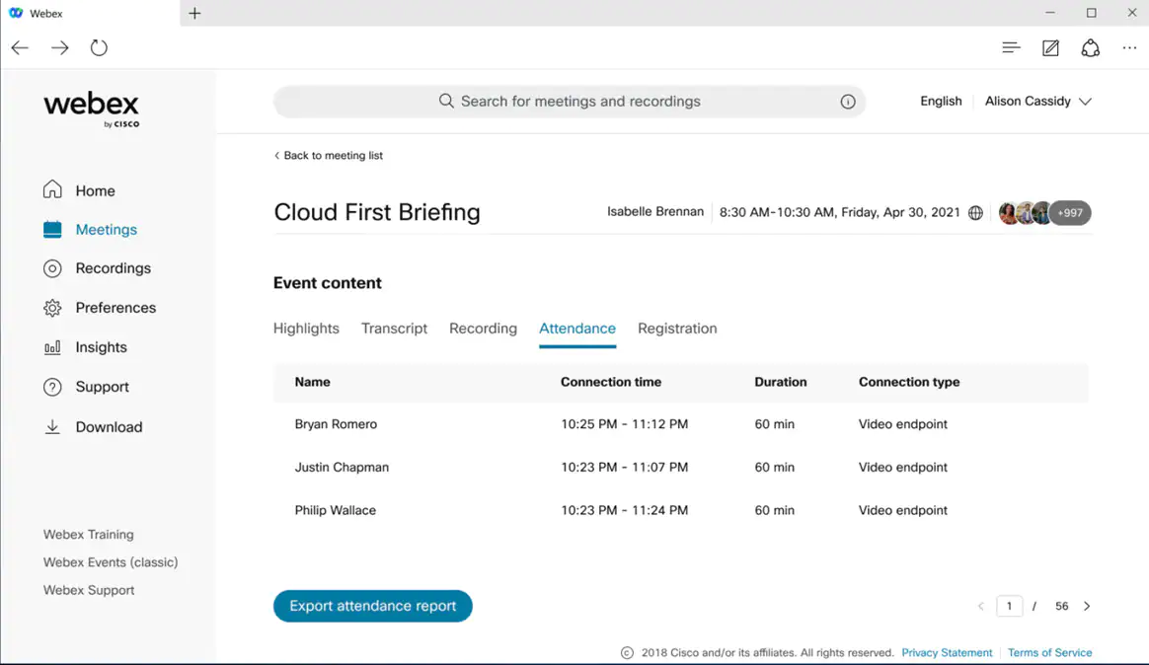

9. Edge callback GDM

In the continuous effort of improving our customers' meeting experience, we’ve enabled a new Edge Audio feature Callback GDM (Global Distributed Media) for all Webex Edge Audio customers. Your branch offices across the globe will now receive Edge callback from your closest Cisco Data Center, and we’ll carry your cross continent on-net traffic through Cisco Network Backbone instead of the Internet—thus improving voice quality and stability.
For example, you have a Webex site in the United States that has a branch office in Japan. Earlier users from the Japan office would receive an Edge callback from the United States Data Center through the Internet. When the Japanese user speaks, their audio is transferred to United States for audio mixing, and again through the Internet. Once this feature is enabled, the user receives the Edge callback from our Asia-Pacific Data Center - which is much closer. Moreover, their audio pockets will only need to reach Cisco Asia-Pacific Data Center through Internet, and then the majority of cross continent distance between Asia-Pacific Data Center and United States Data Center is be covered through Cisco’s Network Backbone.

10. Enable custom options for Webex Events (41.10.3)
As an administrator, you can enable and disable options for events to comply with your site requirements. This allows you to configure a site to follow the HIPAA compliance.
By default, the following options are enabled in Webex Events (new):
- Annotation tool
- Application share
- Application sharing remote control
- Chat
- Desktop share
- Desktop sharing remote control
- Document and presentation share
- File transfer
- Practice session
- Q&A
- Recording—local computer
- Recording—network
- Web browser sharing
- Web browser sharing—remote control
- Whiteboard

Ignored features from the above list:
- Support available for Apple iOS 15 and new iPhone devices
- Stream your Webex Meetings or Webex Events to Vbrick available for Webex for Government
- Display attendees' names for reactions
- Webex devices in breakout sessions
- SIP user to see a warning message if they screen share in a restricted meeting
- Events- Panelist and Attendee Chat Enhancements (In Android and iOS, attendees can chat with individual panelists, all panelists, and everyone in Webex Events (new).​ Panelists can chat with all panelists and everyone in an event.)
- Support for 1080P Video​ in a Meeting (iOS and Android apps support receiving 1080p video in a meeting.)
- Support available for new iPhone models
- Support available for Apple iOS 15
- End of support for Office 2010 file sharing
- End of life announcement for join by meeting number using prefix and suffix
- Webex Meetings API support for Webex Events (New) (Developers can now schedule events using the meetings API. The API supports standard CRUD operations in line with the current meetings API video devices. We'll be releasing more API features to support Webex Events (new), so stay tuned to learn more in the coming months.)

