1. New webcast view experience in Webex Webinars (version 42.11.5)
We’re happy to announce the new webcast view experience, coming in November.
Hosts can set up a customized logo in the scheduling step. The host and their attendees are impressed by the polished look of Slido’s polling and Q&A, as well as the variety of the polling questions. In the previous update, attendees view couldn’t be maximized, but in this update, attendees can max out the web browsers' space to view the webcast.
In terms of limitations, hosts can view the total number of attendees but can’t view the individual attendees in the list yet. Also, the chat doesn’t have emojis or the ability to adjust font.

2. New Webex whiteboard
Previously this feature was available with a beta tag, but in 42.11 it is generally available to everyone. The new Webex whiteboard is an infinite canvas where you can collaborate together with any meeting participants whether they are using Webex Meetings app, Webex App, or Webex devices.
There are some new tools that are added to the new whiteboard:
- Text—It's much easier to type text than writing with a mouse.
- Shapes—There are some built-in shapes, you can discover them by clicking the Shapes tool.
- Lasso-selection—When choosing the Arrow tool, you can lasso-select objects in the canvas and move them, delete them, bring to front or send to back.
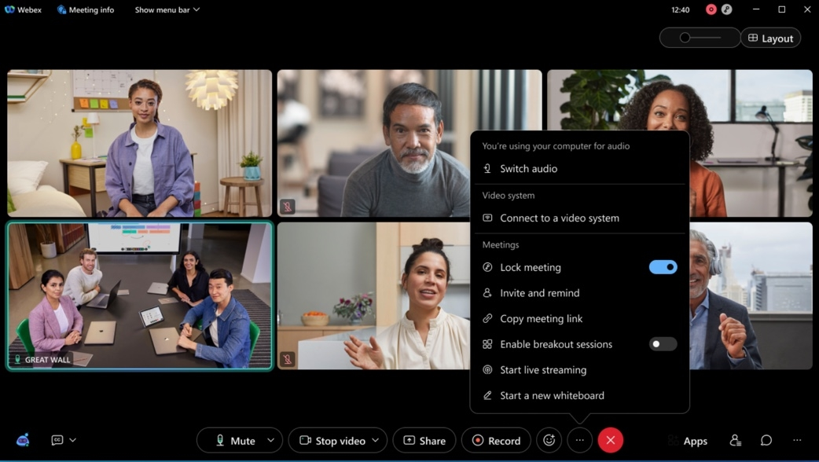

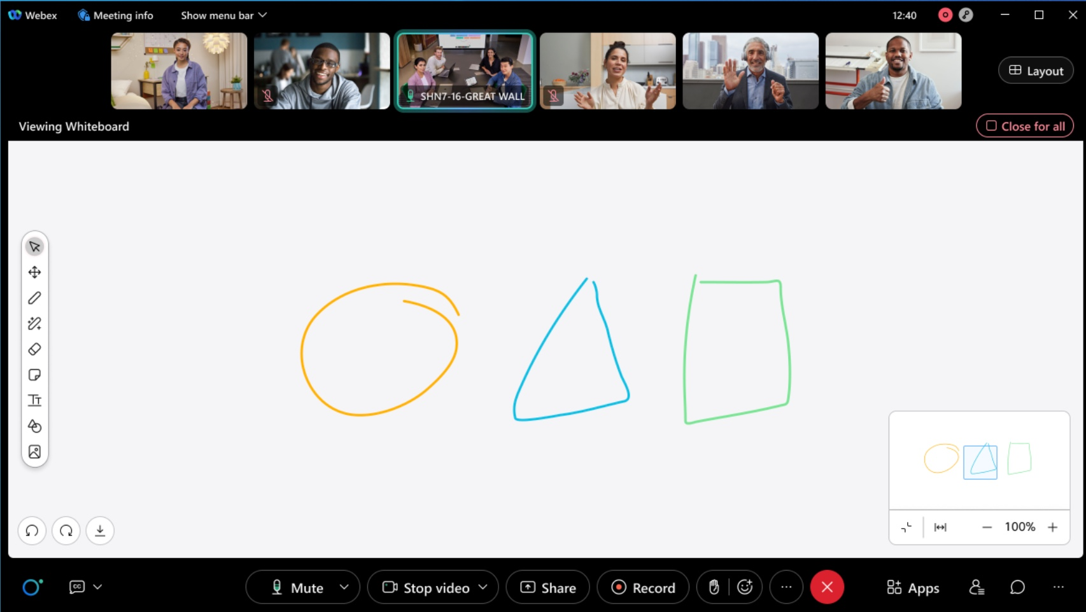

3. Edit In-meeting display name
You can now edit your in-meeting display name in the meeting. This makes it easier to use a preferred name or control how you want your name is seen by others.
As a Meetings participant or Webinar panelist, in the Participants panel, simply right-click your name and select Edit Display Name to edit your name for this meeting. Hosts and cohost can edit the display name of any Meetings participant or Webinar panelist in the meeting or webinar.
The meeting recording and usage report always show the last-edited name of a user.
For customers who prefer to block the ability to edit display names, the can administrator can disable it.
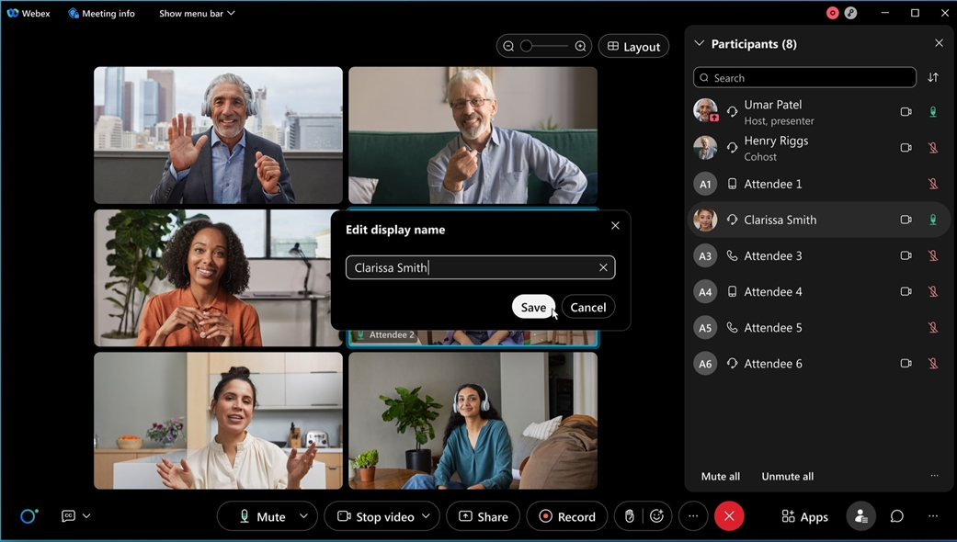

4. Notice of default value change to ON for the Enable Webex Assistant administration site setting
The Enable Webex Assistant setting is on by default, in November, unless an administrator has already manually set it to Off. In November this change is applied to all customers, including both slow and fast channel customers.
This setting only makes Webex Assistant available in meetings but doesn’t automatically turn it on. Whether or not Webex Assistant is turned on in meetings depends on the host's choice.
Administrators can also control Webex Assistant availability for individual users and groups using the settings templates.
If a customer prefers Webex Assistant to be unavailable for all users, then they can ensure that the Enable Webex Assistant setting is turned OFF by following these steps:
If the setting is currently OFF:
- Turn the setting ON.
- Save the page.
- Turn the setting OFF.
- Save the page.
If the setting is currently ON:
- Turn the setting OFF.
- Save the page.

5. Custom Dictionary
The Custom dictionary feature in Control Hub allows administrators to specify custom out-of-vocabulary words that aren’t part of the standard dictionary, so that when these words are uttered in meetings, they can be transcribed more accurately in the closed captions and transcript.​ The keywords include organization acronyms and jargon, industry terms, product names, organization name, and people's names. In this update, this dictionary is limited to 100 words and English language support only.

6. New lobby controls for Personal Room meetings
The new lobby controls for Personal Room meetings re-categorizes guest users, separating them into two groups with separate lobby controls.
These two new users groups are:
- Unverified Users: Users who have not signed in and whose identity can't be verified.
- Verified External Users: Users who have signed in, but belong to a different organization to the one hosting the meeting.
Each of these user groups have separate and independent lobby controls:
- They can join the meeting.
- They wait in the lobby until the host admits them.
- They can't join the meeting.
Distinguishing between unverified and verified external users allows administrators to enhance meeting security by applying more stringent meeting entry controls for unverified users. For example, unverified users can’t join the meeting, while verified external users are placed in the lobby or unverified users are placed in the lobby, while verified external users can join the meeting directly.

7. Webex Scheduler support preferred site to login
Webex Scheduler uses the default Webex site when scheduling a meeting. You can change the default Webex site in Webex App preferences. Administrators can perform a bulk default Webex site change for users by a user CSV export and import in Control Hub.

8. Change attendee status to pending in the Manage Webinar Registration page
You can now see a Change status to pending button in the manage webinar registration page, which allows you to change the registration status of an approved or declined attendee to pending.
Attendees marked as pending are listed in the pending tab of the manage registration page.
When the status of an approved attendee is changed to pending, the attendee receives an email informing them that their invitation to the webinar is cancelled. No such email is sent to attendees whose registration status has been changed from declined to pending.

9. Host notification for recordings reaching expiry based on retention policy
Webex users receive an email notification if they have recordings reaching expiry soon. They can see an expiring soon label next to their recordings in the recordings tab in the Webex site.
These notifications are set either weekly or monthly, depending on the retention period set by the administrator. These notifications are controlled by the existing recording email notification toggle in settings.

10. Restrict meeting experiences using registry keys on your company devices
(Note: ) This feature is available in the 42.11 update, but was added after the initial November 2022 (42.11) features were communicated.
IT administrators can restrict their company devices to adhere to certain meeting experience based on their company policies. This can be done via pushing down a registry key across all your company owned devices. More info on how to configure that : Collaboration restrictions for Webex Meetings in Control Hub
Today if a user is signed-in they adhere to their company policies no matter the device they join the meeting from. This behavior changes with the registry key installation from this update. Going forward if the restricted machine or device has a registry key the experience is the most restrictive policy. For example, devices or machines restrict file transfer but the user policy allows for this feature, if the user joins the meetings using this restricted device they can no longer perform file transfers in that meeting. we will go with the most restrictive policy

11. Forced authentication before joining Webex Meetings
In this update, IT administrators can now lock the company device to allow only authenticated company users to join meetings using this device. You turn ON this feature in Control Hub.
This feature is applicable if you are using company device to join meetings that are held within your organization or joining external meetings (meetings held outside of your organization). This feature leverages registry key and token that are introduced. For more information on token and registry keys, see Collaboration restrictions for Webex Meetings in Control Hub.
Without a registry key, if Authenticated Sign-in is ON, it applies to everyone trying to join meetings with a claimed email address.

12. Ability for IT administrators to control secondary camera experience for their meeting users
IT administrators can now decide if their users should have the secondary camera capability in their meetings or not. Administrators can apply this configuration to a specific user, group of users, or to their entire organization using Control Hub settings template or to their entire organization using org level settings on Control Hub. Administrators can also choose which meetings (internal or external) these settings apply using the options that are provided to them in the settings templates.
The end user is provided with an appropriate notification from the app when this secondary camera feature is disabled for use by the IT administrators.

13. Trusted domains for Personal Room meetings and internal only Personal Room meetings
This feature provides more granular control over internal Webex Meetings.
Previously this Control Hub feature allowed an administrator - to make all scheduled and Personal Room meetings:
- Accessible by all external users
- Accessible only by users from approved email domains
- Accessible only by internal users
This feature can be applied to:
- All users in the organization
- A group of users in the organization (using Templates and User Groups)
- An individual in the organization
This new feature allows the above controls to applied only to Personal Room meeting such that:
- Scheduled Meetings and Personal Room meetings are accessible by all external users.
- Personal Room meetings are accessible only by users from approved email domains, scheduled meetings are accessible by any external user.
- Personal Room meetings are accessible only by internal users, scheduled meetings are accessible by any external user.
This Personal Room meeting only filter can be applied to all users in the organization, a user group, or an individual user.

Ignored features from the above list:
- Webex Scheduler to support Webinar for Microsoft 365 Cloud Customers You can now schedule a webinar from Webex Scheduler for Microsoft 365 Cloud users. The Outlook invitations are sent to panelists. Meanwhile hosts receive another email which is forwarded to other attendees. Hosts can continue editing a webinar on the landing page and materials in the Webex page.
- Microsoft Edge WebView2 (Windows) In this update, Microsoft Edge WebView2 run-time is automatically installed with the latest version of Webex Meetings and Webinars, if it’s not already installed. This ensures that WebView2 is always running with the latest updates. (Note :) For VDI Environments, Webex users are prompted to install WebView2 each time they sign in. To avoid this, we recommend IT administrators deploy WebView2 to their VDI environments.
- Slido experience
  - Participants are now able to withdraw their replies to questions You can now withdraw reply using icon > Withdraw. The feature works similarly to question withdrawal and therefore the withdrawn submissions are anonymized.

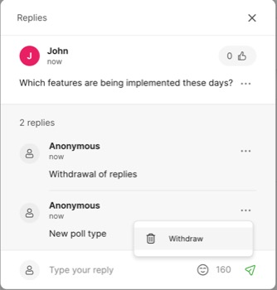

  - Create a new modal from Slido administration Along with the fresh design, you can notice that we’ve removed the event code and invite collaborators input fields. They’re still available under Event Settings. We believe this makes it easier and faster for new users to get on board, while only minimally impacting experienced users’ flow.

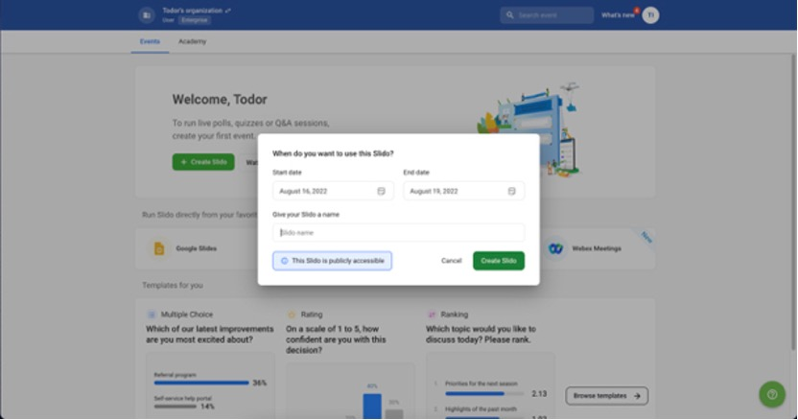

  - Typing indicator in administration To be sure that you aren't missing anyone’s responses before moving onto the next poll or question while moderating from Slido administration, you can now see the number of people that are still typing.
  - PPT and Switcher applications for organizations in US data centers Up until a couple weeks ago, the PowerPoint Integration and Switcher Application weren’t available for organizations hosting their Slido data in US data centers. You can view the articles that are linked above to find out more about these integrations and how they can help you make the most out of your meeting experience.

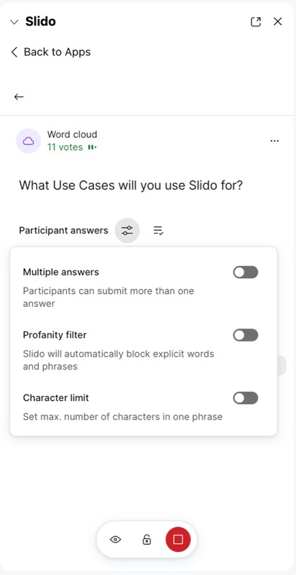

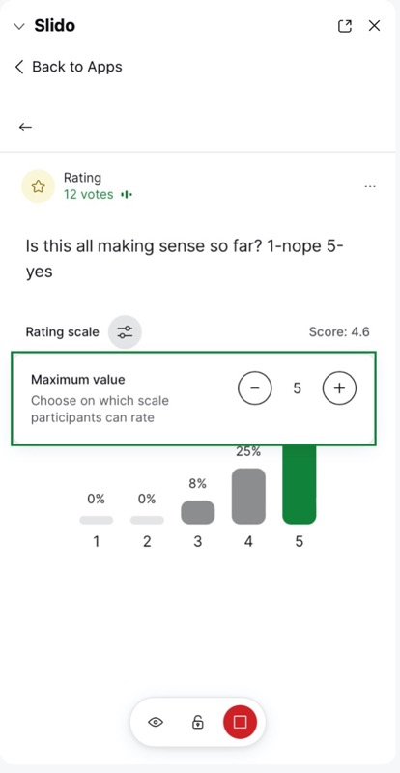

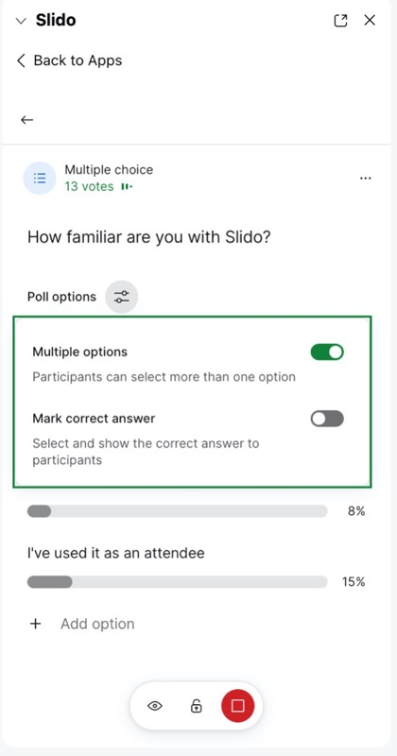

  - Ability to change settings when poll is live As a user, you can change the settings even when the poll is live, the toggles appear changeable as opposed to being grayed out as they previously were in this state.
  - Accessibility Improvements for Slido Webex Sidebar The improvements are:
- Focus: Slido now manages keyboard focus more efficiently so users can navigate the interface easily.
- Screen reader announcements: Slido correctly announces several elements in the user interface and helps users understand what content is presented.
- Quiz improvements: Timed questions are now announced to let users know when a question is closed.

