1. Configuration of Webex Control Hub and Webex Site Administration to support eCDN
This feature leverages a Vbrick Rev tenant for enterprise content distribution (eCDN) and video content management (eVCM).
After the administrator turns on and configures Vbrick Rev eCDN site users on the Webex site, they have the ability to get webcast events configured on Vbrick Rev tenant site that supports eCDN.
You’ll need to acquire the Vbrick service to use this feature.
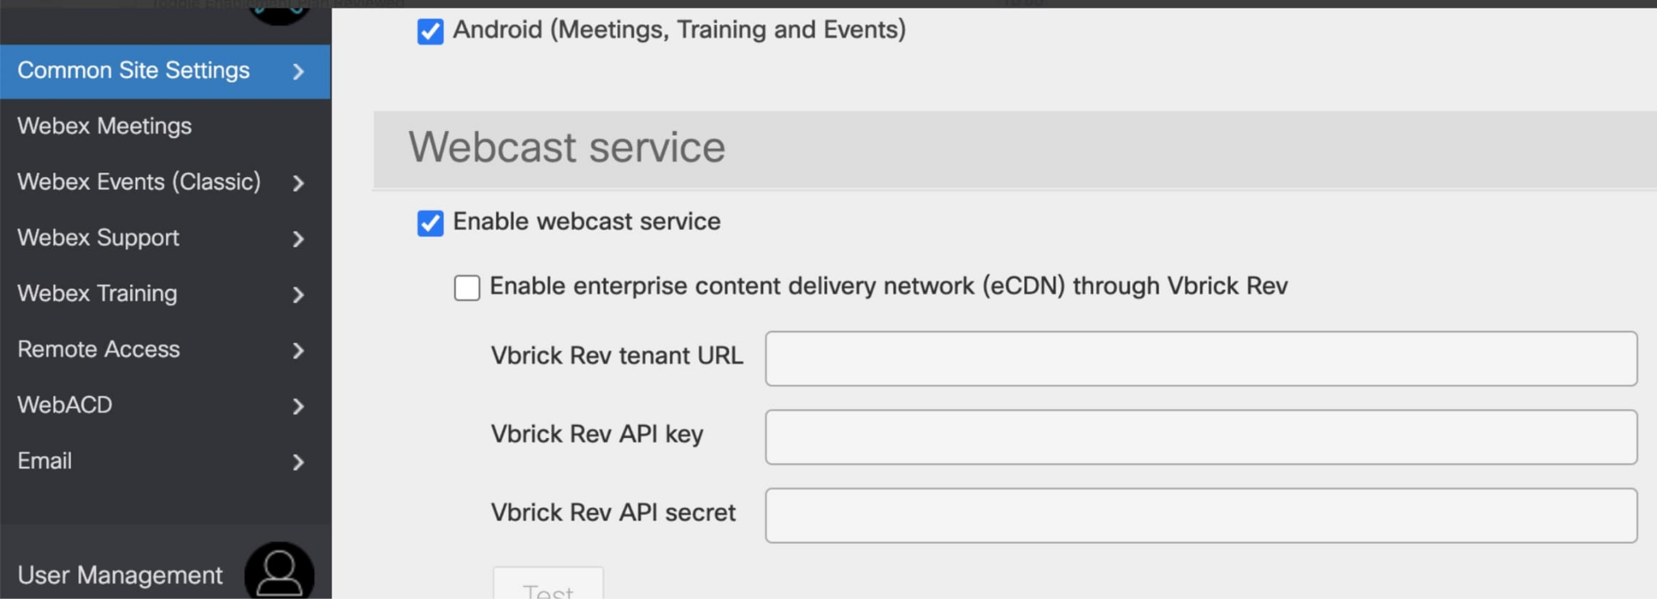

November 2021 (41.11.4)
Update from Site Administration to Control Hub
Administrators can now confidently update their Meetings site management to Webex Control Hub . Previous, meetings data such as upcoming meetings, recordings, site settings, and user preferences are maintained.
The benefits of managing all Webex services in Control Hub include:
- Unified way of licensing across all Webex services (Messaging, Calling, and Meetings)
- Consistent security policies across all Webex services
- Common login for end users for all Webex services
- Modern administration controls like directory connector, System for Cross-domain Identity Management (SCIM), Active Directory (AD) groups, and more Licensing templates by AD Groups
Review the site conversion doc before updating administration to Control Hub. It’s important to review and follow “Prepare your Control Hub Organization” before you attempt to update your site.
Update administration (from Site Administration to Control Hub) is enabled on most sites shortly after this version update. This feature won't require an update of client versions.
Limitations:
- Sites whose users have not been linked to Control Hub are not eligible for this update.
- Some sites aren’t enabled for this update of administration to Control Hub until their partners are ready.
This feature isn’t yet available for Webex for Government and will be available in a future update.

2. Web scheduler now supports Multiple time zones

Similar to Webex Events (classic), the host can use the Time zone planner in the Webex Meetings and Webex Events Scheduler page to plan a time where the invitees who are based in multiple time zones can attend.
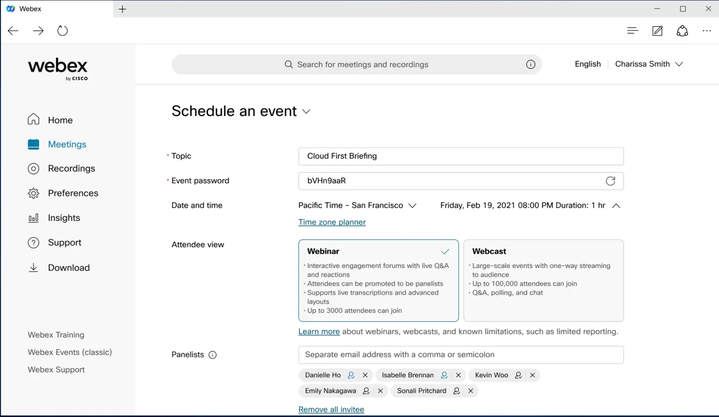

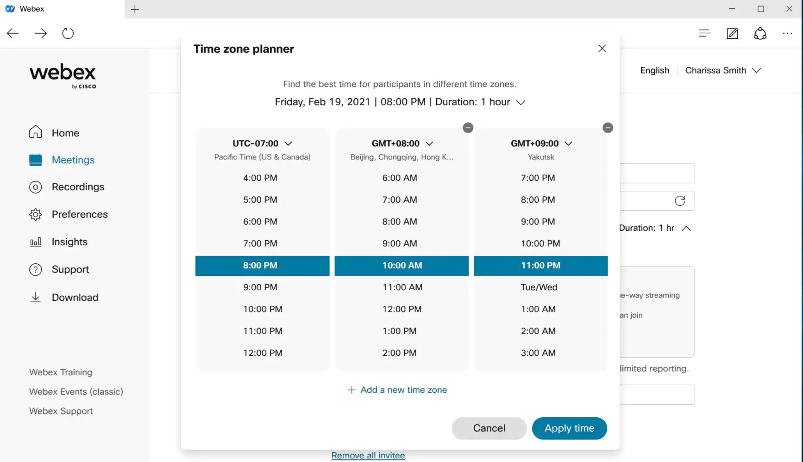

3. Easy to use audio mute state management, recording controls, lock state, and raise hands available on Webex on-premises devices
It’s now possible to accurately reflect the mute status in the meeting participant list for Webex on-premises registered video devices. Previously, when they muted or unmuted themselves, this wouldn't show up in the participant list.
When the host requests the video device user to unmute, there will not be any visual indications on the video device any more. However, the host can alway verbally ask the user to unmute themselves.
In addition, when the host turns on or off the ability for participants to unmute themselves, users on video devices then see appropriate messages rendered on their video device.
When a meeting is setup in the moderated unmute mode, hosts on the Webex App can continue to mute and unmute video device users directly from the app.
There’s no request to ummute and response flow. Keep in mind that in this mode, if a user on a video device uses their local mic button to control their mute state, this is not reflected on the Webex App participant list.
As a host on a Webex on-premises registered video device, you can now record meetings using controls on the device interface instead of using DTMF controls, see direct device messages indicating the lock status of a meeting, and can now raise and lower your hand in a meeting using controls on the device interface instead of using DTMF controls.
With the first tap on the recording control a new recording is started. Tapping on the recording button again stops the current recording.
In addition, all users on Webex on-premises registered video devices see a recording icon shown on the edge of the screen. When the recording stops, the icon is removed.
When a meeting is locked, there’s a key icon shown on the edge of the screen to indicate that the meeting is locked. When the meeting is unlocked, the key icon is removed.
When someone else raises their hand, you see a hand icon displayed on the edge of the screen. When all hands have been lowered by the host, the icon is removed from the screen.

4. Registration IDs in Webex Events (New)

When a host schedules an event, they have the option to ask Webex to generate a random ID (usually 6 digit) for each of the attendees. When an attendee joins the event, the attendee needs to input the ID together with an email address to join the event. This can prevent unauthorized attendee joining the event using the event link.

5. Hosts can invite attendees or upload CSV Files in Webex Events (New)
Hosts can invite attendees using the event information page once they schedule an event. If there are a lot of attendees, then the host can upload .csv files that contain up to 10,000 attendees. If the host wants to add more than 10,000 attendees, they can upload multiple .csv files.

6. Support Q&A and chat during a practice session in Webex Events (New)
Webex now allows attendees more interaction with panelists and hosts when the practice session is in progress. Attendees can ask questions and can chat with everyone (public chat) and chat with panelists.

7. Advanced host and cohost mute control in breakout sessions
When a host or cohost is in a breakout session, they can manage the audio of those attendees in that breakout session. This gives hosts and cohosts the same functionality they have for attendees when in the main session.
- Allow attendees to unmute themselves.
- Moderated Unmute Mode
When a host or cohost isn’t present in the breakout session, attendees in that session can mute and unmute themselves, like today.
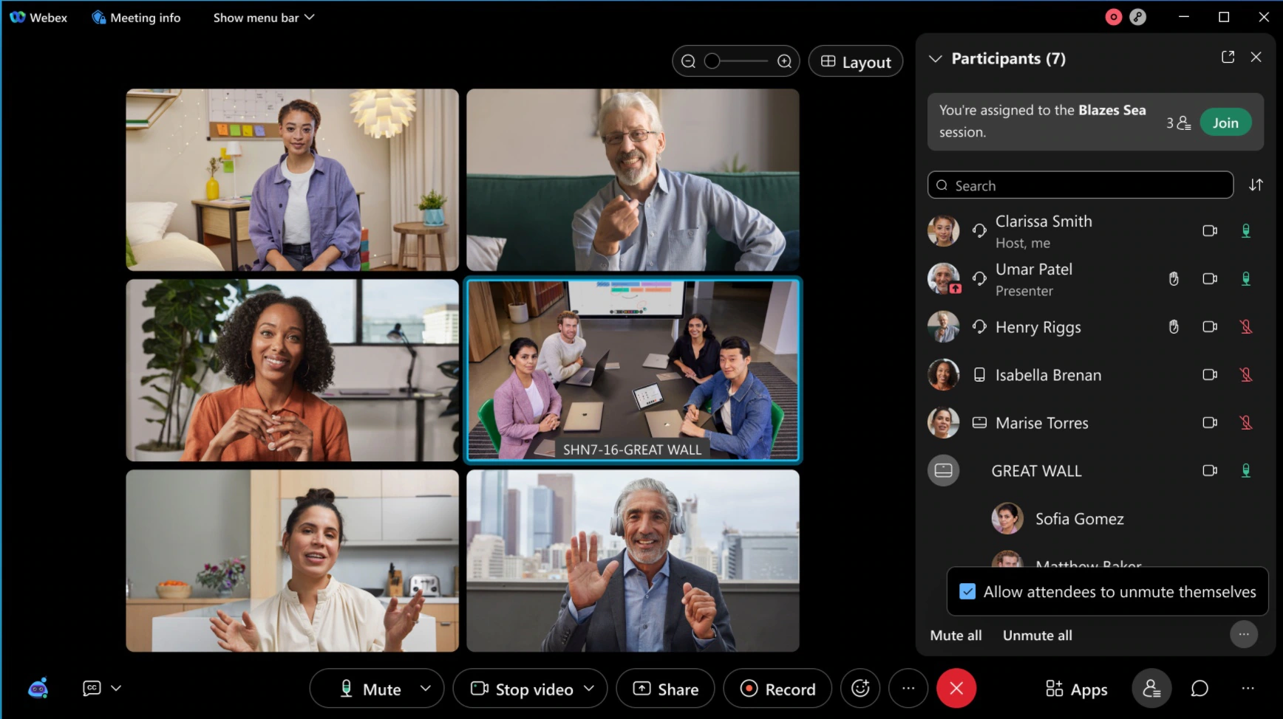

8. Fullband support in music mode now available for Mac and Windows
Music Mode can now support up to Fullband audio quality on Webex Meetings app for Mac and Windows.
Administrators that require higher quality audio for Music Mode can request the feature to be turned on for their site.
When turned on, Music Mode sessions are encoded using up to Fullband audio quality. Without this toggle being turned on, Music Mode continues to operate up to super wideband audio fidelity on desktop apps.
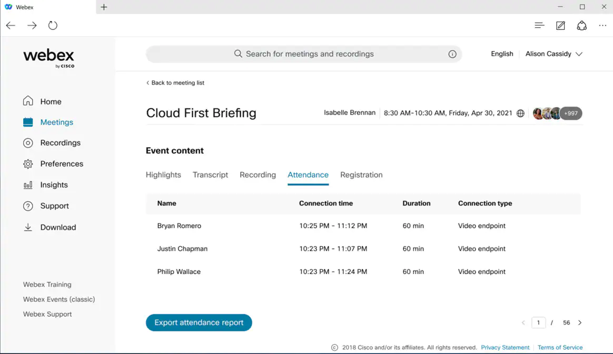

9. Include log report in post-meeting survey

To better evaluate user satisfaction, you now have an option to include the meeting log report when filling out the post-meeting survey. The option to include a meeting log report displays when selecting a score of 7 or less in the How likely are you to recommend this app to a friend? question. Users are able to upload meeting client log if they give the NPS score is below 8. This helps to use the log to analyze the issues that they reported.
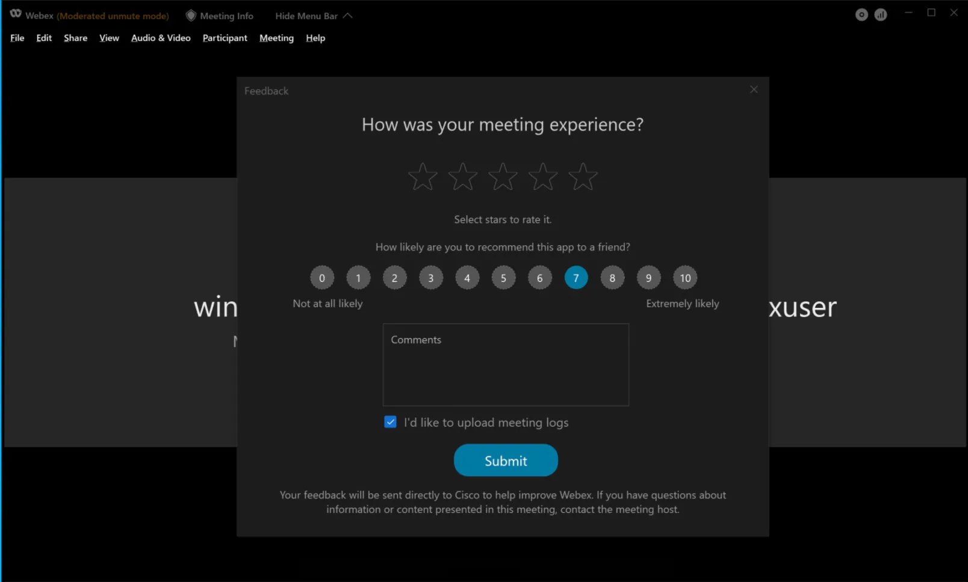

10. Easy to use audio mute state management, recording controls, lock state, and raise hands on available for Webex on-premises devices
It’s now possible to accurately reflect the mute status in the meeting participant list for our on-premises registered video devices. Previously, when they muted or unmuted themselves, this wouldn’t show up in the participant list.
As a host on a Webex on-premises registered video device, you can now record meetings using controls on the device interface instead of using DTMF controls, see direct device messages indicating the lock status of a meeting, and can now raise and lower your hand in a meeting using controls on the device interface instead of using DTMF controls.
For more information, see the Highlighted Features for this update.

11. Show contact information
The organization administrator can customize the Contact information in organization settings in Control Hub. The customized information is valid for Control Hub managed sites. This enhancement gets contact information consistency among all sites. Meanwhile, the users can find the appropriate administrator contacts on the Webex support page.

12. New GDM Location
We’re adding a Mumbai Data Center to the list of our GDM locations. This move allows all Webex Meeting application (Desktop, Mobile, and Web) to select the Mumbai Data Center as the destination for their computer audio sessions into their meetings. This is expected to significantly enhance the computer audio quality of Webex meeting participants from India and nearby regions in Asia Pacific.

Ignored features from the above list:
- Support for VDI plugin on MacOS
- Support for Android 12
- Support available for new operating system and browser (Webex site functionalities are available on browsers in Windows 11.)
- Windows task bar notifications (In response to customer feedback, we’re turning off the Webex Windows task bar notifications.)
- Scheduling Webex Events (New) now becomes easier (As a host, you can see the Schedule an event button on the site home page rather than it being hidden under the Schedule a meeting button.)
- User interface change in Webex Events (User interface changes in Webex Events (new) are aligned with the behavior in Webex Events (classic). By default, the Start button changes to Schedule in the Schedule an Event section.)
- 4:3 Aspect Ratio cameras now supported on Mac and Windows (We’ve added support for 4:3 aspect ratio cameras to Webex Meetings desktop apps for Mac and Windows. Select Zoom to fit in the Video settings and the app zooms into the camera content to fill the stream leaving no borders. You can see the effect that it has on relevant cameras in the live camera preview. When this feature isn’t active, we use the default camera aspect ratio and there are visible bars for cameras that don’t support a 16:9 aspect ratio.)
- Change app name (As a part of the rebranding efforts, we’re changing the app name from Cisco Webex Meetings to Webex Meetings.)
- Support for Android 12 (Webex Meetings now supports Android 12.)
- Webex App download (The user can download the Webex app on different operating system types including MacOS (Intel chip), MacOS (Apple M1 chip), and Windows (32-bit).)
- Folder and version compatibility changes
- Support for VDI plugin on MacOS (The VDI plugin is supported on MacOS.)
- Removal of the VDI toggle in Site Administration (In the 41.11 update, users can no longer turn on or off the VDI toggle in site administration. The check box for Enable meeting client for VDI isn’t available. The VDI optimization is turned on by default.)

