1. French, German, and Spanish spoken language transcription available in closed captions
For meetings with Webex Assistant or closed captions, the host can now select the spoken language (transcription) of the meeting in four different languages: French, German, and Spanish, in addition to the existing English.
If users wants transcription in more languages, as well as translation capabilities, that can be obtained with the real-time translation add-on, which enables spoken language (transcription) in 13 languages, and caption language (translation) in 100+ languages.
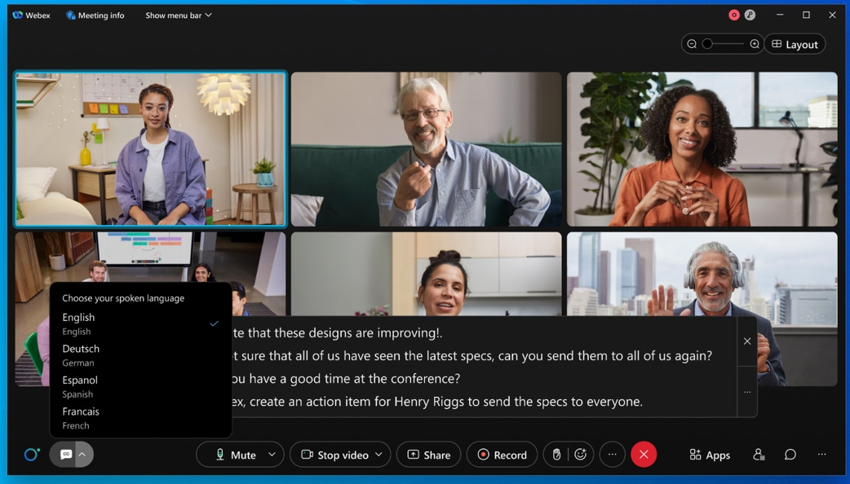

2. Introducing People Focus (Beta)
We're excited to introduce People Focus—a new way to use Grid view, that maximizes screen space by using AI to dynamically crop videos to focus on the individual, rather than their surroundings.
This gives you a better face-to-face experience with the people you are meeting with, regardless of how the person is positioned in front of their camera, making you feel more connected. Click Layout to turn on People Focus.
Current limitations in this Beta:
- Video cropping is supported for participants using Mac, Windows, and Board Series Devices.
- Participants using the mobile app, web app, or Desk Series Devices videos don’t support cropping at this time.
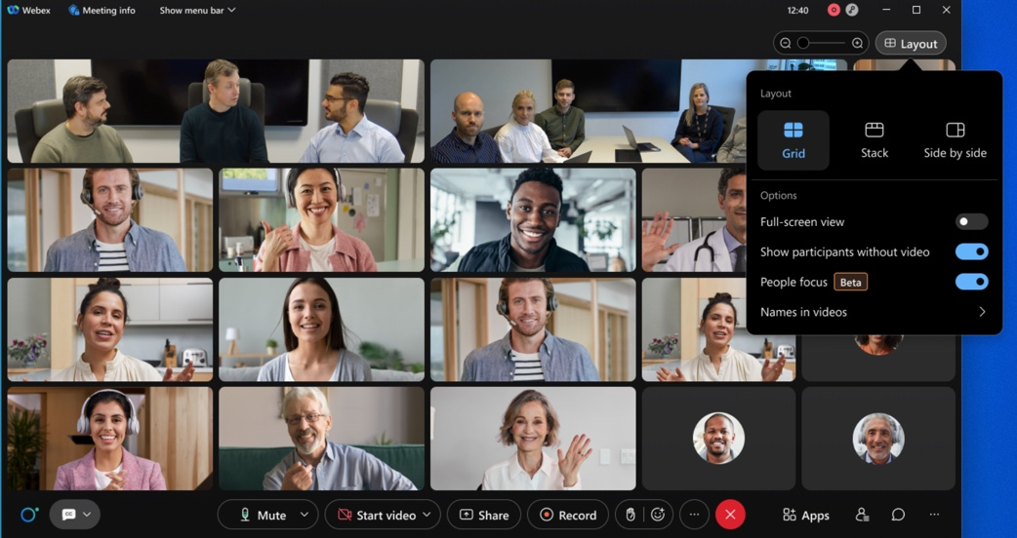

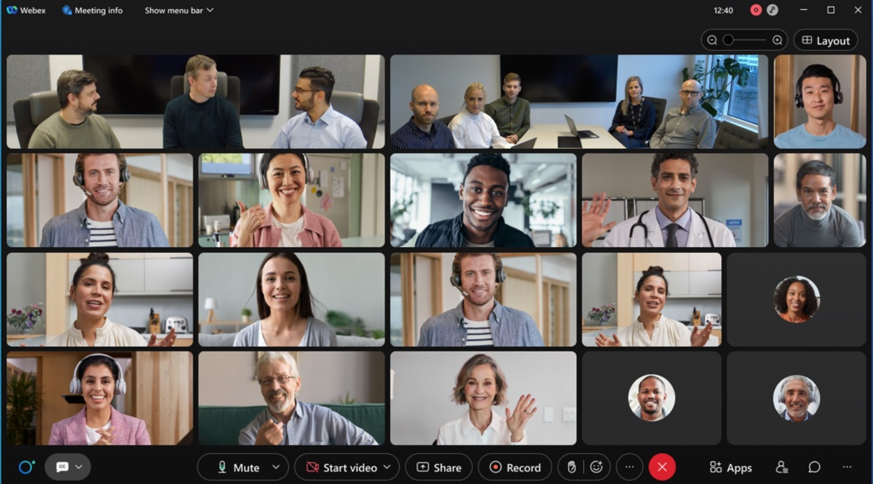

3. Resize the closed captions box
Users can now change the size of the closed captions (CC) box to show more or fewer lines.
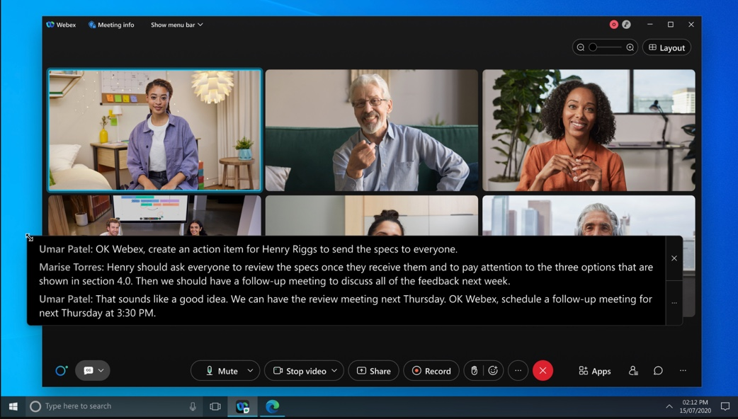
Administration experience
As site administrators, for security reasons, make sure that you provide a list of domains so that the users can save the URLs containing the domains. Without the approved domains, the users won't be able to save any URL due to security considerations. For example, here are a few domain types for your consideration, survey domains (qualtrics.com, surveymonkey.com, typeform.com, to name a few), and your company's domain(s).
Site Administration
- Go to Site Administration > Common Site Settings.
- In the Allow the following URL domain names enter the domain names.
The URL containing the domains are considered approved so that the users can save them.

4. Introducing the Webex Meetings for Chrome PWA

We're excited to announce that the Webex Meetings web app is now available for download as a Progressive Web App (PWA) for ChromeOS in the Google Play store.
This makes it easy for Chromebook users to access Meetings directly from their desktop, without having to go through the browser. Similarly, this provides you with more flexibility to manage services and apps for your users.
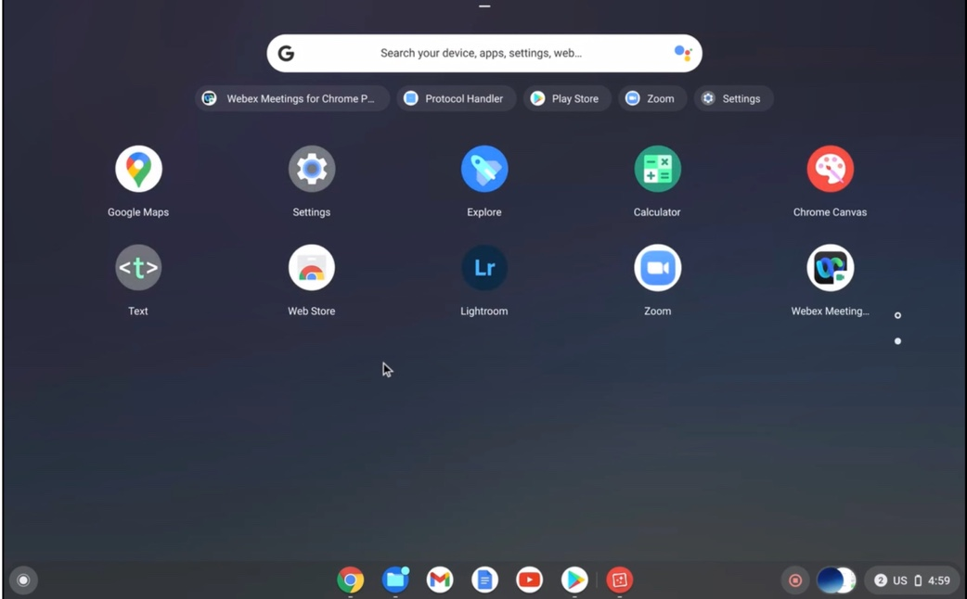

5. Move Webex Meetings from your desktop to mobile app using a QR code (NN: seems a duplicate of the previous version [April 2022])
We are introducing the Move Meeting to Mobile feature where users can scan the QR code using their mobile camera and move their meeting to Webex Meetings mobile app without disrupting or disconnecting the meeting.
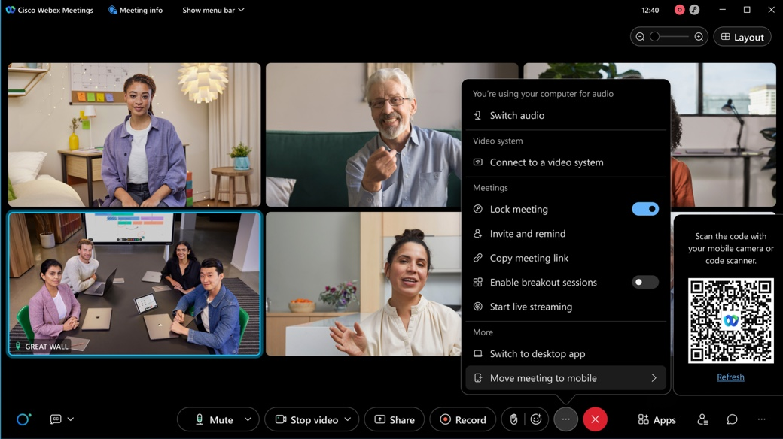

6. Update your meeting app before you join the meeting
The goal is to ensure that all attendees are able to participate in the meeting effectively and use all the available features. We’re giving you the option to update your app before you join the meeting. Then you’ll be sure to have the latest features for an optimal meetings experience.

7. Support email reminder for up to 100,000 licenses
Today, organizations or sites with licenses of 10,000 and below can schedule email reminders to attendees. Starting with the 42.5 update, organizations or sites who have more than 10,000 licenses can also schedule email reminders. To support a large volume of emails, the reminder can be scheduled to be sent at least 12 hours before the start time. This feature also supports webcast view for attendees.
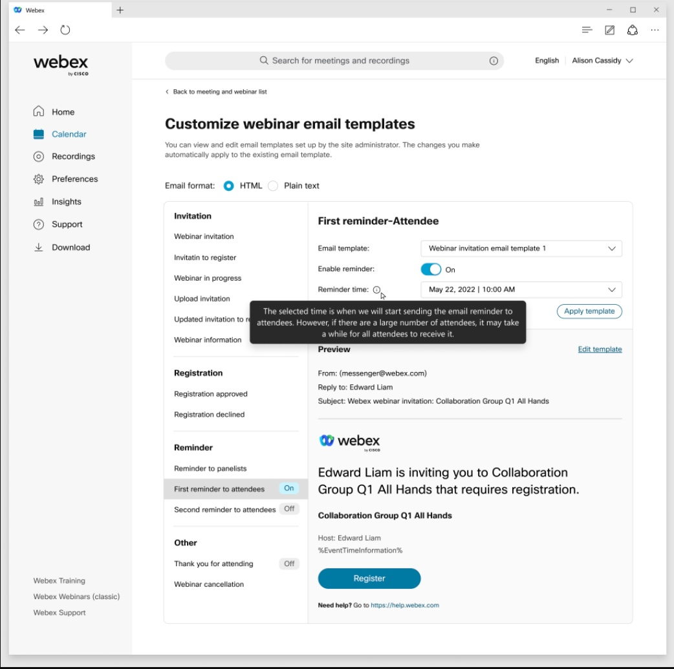

8. Improved Registration page
Now, when you go to register for an upcoming meeting, you see the meeting title, time, and host. This helps make it clear what meeting you're registering for. We've also removed the meeting password in the Registration page since you don't need that information during registration.
If you're the host, you also get a registration link that they can copy to the Meeting information page.
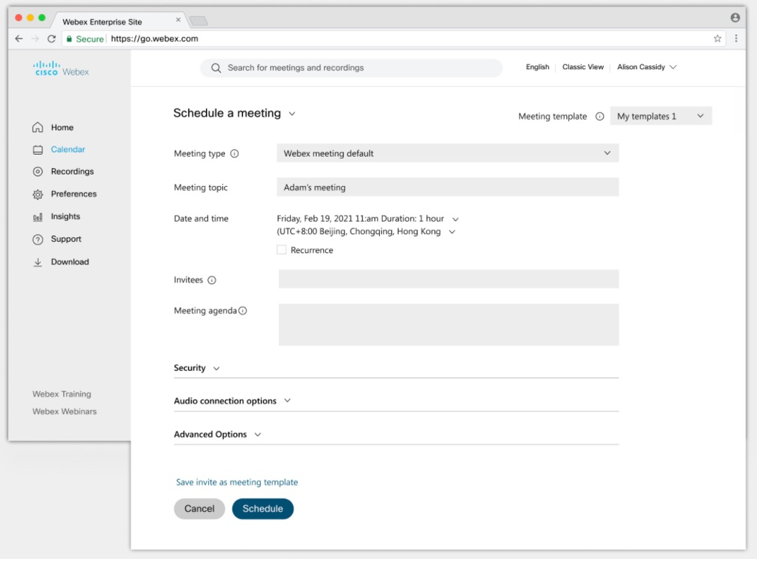

9. Entry and exit beep changes
All new sites have this feature turned off by default. For existing sites that have entry and exit beep that is turned on, phone users continue to hear the beep, while it is turned off for computer audio users.

10. New and improved scheduler for Meetings and Webinars
Scheduler on website for Meetings and Webinars is undergoing following UI enhancements,
- A new section that is called Security is added and all scheduling options that are related to security are moved here. This includes passwords for meetings and webinars.
- Tooltips are added to most scheduling options including options under Attendee privileges and Meeting options.
- Agenda is now part of the main or basic scheduling flow instead of under advanced options.

11. Fullband audio support in Music Mode on by default for Mac and Windows
Music Mode now uses Fullband audio quality on Mac and Windows Meetings app, by default. Administrators that require the use of lower quality audio for Music Mode can request the feature toggle to be disabled for their site. By default, Music Mode sessions are encoded using up to Fullband audio quality. With this toggle disabled, Music Mode operates up to Superwideband audio fidelity on desktop clients. But Webex takes up more network bandwidth.

12. Breakout support for audio-only users
A user joining a meeting using Audio only (PSTN), can now be placed in a breakout session. This feature is available for meetings desktop and mobile.
Attendee experience:
- The attendee is prompted when they are moved to a breakout. They can be moved immediately or asked to join later which they can do by pressing *2.
- When turned on, the attendee can return to main session and rejoin the breakout by pressing *2.
- When a host or cohost closes the breakout sessions, the attendee is warned and then moved to the main meeting.
Host experience:
- An audio-only host, when assigned to a breakout session by a cohost, can join the breakout session later by pressing *2, regardless of selected settings.
- They can also return to the main session and rejoin the breakout session by pressing *2 regardless of the selected settings.
- Host is warned with an audio prompt when a cohost moves them to another breakout session.
- When a cohost closes the breakout sessions, they are warned and then automatically moved to the main meeting.
Limitations:
- In meetings, attendees cannot view or choose the breakout session to self-join. They must be assigned to a breakout session by the host or cohost.
- This feature is not supported for attendees in Webinars, only supported for panelists.
- If using a Meetings desktop app version earlier than the current version, audio-only users aren't listed in the Participant of the breakout session.
- Only following DTMF tones are available inside the breakout for
Host: *2, *6, ** Attendees: *2, *3, *6, **

13. Display an image to attendees while conducting a practice session
When the practice session starts, attendees can now view an image that the host has uploaded. The host can upload an image before the webinar starts.
This feature doesn’t support webcast view. The ability to upload other file types will come in a later update.
Attendee view during practice session:

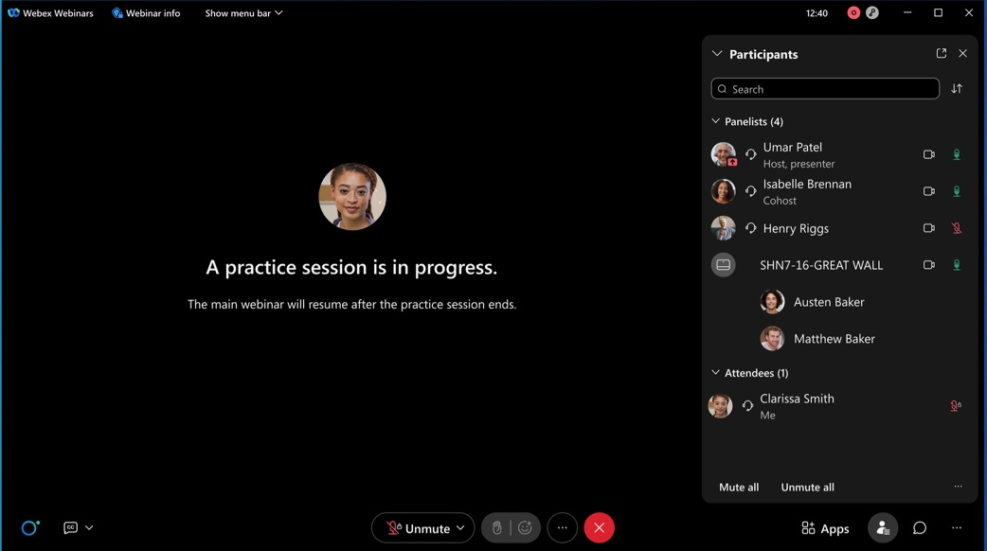
Host, cohost, panelist view during the practice session:
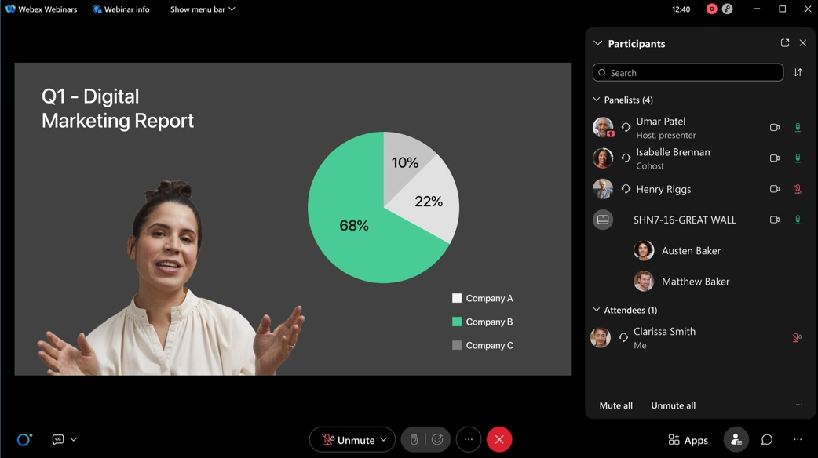

14. Slido rating poll improvements
We're adding the option to choose between the emoji and star scale.
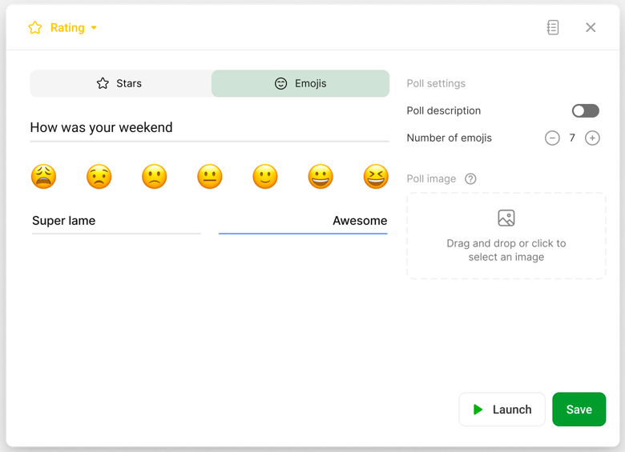

15. Collaboration restrictions for your company users from Control Hub settings templates
With this update, collaboration restrictions can now be applied at an individual user and group level from the settings template in Control Hub.
Today, IT administrators can block users from joining meetings that are hosted on the external sites at the org level only. With this update you can apply this policy at group and user level using settings template. Collaboration restrictions are applicable to the permitted sites too.
The Settings template is applicable to your company user joining both internal meetings and external meetings, with separate collaboration restriction toggles.
More than 20+ compliance control features are available for you to apply across your company users joining internal or external meetings.
Users are provided with appropriate messaging while using Webex Meetings based on their company policy.
[This feature is not available for Webex for Government.]

16. Webex Meetings compliance policies for Bring Your Own Device (BYOD)
IT administrators can now prevent users from joining company meetings from a BYOD. This feature leverages registry keys or tokens.
Users can join your company meetings using BYOD only if a registry key or token is detected on that device.
For more information on tokens and registry keys and how to configure them, see Collaboration restrictions for Webex Meetings in Control Hub
[This feature is not available for Webex for Government.]

17. Forced authentication before joining Webex Meetings
In Control Hub, as an administrator, you can now lock the company device to allow only authenticated company users to join meetings using that device.
This feature is applicable to your users using company device to join meetings that are held within your organization or joining external meetings (meetings held outside of your organization). This feature leverages the registry key and token that have already been introduced. For more information on tokens and registry keys, see Collaboration restrictions for Webex Meetings in Control Hub.
Without the registry key, if Authenticated Sign-in is ON, it applies to the user trying to join meetings with a claimed email address.
[This feature is not available for Webex for Government.]

18. Ability to disable Broadcast Message
Administrators can now disable Broadcast Message using Control Hub templates for meetings and webinars. The control to disable this feature is available at the user, group, or org level.
When the administrator has this feature disabled for the user, they won’t be able to receive broadcast message. The user as a host or cohost won’t be able to use the Broadcast Message feature in breakout rooms. The host and cohost are notified of the feature limitations.

19. New join policy for your company meetings with allowed lists for IT administrators
IT administrators can now set rules on who can join your company meetings. You can choose to allow anyone to join your internal meetings or choose to create an allowed list of domains. Only users who are authenticated on that domain can join your internal company meetings.
This policy can be applied at the organization level. You can also choose to apply this policy at user and group level using the settings template in Control Hub. This feature is available for meetings desktop and mobile.

Ignored features from the above list:
- Slido updates There are several Slido enhancements coming this month. See the In-meeting experience section for more information.For more product details see https://community.sli.do/product-news-23. Slido releases are not dependent on the Webex upgrade cycle.
- Full HD (1080p) content sharing for motion and video Webex Meetings app for Mac and Windows can now support sharing Full HD (1080p) video quality with high motion content. This works when selecting Automatically Optimize or Optimize for Motion and Video with high motion content.
- Keyboard shortcut change: Ctrl+Shift+Alt+X to hide participant video (Windows) To better align with the shortcuts in the Webex App, we have changed the Windows shortcut to hide participant video from Ctrl+Shift+X to Ctrl+Shift+Alt+X.
- Outlook add-in user experience improvements for on-premises exchange environments Users of the Outlook add-in in on-premises Exchange environments now see improvements in the scheduling experience. Users in environments with Hybrid Calendar deployed no longer need to manually click Update to update Webex Meetings with changes that are made to Outlook (these changes sync automatically). Additionally, for all on-premises Exchange users, Outlook events are no longer auto-saved if a Webex Meeting is added. This brings back the Outlook modal for customers that want to see it.
- Web App: receive 4K shared content When 4K content is being shared in a meeting or webinar, users joined through the web app can now see that content in 4K (rather than being downgraded to 1080p).
- Better attendee experience with images in Slido polls In the Webex-Slido integration, attendees can zoom in on a picture that is inserted into a Slido poll.

Slido collaboration functionality We're simplifying the invitation flow and streamlining the first-time user experience. In practice, we're consolidating all Slido invitation flows under the unified design system.

Remotely control interpretation on device (Windows) When the Webex Meetings app for Windows is paired with a new cloud-registered device that is supported for Simultaneous Interpretation (attendee view only), the interpretation controls can be toggled remotely on the app (or directly on the device). [Remote control for Mac will be supported in a future update.]

User setting for webinar default video layout The default video layout for webinars on iPad and tablet is Stack view and for mobile is Focus view. Users can change their webinar default layout by going to Settings > Audio & video settings menu.

Increased fidelity available for VoIP Fullband audio for VOIP in meetings and webinars is available by request. This feature provides the highest level of audio quality available on the Webex service. Higher quality audio uses more bandwidth, so fullband audio isn't enabled by default. Site administrators can ask to have it enabled.

Support Bulk registration for Webinars and Meetings Currently, when applications utilize Webex Meetings APIs to register for a specific participant to join a Meeting or a Webinar, it must happen on a participant-by-participant basis. In this update, this API is updated to allow bulk registration of participants for more efficient use of the APIs. Visit the updated API: https://developer.webex.com/docs/api/v1/meetings/register-a-meeting-registrant.

Meeting options using APIs Webex Meetings management APIs is updated to allow applications to configure meetings options. Meeting options are used to define the features you can use in the meeting. For example, if a certain use case requires that you can’t view and use chat during a meeting or allow you to turn on closed caption. Meeting options are available for create and update meetings and are a part of listing meetings. To view the related APIs, please visit: https://developer.webex.com/docs/api/v1/meetings.

List meetings by Type The Webex Meeting list API https://developer.webex.com/docs/api/v1/meetings/list-meetings is updated to allow applications to list meetings by their type.

