1. Admit a participant from the lobby directly into a breakout session
You can now admit participants waiting in the lobby directly into a breakout session without having to admit them to the main session first. This is a great way to verify or brief a meeting participant privately, before admitting them to the main session, or helping to get participants who joined late directly into the appropriate breakout session.
Admitting a participant into the meeting works just like it did before. However now, if breakout sessions are currently running, you see a drop-down menu where you can pick which session to admit your selected participants to:
Alternatively, you now also find participants in the lobby listed in the breakout session assignment window:
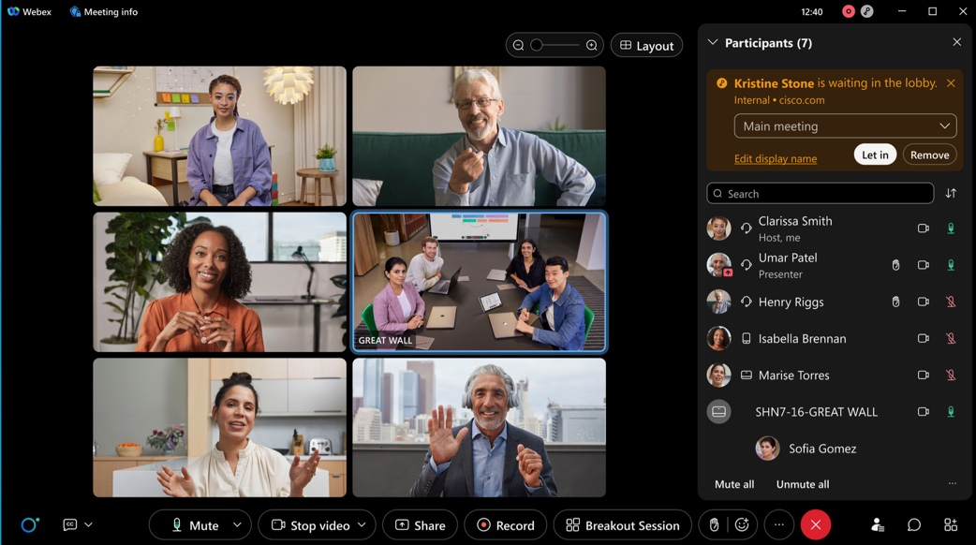

Any participants who have already been preassigned to a breakout session, are automatically admitted to their respective breakout sessions when admitting them from the lobby, where breakout sessions have already been started:
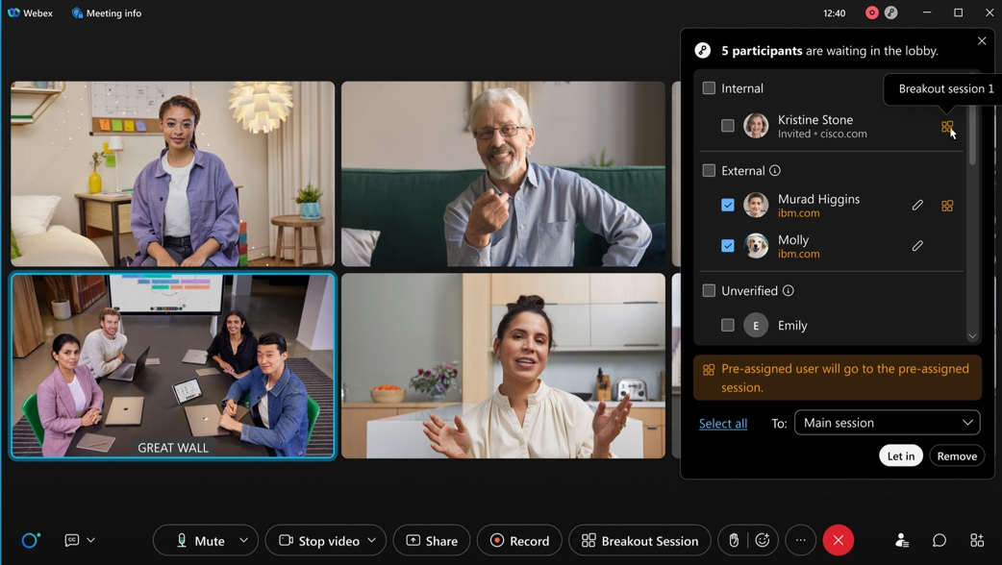

2. Enhance meeting security with Auto Admit
We’re excited to introduce Auto Admit that is designed to make your life easier as a meeting host while increasing the security of your meeting.
New default behavior introduced with Auto Admit allows invitees who are signed into Webex to join a scheduled meeting directly without having to wait in the lobby. No more admitting people from the lobby when they were supposed to be in the meeting anyways!
No passwords or PIN numbers required! Even Webex Room systems that you add to your meeting invite can join the meeting directly.
Remind your invitees to sign into Webex to be able to take advantage of this amazing new usability improvement.
For users who aren’t signed into Webex and those who aren’t on the invite, they continue to wait in the lobby until you or a cohost admits them. For more information, see Use the lobby to control meeting access for guest users.
Important callouts:
- This feature doesn’t apply to Personal Room meetings.
- Settings for existing customers will be honored with this feature. For net new customers, lobby is the default setting.
- Allowing participants in your organization to always join unlocked meetings is now an admin level option that controls the behavior for all meetings in your organization. Users in your organization who aren’t invited to a meeting are no longer permitted to join unlocked meetings unless the new admin setting is enabled.
- Under our Advanced options for scheduled meetings, the behavior behind the following cohost settings has been modified to check for invitee status before assigning the cohost role.
  - The first person to join the meeting who has a host account on the site becomes a cohost.
  - All attendees who have host accounts on this site become cohosts when they join the meeting.
For more information, see Securing scheduled meetings.

3. Multiple Windows Support on iPad
With Apple iPad OS Multiple Windows (multiple scene) Support, users can now pop-out the shared content into a separate window and run multiple instances of the app side by side.
Pop-out shared content on iPad: users can drag the shared content or click on the pop-out icon to view standalone shared content window on iPad. Users can change the shared content window size to full screen by swiping the right to left as shown the in image.
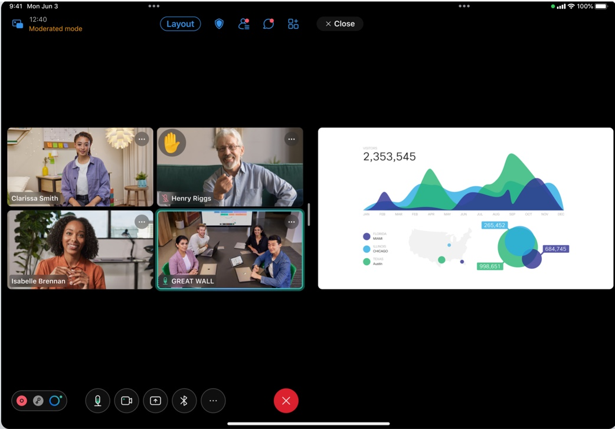
Multiple instances of app: Users can run multiple instances of Webex Meetings App for iPad App next to each other.
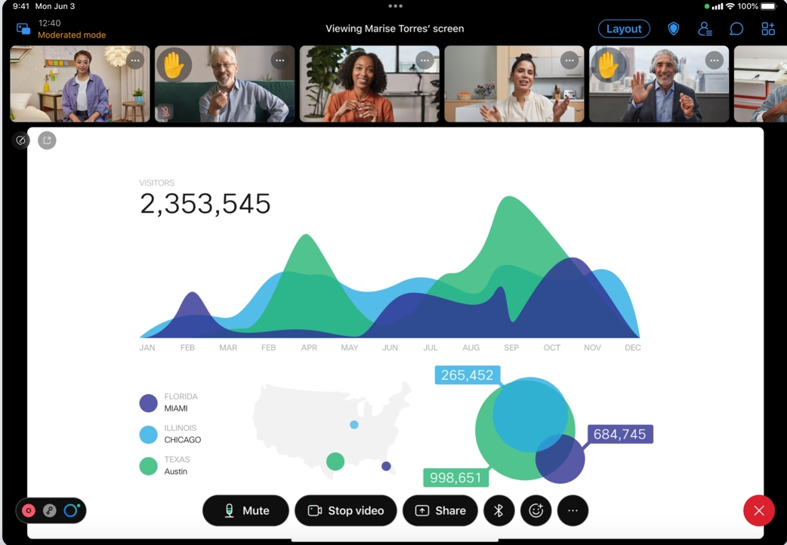

4. New user interface for fold and flip phones
With new UI enhancements, Webex Meetings Android users can enjoy the best meetings experience in all modes available on fold and flip phones: Flex mode, Tablet mode, and Folded mode.
You can view up to 12 people on the same screen with a 3 x 4 grid in flex mode and tablet mode
Take advantage of the flex mode and tablet mode real estate to see everyone in large meetings.

5. Start a meeting on a device
You can now walk into a room and start an instant meeting on a Webex device. Once you start a meeting, you no longer need to struggle to invite guests to a meeting. In the invite pop-up, you can now invite any guests to a meeting. Scan the QR code, and then you can copy and share the meeting information with anyone.
This feature isn’t available for Webex for Government.
This feature is available on a delayed release cycle. Check status.webex.com/maintenance to see when it’s available on your site.

6. Changes in retention storage policy for Webex Meetings
Webex is removing the option to retain post-meeting data (recording and transcripts) for an indefinite period.
This retention policy is applicable for Meetings, Webinars, Training, and Support.
For pro pack users, if the retention policy is set to indefinite today, then the default retention period changes to 360 days, with the option of changing it from 7 days to a maximum of 3600 days. Additionally, customers have the option to purge user-deleted recordings within 30 days or make them follow the retention policy.
For Webex customers with the pro pack offer, these changes come into effect 31st March 2023.
To avoid any interruptions, Webex customers with the pro pack offer can choose to change the retention policy from indefinite in Control Hub to a value between 7 days to 3600 days.
This feature is on an independent release schedule. Check status.webex.com/maintenance to see when it’s available on your site.

