1. Speaker labeling and closed captions feed update
Speaker labels are added in the closed captioning box to further enhance live transcript readability. The closed captions feed behavior is also updated. More lines and up to two final utterances can be shown at once, depending on font size. Previous lines stay on screen, until new spoken lines push the script up.

2.Introducing people focus (Beta)
In this update we're excited to introduce a new way to view Grid View, that maximizes screen space by using Artificial Intelligence to dynamically crop videos to focus on the individual, rather than their surroundings.
You’ll get a better face-to-face experience and feel more connected, regardless of how they’re positioned in front of their camera. People focus can be turned on from the Layout menu when in Grid View and can be turned off at any time. Give it a try!

3. Q&A, chat, and polling report for webinars
Hosts can download the in-webinar activity report for Q&A, chat, and polling for completed webinars. If Q&A or polling is done using Slido, hosts can find that information in Slido's report. This option is only available for recorded webinars. Webinars in webcast view also supports Q&A, chat, and polling.

4. Webinars to support breakout sessions

When the host schedules a webinar, they can preassign panelists to different breakout sessions. Attendees can't be preassigned but they can join breakout sessions by clicking the join link. Hosts can create up to 100 breakout sessions. Each breakout session can host up to 1000 attendees.

5. Optimize your meetings, webinars, and events for all voices
In meetings, webinars, and events, you can filter out all background noises and enhance the voices of all users picked up by the microphone. The voice of the users that are farther away from the microphone are amplified to sound like they are much closer. This is done to create a better and more engaging experience during your meetings and events.
This feature is only available when you use Use computer audio only.
You can optimize your audio to prioritize speech before or after you join a meeting or webinar, by doing the following:
- Click Audio options 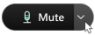 , click the drop-down arrow under Webex smart audio, and select Optimize for all voices.
- Click Audio options , click Audio settings, and select Optimize for all voices.
Once you've selected a Webex smart audio option, the option you selected is set as the default option for your future meetings and events on your site.

6. Display speaker name in close caption feed
In order to enhance the clarity for people who are deaf or hard of hearing, we need to provide them with an option to display speaker labeling within the closed caption feed.

7. Simultaneous interpretation volume balance adjustment
The volume balance in the simultaneous interpretation feature now shows interpreter on the right side instead of the left, so to hear the interpreter at a higher volume, users can slide the balance to the right.

8. Optimize audio for your voice
Similar to desktop, Webex Meetings mobile app users can now enhance their meeting experience using Optimize for My Voice option. You can now suppress all background talkers and noise to allow others to hear you better, by selecting the option to Optimize for My Voice during a meeting by clicking More > Webex Smart Audio. Users can set their preference prior to a meeting by accessing Audio and Video menu in the app setting under the Webex Smart Audio section. The default option is Noise Removal that is enabled (previously, called Remove Background Noise).

9. Email notification to users when their meeting recordings are deleted or reassigned
IT administrators can make changes to meeting recordings such as reassigning to a new owner or deleting the recording file based on compliance regulations. In this update, we provide a setting at the site level for the IT administrators to notify the user when such actions take place.
Users in the following scenarios receive an email notification when this setting is enabled:
- When the recordings are older than the retention period and they get moved to trash.
- Site administrators reassigns the recordings to another user.
- Site administrators moves the recording to trash, deletes, or restores it.

10. Polling support in webinar (Webex for Government updates)
In addition to polls using Slido, you can now start polls in webinars from the Polling panel, similar to Webex Meetings. Use polls to engage your participants, even if Slido is not available in your webinar.
To pre-configure the polling questions the host can start any webinar to create questions and save the polling file in .atp format. During the webinar, the host can quickly add the questions by uploading the previously saved file.
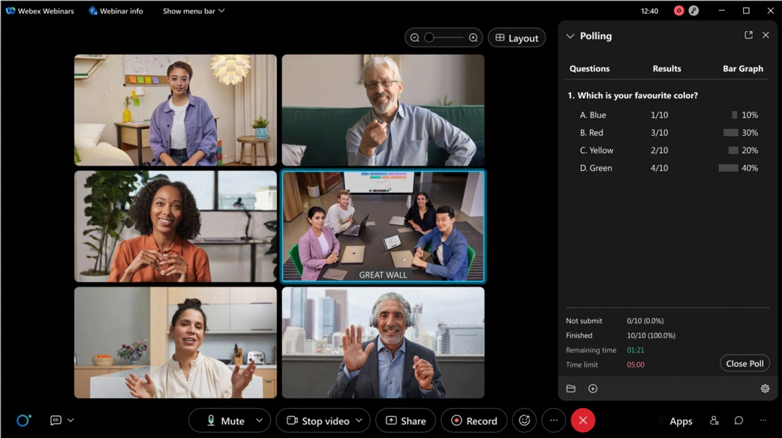

11. Easy to use audio mute state management, recording controls, lock state, and raise hands available on Webex on-premises devices
It’s now possible to accurately reflect the mute status in the meeting participant list for Webex on-premises registered video devices. Previously, when they muted or unmuted themselves, this wouldnt show up in the participant list.
When the host requests the video device user to unmute, there will not be any visual indications on the video device any more. However, the host can alway verbally ask the user to unmute themselves.
In addition, when the host turns on or off the ability for participants to unmute themselves, users on video devices then see appropriate messages rendered on their video device.
When a meeting is setup in the moderated unmute mode, hosts on the Webex App can continue to mute and unmute video device users directly from the app.
As a host on a Webex on-premises registered video device, you can now record meetings using controls on the device interface instead of using DTMF controls, see direct device messages indicating the lock status of a meeting, and can now raise and lower your hand in a meeting using controls on the device interface instead of using DTMF controls.
With the first tap on the recording control a new recording is started. Tapping on the recording button again stops the current recording.
In addition, all users on Webex on-premises registered video devices see a recording icon shown on the edge of the screen. When the recording stops, the icon is removed.
When a meeting is locked, there’s a key icon shown on the edge of the screen to indicate that the meeting is locked. When the meeting is unlocked, the key icon is removed.
When someone else raises their hand, you see a hand icon displayed on the edge of the screen. When all hands have been lowered by the host, the icon is removed from the screen.

12. Closed Captions
All meeting participants will automatically have closed captions and can turn them on in one click. A captions panel is available when the closed captions feature is turned on. Currently, closed captions will only show English transcription.

13. Recording Transcripts
You can enable the automatic transcription of the audio for all recorded Cisco Webex meetings and events or you can enable the feature for specific users only. The transcripts appear during recording playback. Users can search for text in the transcript to verify what was said, and when. The transcripts are available in English and only support transcribing the English Audio.

Ignored features from the above list:
- Increased High Frame Rate Content Sharing Resolution to 1080p (from 720p) Webex Meetings app for Mac and Windows now supports up to full HD (1080p), when sharing high frame rate content. This means a higher resolution when using Automatically Optimize and moving between static content and content with a lot of motion.
- Webex Meetings compliance policies for Bring Your Own Device (BYOD) IT administrators can now prevent users from joining company meetings from a BYOD (Bring Your Own Device). This feature leverages registry keys or tokens. Users can join your company meetings using BYOD only if a registry keys or token is detected on that device.
- Slido There are several Slido enhancements coming this month including a new look for Slido, visible survey results in participant mode, question topics, and poll templates library.
- Registration form compliances with privacy law To complete registration for a Webex meeting, webinar, event, or training session, if an attendee selects a country that enforces privacy law, the attendee needs to agree to compliance when the option appears.
- Webex Scheduler add-in schedule-on-behalf enhancements The Webex Scheduler now uses built-in Microsoft Outlook delegate settings. Users no longer need to specify the schedule on behalf privileges from the Webex site.
- Shared Timer app for Webex Meetings and Webex Webinars The Shared Timer app allows meeting hosts and participants to view and interact with a countdown timer during their meetings. The meeting host can launch the Shared Timer from the Apps panel, set a timer and share it with other meeting participants. Participants can start, pause, and add more time.

New name label style for meetings We've made some small, but effective changes to the style of the name labels in the video windows. So that they don't cover up as much, particularly in smaller window sizes.

Simultaneous interpretation volume balance adjustment The volume balance in the simultaneous interpretation feature now shows interpreter on the right side instead of the left. To hear the interpreter at a higher volume, users can slide the balance to the right.

Health status indicator update for Mac and Windows In this update, we’ve enhanced the in-meeting Health Checker. There is now a colored status icon that appears in the top right of the application showing your current Health Status. Moving your mouse over the status indicator shows the current status and provide a button for View Health Checker.
- Make Share button clickable when anyone can share is disabled Previously, the Share button was disabled for participants when anyone can share is disabled, confusing the user. Now it's clickable and shows a message saying that the user can't share if they click the button.
- Slido in Webex has a new look The Slido redesign supports new features, making continuous improvements, and creating a technology that caters to all your needs. With this update, you can experience the same product interface across all our integrations and solutions.

  - Survey results visible in the Slido participant mode Similar to individual polls, participants can see survey results directly in their participant panel after they vote.
  - Question topics This feature has a gradual rollout schedule, so only a part of the newly created Slido events is available. Question topics are automatically generated in the Slido audience Q&A so that users can better navigate through the submitted questions.
  - Poll templates library This feature has a gradual rollout schedule. The library is a collection of poll templates, giving you inspiration or concrete examples, you can use during meetings. In addition, we’ve made it easier for you to reuse previously created polls as templates. You can access this template library from your account at slido.com under Add poll from templates.
  - New polling experience in Slido administrator sidebar This feature is being released as a toggle, the old sidebar is still default, but users can decide to toggle the new one on. It’s a fresh, simpler, and redesigned Slido administrator experience. Limitations: The quiz feature is currently supported only in the old version but coming soon to the new one too.
  - Enhanced participant privacy settings At the organizational level, Slido owners can choose the level of privacy for their participants. As a Slido owner, you can keep participants anonymous or named, by default, or just for specific activities such as polls and Q&A.
- Dedicated network origination port ranges In this update we added the ability to change the network port numbers that we use to initiate media streams. Customers can request this to be enabled on their site from their Customer Success Manager. This feature allows customers to appropriately mark Meetings network packets for audio and video Quality of Service (QoS) to prioritize Webex media on their network.
- CarPlay support for iPhone and iPad users using in-meeting setting During a meeting, iOS app users can go to settings and enable CarPlay to connect their meeting to CarPlay-supported device. Limitation: The user has to manually switch on CarPlay setting to connect their Webex meeting to the CarPlay device.
- Option to hide Who's Speaking in stage mode On iPad and Android tablets, part of the shared content is hidden when the speaker’s name or multiple speaker names are displayed in stage view layout. Users now have option to hide the names of Who's Speaking in the stage view if they face this issue.

