1. Lock breakout sessions in webinars
Similar to meetings, webinars now have the capability to lock breakout sessions. By choosing Only allow assigned participants to join during pre-assignment, only permitted pre-assigned attendees or panelists can join a particular breakout session.
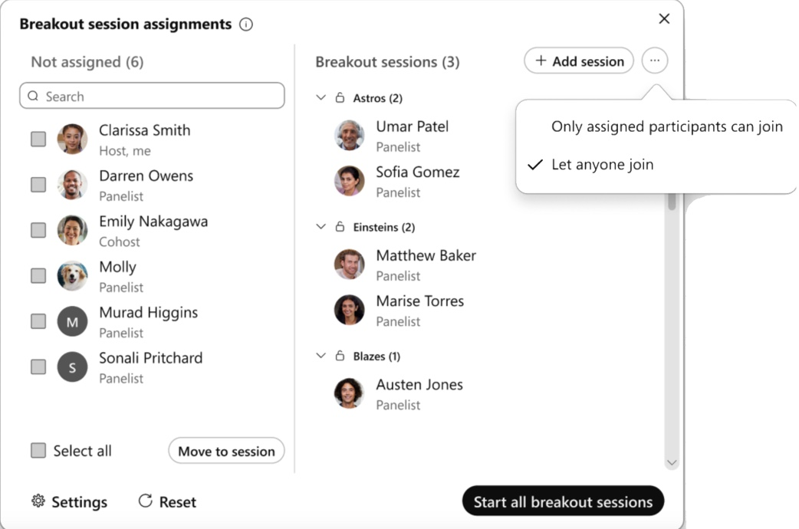

2. Stage view with customizations can be recorded
With this enhancement, changes made through stage manager in Webinars, are now reflected in recordings, webcasts, and on Cisco devices.

3. Allow only one join per email for webinars and webcasts
Attendees can join a webinar or webcast with the same email address only once. This prevents uninvited attendees from joining. However, if the webinar or webcast doesn’t require registration IDs, there is no limit on the number of times an attendee can join using the same email address.

4. Changes in retention storage policy for Webex Meetings
Webex is removing the option to retain post-meeting data (recording and transcripts) for an indefinite period.
If the retention policy has been set to indefinite today, then the default retention period changes to 3 years, with the option to change it from 7 days to a maximum of 10 years. You also have the option to purge user deleted recordings within 30 days or make them follow the retention policy.
If you have the pro-pack offer, these changes come into effect from March 2023 and are completed in July 2023.
To avoid any interruptions, change the retention policy from indefinite in Control Hub to a value between 7 days to 10 years. For more information, see Data retention changes coming in 2023.
This feature is available on an independent release cycle. Check status.webex.com/maintenance to see when it’s available on your site.

5. Support for Webex Meetings on Meta Portal devices ends July 1, 2023
Meta (formerly Facebook) has made an announcement on their Portal website that they are no longer selling Meta Portal effective immediately. Webex Meetings won’t be supported on the Meta Portal device from July 1, 2023.

6. Webex Meetings sites to get user profile data from Webex Identity
When a Control Hub managed site is updated with this feature, user profile data for that meeting site is acquired from the Webex Identity in Control Hub rather than it being specific to each meeting site. Each site does a one-time sync as part of this switching to Webex Identity as the source for user profile data.

This feature is available on an independent release cycle. Check status.webex.com/maintenance to see when it’s available on your site.

Ignored features from the above list:

1. Slido experience
Slido isn’t available in Webex for Government.
Here are the Slido enhancements coming this month. For more product details, see Product News (https://community.slido.com/ideas-and-other-features-59/using-spaces-to-share-events-and-collaborate-2278).
Slido releases aren’t dependent on the Webex upgrade cycle.
New Q&A interaction: Q&A is now an interaction that you can add to your meeting. When it’s added, Q&A is open for all participants. If you want to stop Q&A, close it or remove it as an interaction.
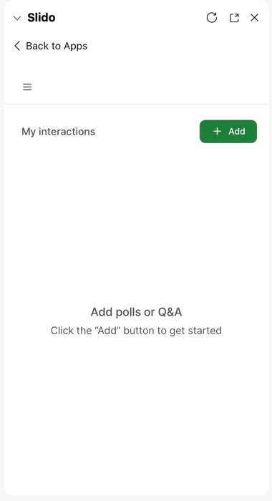

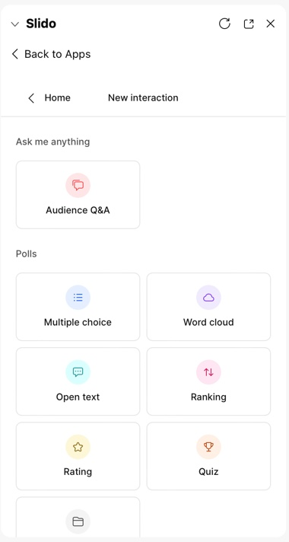
You can find your Q&A interaction under the Add button in the main menu.
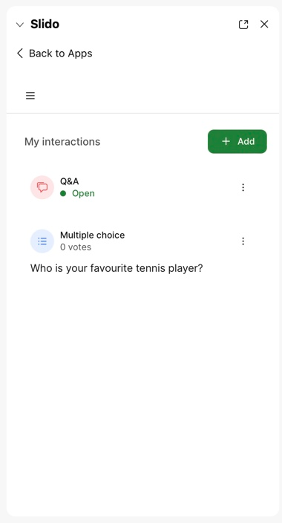
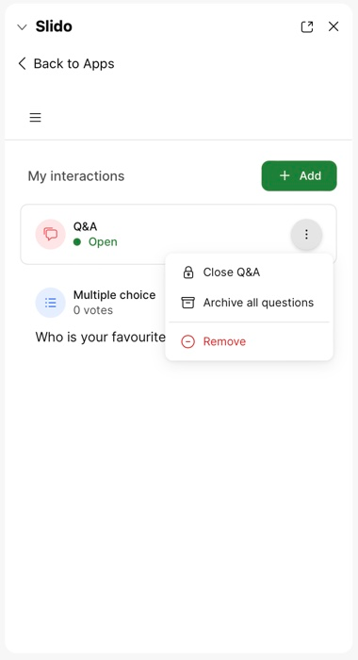

Vidcast experience

Vidcast isn’t available in Webex for Government.

Vidcast releases aren’t dependent on the Webex upgrade cycle.
Vidcast and Slido Integration
We are excited to announce that Slido can now be integrated with Vidcast!
With the Slido integration, you can place polls anywhere in your Vidcast videos to create two- way conversation, ask for feedback, make decisions, and directly engage with your audience before or after a meeting.
The Slido integration is currently available for Webex customers only and includes the following poll types:
- multiple choice
- word cloud
- open text
- rating poll
You can learn more about how to add Slido polls into your Vidcast video in the step-by-step guide.
Current limitations:
- Up to 20 polls can be added to a Vidcast video.
- Slido Q&As, ranking polls, quizzes and surveys are not available currently.
- Analytics and exports are available using slido.com.

