1. End of Life–Classic meetings associated with a space
[NN notes: source = https://help.webex.com/en-us/article/8dmbcr/What's-New-in-Webex-Suite#Cisco_Reference.dita_bcb8b1a9-0b98-4cee-9867-84460e74323d and post date = January 18, 2024]
In case you missed our previous announcements, we're phasing out support of Basic and Advanced meetings associated with a space (Classic meetings associated with a space). After January 31, 2024, your static meeting links related to Classic meetings associated with a space will no longer work.
In October 2022, we released a new feature for meetings in spaces called Improved Meetings Associated with a Space. Unless you have a dependency on static meeting links or you use our SDKs, you should now have improved meetings associated with a space.
We’ve compiled a list of customers who are impacted by static meeting links or who use our SDKs. Those customers will still have access to their Basic and Advanced meeting links until a solution is available in Improved Meetings Associated with a Space.
If you purchase Webex through a Service Provider, your Service Provider will be communicating to you the details and timing of the move to Improved Meetings Associated with a Space. Please contact your Service Provider directly with questions.

2. Improved meetings associated with a space
[NN notes: source = https://help.webex.com/en-us/article/gxw5jz/Webex-App-|-Improved-meetings-associated-with-a-space and post date = January 26, 2024]
We’ve enriched your meetings experience in a space. Now, when you join or schedule a meeting in a space, you have access to the features you’ve come to enjoy in Webex Meetings. You can leverage this new experience in every meeting you schedule or join from here on in.
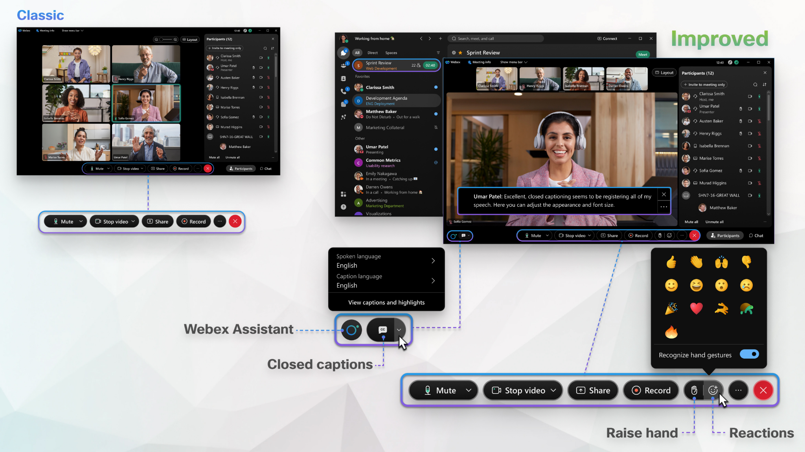
Before this release, your experience in a meeting associated with a space was tied to who created the space (known as the meeting sponsor). The feature set available to you depended on the type of account that person had. From here on in, we'll refer to this as the classic meetings experience.
We’ve removed the concept of meeting sponsorship. Now, only the host's license determines the meeting capabilities. If you have, at minimum, a Basic Meetings license and you're in the same organization as the person who created the space, you can schedule or start a meeting in that space. If you're not in the same organization, you won't be able to schedule or start meetings in that space. For more information about our Basic Meetings license, see Basic Meetings in Control Hub and Site Administration.
Any meetings that are already in your calendar, however, will use the classic experience based on meeting sponsorship and have a potentially limited feature set. We encourage you to reschedule those so that you can get the most out of your meetings.
Now, when you schedule or join a meeting associated with a space, you get either the full-featured meetings experience or the enhanced meetings experience. Find out if you're set up with full-featured meetings. If you are, you have access to a full set of Webex Meetings features.

