1. Increase End-to-End Encrypted meeting to 1000 participants
You can now host up to 1,000 participants joining end-to-end encrypted (E2EE) v2 Webex meetings. E2EEv2 meetings are part of Webex by Cisco's Zero Trust Security initiative and Cisco's security pillar that privacy is a fundamental human right.

2. Cohosts can record, view, and share cloud recording and support anyone can record
We’re excited to announce that we’re going to allow cohosts and meeting participants to record a meeting in the cloud. This makes it easy to record a meeting if the host isn’t available or busy during the meeting. This has been a highly requested feature from users who mentioned that this makes the meetings less interruptive as any cohost or meeting participant can record the meeting.
With this feature, cohosts or meeting participants can record the meeting and have the capabilities that a host to start, stop, or pause the recording. After the meeting ends, the recording is still owned by the host. However, the recording is shared automatically with the cohosts who are from within the organization.

3. Enhance meeting security with Auto Admit
We’re excited to introduce Auto Admit that is designed to make your life easier as a meeting host while increasing the security of your meeting.
New default behavior introduced with Auto Admit allows invitees who are signed into Webex to join a scheduled meeting directly without having to wait in the lobby. No more admitting people from the lobby when they were supposed to be in the meeting anyways!
No passwords or PIN numbers required! Even Webex Room systems that you add to your meeting invite can join the meeting directly.
Remind your invitees to sign into Webex to be able to take advantage of this amazing new usability improvement.
For users who aren’t signed into Webex and those who aren’t on the invite, they continue to wait in the lobby until you or a cohost admits them.
Important callouts:
- This feature doesn’t apply to Personal Room meetings.
- Settings for existing customers will be honored with this feature. For net new customers, lobby is the default setting.
- Allowing participants in your organization to always join unlocked meetings is now an admin level option that controls the behavior for all meetings in your organization. Users in your organization who aren’t invited to a meeting are no longer permitted to join unlocked meetings unless the new admin setting is enabled.
- Under our Advanced options for scheduled meetings, the behavior behind the following cohost settings has been modified to check for invitee status before assigning the cohost role.
  - The first person to join the meeting who has a host account on the site becomes a cohost.
  - All attendees who have host accounts on this site become cohosts when they join the meeting.

4. Stage manager in Webex Webinars
Host and cohost can now give your webinar a professional and polished look by adding a background wallpaper and logo to the stage, customize the speakers’ name label with name and subtitles. You can set up the background, logo, and name labels in the information page before the webinar starts, or setup and do a last-minute check when you're in the webinar. Attendees only see the produced and customized stage when you sync the stage to everyone.
Known issue:
- Produced stage is shown to panelists and attendees in the Webex Meetings app. Produced stage can’t be shown on device, recording, or webcast view. These are coming in updates.
- If the panelist uses the phone number provided by Join by phone to dial in directly, the name and subtitle that the host has setup for them based on their email isn’t applied to their phone number.

5. Add support for NDI video export for meetings and webinars
Meeting and webinar hosts can now enable NDI® streaming technology for their meetings and webinars. NDI is used in many video production environments to transport video streams over the network, between applications, and hardware devices. After the host has enabled use of NDI in Meeting Settings > NDI Management > Allow NDI technology for my meetings and webinars any host or cohost can enable NDI mode on their Meetings client. The meeting host must have live streaming and NDI permissions granted in the user configuration in Site Administration or the Advanced settings per user in Control Hub. Existing live streaming users automatically gain access to NDI streaming.
Enabling this special mode allows you to receive high-quality streams for up to four selected participants, local camera video, active speaker, and any content being shared. More participant outputs can be created by using additional apps in NDI mode.
The NDI interface allows selection of output with a preview of the stream, removing output of an existing stream, or switching the participant that is being output with a preview. All meeting participant audio is output mixed on participant and active speaker channels.
For more information on NDI® please see http://ndi.tv/
NDI is a registered trademark of NewTek, Inc.

6. Italian spoken language
If you have a paid Webex plan, now you get Italian spoken language for free, just like the existing English, French, German, and Spanish spoken languages. During the meeting, the host can select Italian as the spoken language for the meeting, which then appears in the closed captions and transcript.

7. Visual changes to the meeting preview window
We’ve updated the meeting preview window to make it easier to get into meetings. The window size has been changed to be smaller than the meeting window and not be expandable. This prevents users from thinking the preview window is the actual meeting window. We’ve also added a new tool tip to encourage users to click Join or Startmeeting.
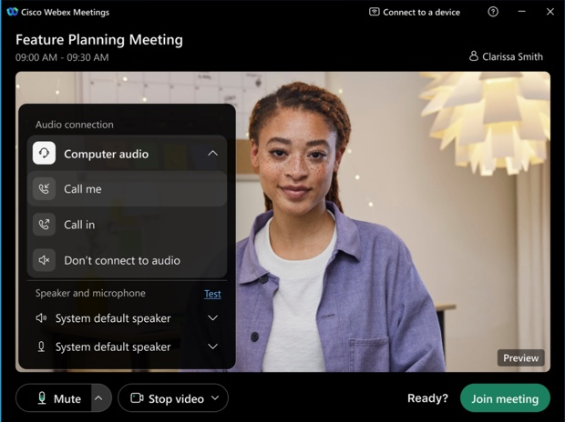
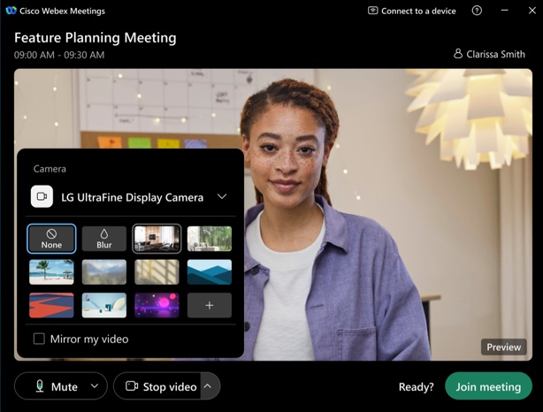

8. New End control button and keyboard shortcut when using remote control
We've made it easier to regain control when you've granted control of your screen or application share to someone else. We added a new End control button to the control bar at the top of the screen, and a new keyboard shortcut SHIFT+ALT+R. You can continue to double-click the mouse to regain control as well.
Stop share and pass control (to another user) are now in the More (…) menu.
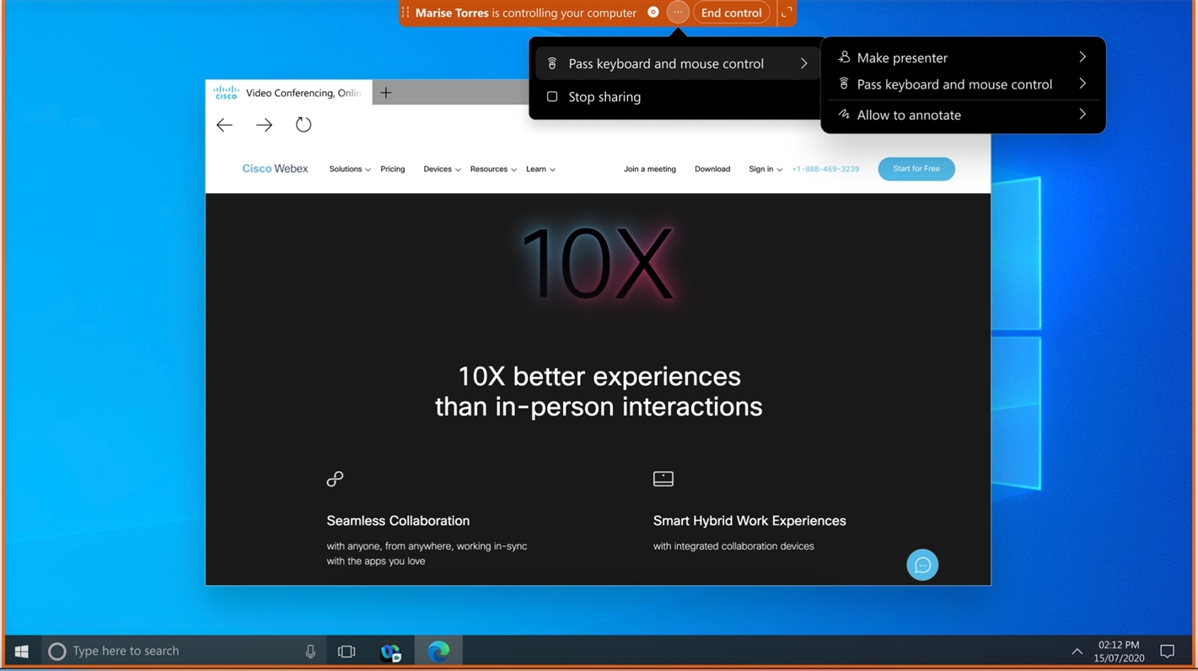

9. Auto-switch camera setting in Windows
Windows users can choose from Preferences -> Video -> Camera -> Automatically select camera to enable or disable automatic camera switching when they connect a new external camera to their Windows computer.
By default, automatic camera switching is turned off (unchecked).
When users connect to the camera, they see a new camera notification.
This is already available for Mac users in 42.9.
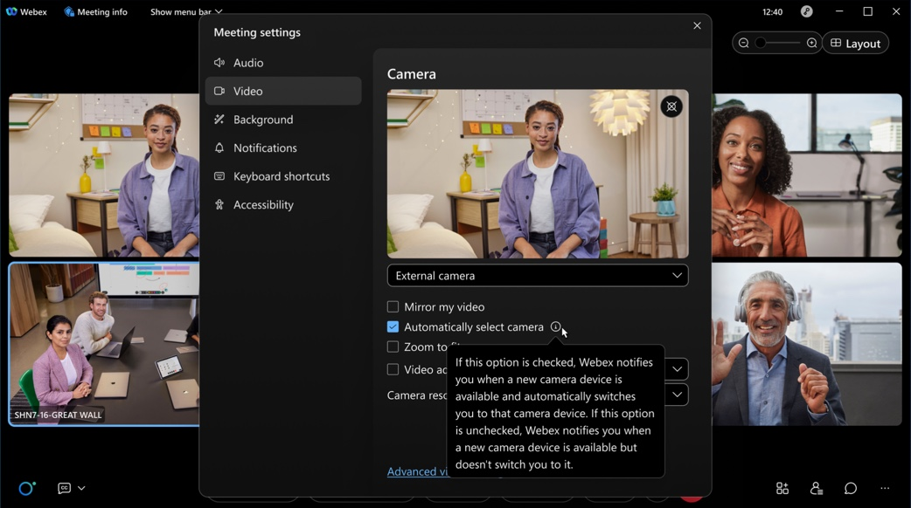
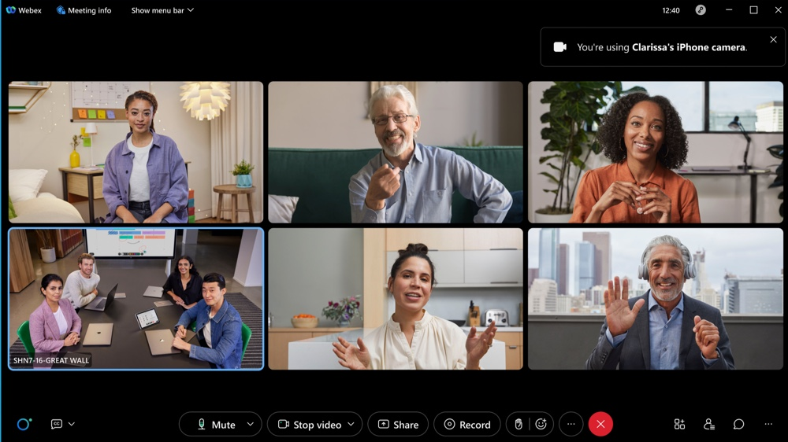

10. Attendees can join from the browser by default (Online Webinar)
Attendees joining Webinars scheduled by online users can now join a using their browser by default. This removes any friction from their join process, which previously required them to download, setup, join by using the desktop app, and better support online webinars.
This feature is for Webinar online users only.
This feature is not supported for Webex for Government.
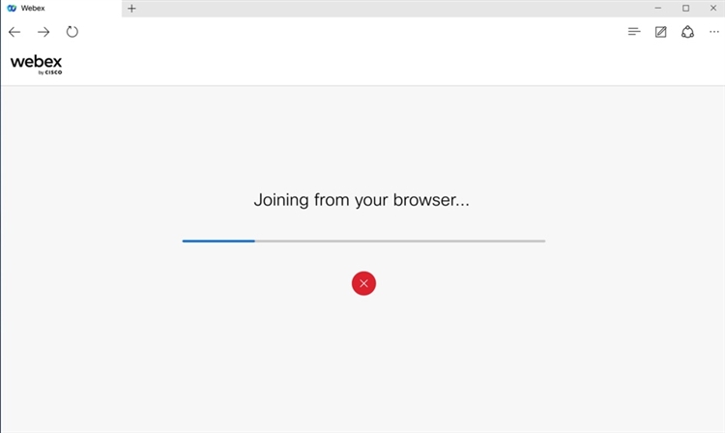
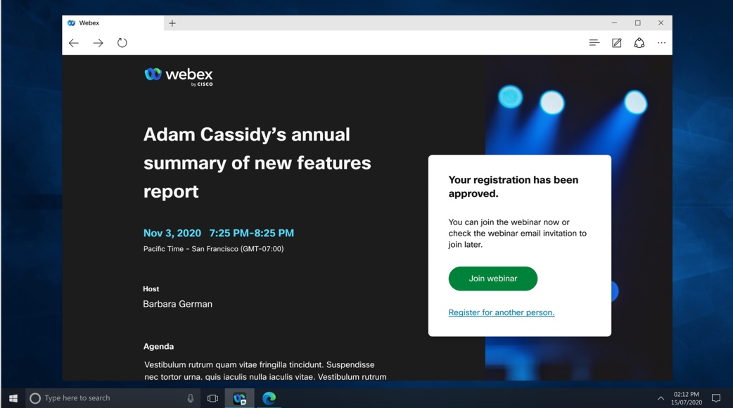

11. Pre-assign attendees to breakout sessions
Hosts and cohosts can now pre-assign attendees to breakout sessions from the webinar information page​.
Hosts can manually import a CSV file containing attendee information with a 'pre-assigned session name' column that creates and assigns attendees to their assigned BO sessions​. They can also automatically assign approved attendees to breakout sessions if registration is required.
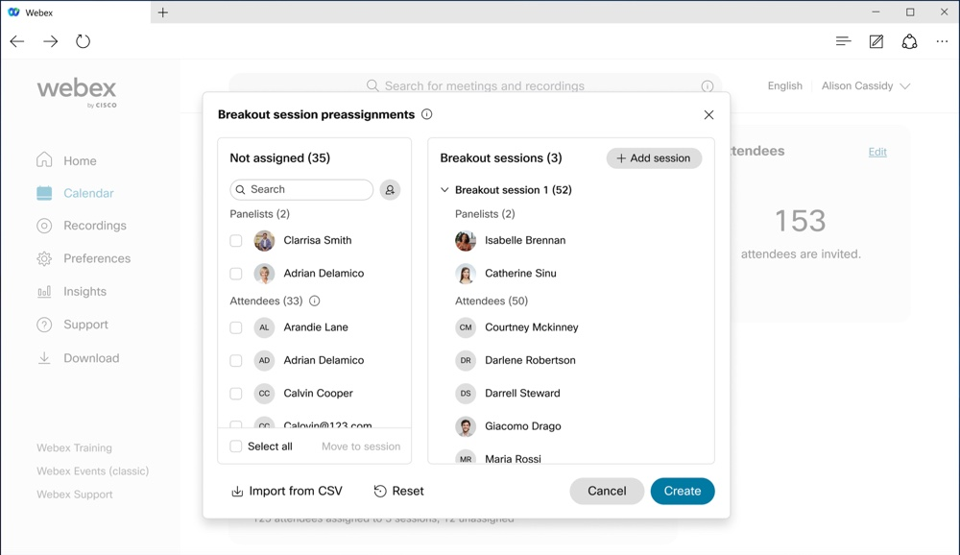

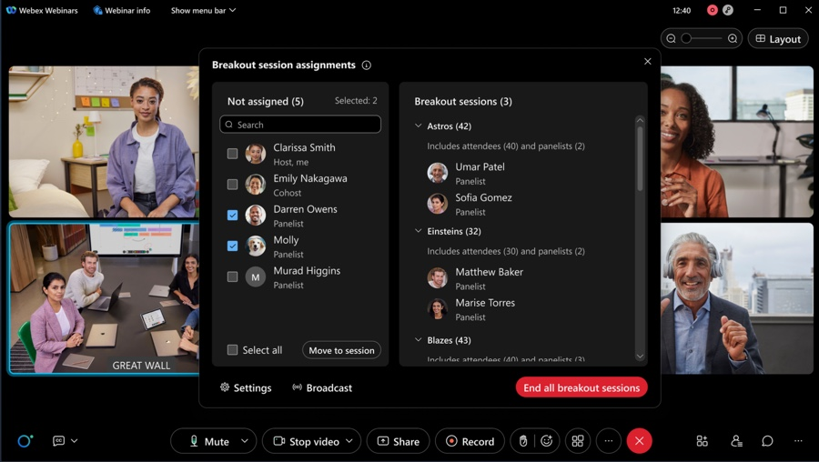

12. Changes in retention storage policy for Webex Meetings
Webex is removing the option to retain post-meeting data (recording and transcripts) for an indefinite period.
This retention policy is applicable for Meetings, Webinars, Training, and Support.
If the Standard retention policy is set to indefinite today, then the default retention period changes to 360 days, with the option of changing it from 7 days to a maximum of 360 days.
For standard Webex customers, these changes come into effect from January 2023.
To avoid any interruptions or the inadvertent deletion of old data, standard Webex customers can choose to change the retention policy from indefinite in Control Hub to a value between seven days to 360 days.

13. Cohosts can record, view, and share cloud recording and support anyone can record
We’re excited to announce that we’re going to allow cohosts and meeting participants to record a meeting in the cloud.

14. Administrators can reassign a new host for scheduled meetings and Webinars
If a meeting host leaves the company, or moves to another group, then the host becomes invalid for their scheduled meetings. The administrators can reassign a new host for the scheduled meetings.
Administrators can search for the meeting using the original host’s email or meeting number, and then select to reassign a new host. The new host can manage the meetings. The direct benefit for the customers is to keep the original scheduling with new hosts, avoiding confusion to the attendees.
In the first phase, this feature supports both Meetings and Webinar scheduled from Webex meeting sites.

15. IT administrator settings template policy improvement for recordings
Settings template in Control Hub gives IT administrators the capability to apply policy per org, user, and group for meetings held within and outside of their company. For recordings, the policy in settings template is only applicable if the user is the host of the meeting. With this release, the role of the user won’t matter. If the user has the recording capability in meetings (can be due to various reasons such as enablement of cohost or anyone can record) the toggle in settings template with make sure if disabled, the end user just can’t record with an appropriate indication to the user.

Ignored features from the above list:
- Slido updates
There are several Slido enhancements coming this month. See the In-meeting experience section for more information. For more product details, see https://community.sli.do/product-news-23 .

Slido releases aren’t dependent on the Webex upgrade cycle.

2. Slido experience

Second poll flow: We added a Plus sign + button to continue adding multiple polls to your event from the Slido integration for more efficient event creation.

Mandatory field in survey: When you create a Survey (from Slido Administration or any integration sidebar), you can mark any questions as required. It’s then visible on participant mode. In At the end of the poll question, there’s a visible asterisk* and below the answer there’s an explanation of what the asterisk means*. If a user doesn’t respond to the required question, they see an error.

Open text topics in slidolabs: This feature helps achieve better meetings by providing instant context to the moderator. Filter responses in the open text poll by their topics. These are automatically generated for English responses and appear on present mode. Recommended for meetings with many participants.

Webcast support for more than 10,000 users: Slido is now supported for Webcast mode for 10,000 or fewer users. However, up to 5,000 quiz participants are supported.

3. Android 6 and Android 7 end of life support from January 1, 2023
Starting January 1, 2023, Webex Meetings isn’t going to be supported on Android 6 and Android 7.
- Existing Webex Meetings users on Android 6 and Android 7 won’t get new app updates. We recommended their users upgrade their devices to Android 8.
Existing Webex Meetings users on Android 6 and Android 7 can continue using their existing app.
New users on Android 6 and Android 7 can’t download and use Webex Meetings app.

4. Flow updated for a user joining a meeting and signing in or signing up for a Webex account using Google credentials
Due to a change mandated by Google, starting with the January 43.1 update, the flow for users when joining a Webex meeting and trying to sign up or sign into their Webex account using Google credentials has changed. Today, the sign up or sign in is part of the app experience. However, starting with the 43.1 update the users are directed to their default system browser to complete the sign up or sign in process before being navigated back to the app to continue joining the meeting. The user is informed in the app that a new browser tab is opened where they need to complete their sign up or sign in process before proceeding with the join. Users who are selecting Google as their social provider when signing up or signing in are impacted. This change is backported to 42.6 (June) and 42.10 (October) updates.

5. Custom Dictionary – Beta release
The Custom Dictionary feature in Control Hub allows administrators to specify custom out-of-vocabulary words that are not part of the standard dictionary, so that when these words are uttered in meetings, they can be transcribed more accurately in the closed captions and transcript. The keywords may include terms such as organization acronyms and jargon, industry terms, product names, and organization name. In this update, this dictionary is limited to 100 words and English language support only.

This update is in beta and continues to improve the transcription accuracy for the custom dictionary feature in subsequent updates.

