1. Host or cohost can easily identify users to admit or remove in the secure lobby
Hosts or cohosts are easily able to identify a participant joining a meeting as Internal to their organization, External to their organization, or Unverified where the user isn't authenticated by Webex and therefore can’t be verified.
Notification of a participant waiting in the lobby is now more prominent and isn’t hidden in the Participant List.
Hosts or cohosts are able to remove a participant from the lobby. They can also select an entire group and admit or remove those participants.

2. Customize your email templates for webinars
As a host, you can customize the templates you use to send the following emails to panelists and attendees:
- invitations
- reminders
- thank yous
- cancellations
You can also choose whether to use HTML or Plain text for your email format and even save the template to your template library for future use.
Hosts and panelists can schedule reminders but only the host can enable two additional reminders for webinars with up to 10,000 participants. Reminders are disabled for webinars with 25,000 participants or more.
When you schedule a webinar, you see separate tabs for panelists, attendees, and hosts, making it easy to copy content and send it to your respective audience.
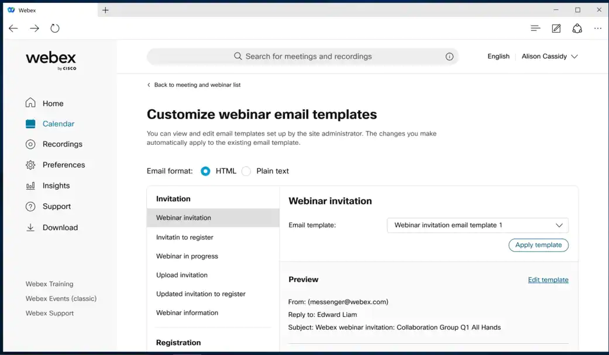

3. Administrators can manage images used in virtual background
This feature includes the following administrator capabilities:
- Enabling virtual background features at the organization level.
- Customizing options for Webex default virtual backgrounds, to use administrator uploaded virtual backgrounds, or allow users to use their own virtual background images.
- Allowing guest users to use administrator uploaded images as virtual backgrounds.
- Cascading virtual background options to each site in control hub.
- Overriding virtual background configuration for each Webex site.
- Uploading a maximum of 10 approved images as virtual background images.
The administrator can flexibly configure various scenarios on different meeting sites and different services, such as Webex Meetings, Webex Calling, and Webex Messaging.
In the Webex Meetings app, users can use different virtual backgrounds according to their administrator’s configuration.

4. Improved Personal Room security

As part of our drive to provide you with secure meetings, we’re letting you know about some security improvements that we’re making to your Webex site.
The default experience today is that anyone joining your Personal Room can jump into your meeting right away, without having to wait in the lobby.
With this update, we're making your Personal Room meetings more secure. Guests who try to join your Personal Room automatically wait in your lobby until you admit them.
In conjunction with these security changes, we’re also making changes to enhance the management of users in the lobby and in the meeting itself. For more information, see What's coming for Personal Rooms.
- Improved lobby notification

We’ve improved the notifications for when someone joins the lobby. So they’re more noticeable to hosts and cohosts, even if they’re sharing content. The notifications are dynamic and update if additional people join the lobby.

- Removing email prompt during guest join flow

Any Webex meeting attendee, joining a meeting hosted by a free online account holder, wouldn’t be prompted to input the email during a guest or unauthenticated join flow.

5. Closed captions selection (on or off) automatically remembered
Webex remembers your closed captioning selection for your next meeting or event. This behavior replaces the preference setting to automatically enable closed captions, to be removed in 42.2. This change applies to sites that have closed captions separated from the Webex Assistant.
This feature has select customer availability for Webex for Government.

6. Host or cohost can easily identify users to admit or remove in the secure lobby
Hosts or cohosts are easily able to identify a participant joining a meeting as Internal to their organization, External to their organization, or Unverified where the user is not authenticated by Webex and therefore can’t be verified.
Notification of a participant waiting in the lobby is now more prominent and isn’t hidden in the Participant List.
Hosts or cohosts are able to remove a participant from the lobby. They can also select an entire group and admit or remove those participants.

7. Hide duplicated tooltips
The tooltip and label name are duplicated in a few controls. This feature is to enhance the user's experience to remove a few redundant tooltips if they are duplicated with the text name.
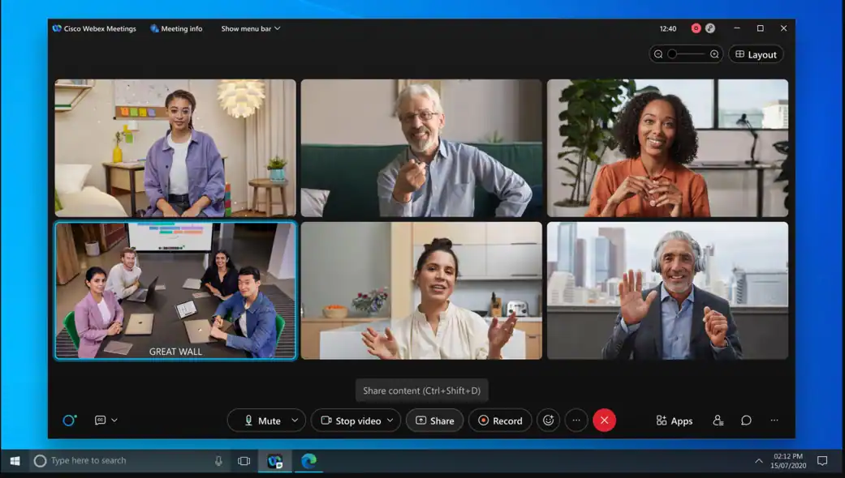

8. Align simultaneous interpretation in webinar with Webex Meeting
Enable simultaneous interpretation and manage available languages for event management in Webex Meetings or webinars. Hosts are responsible for enabling simultaneous interpretation for the meetings and webinars that they schedule, and for managing the interpretation during the meeting. They can preassign interpreters or add new language channels and interpreters to meet the needs of more attendees.
Limitation: If simultaneous interpretation is turned on, practice sessions can’t be started. This limitation will be addressed in a future update.

9. Webex recordings quick Forward and Rewind buttons
While viewing your Webex recordings you can now choose to skip ahead or move backwards easily using the rewind and forward buttons. These buttons help you move forward or backwards in 10 second increments.

10. Web app: Remove Background Noise
Similar to the desktop app, you now have the option to remove background noise when choosing "use computer for audio" in the web app, helping your voice to sound clear and filtering out noise from your surroundings. For more on background noise removal, see Remove background noise during Webex Meetings or Webex Webinar.
- Sometimes, your network or firewall settings may block access to this feature, depending on the port configuration.

- This feature is turned off by default. Contact your Customer Service Manager at Webex to enable this feature.
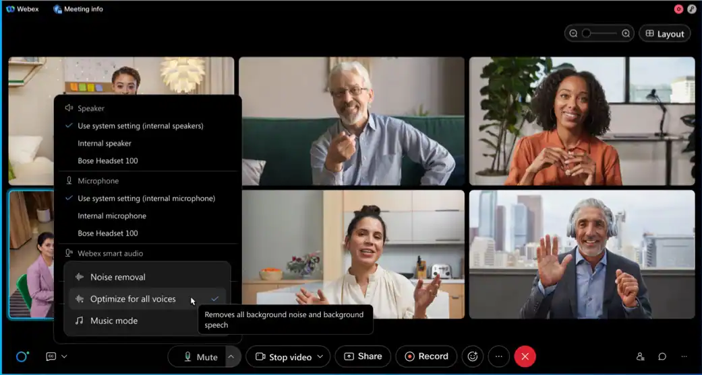

11. Web App: Pop-out panels from the meeting window
Similar to the desktop app, you can now pop-out panels from the meeting window into a separate browser window, in the web app. This makes it easy to float multiple panels, scale them for a closer look, or even move them to another monitor.
Click on the pop-out icon to float the panel in its own window. Once floating, you can pop the panel back into the meeting window at any time, and it snaps right back into place. If you close the floating panel, you're able to reopen it from the meeting window. You can even use the panel buttons in the meeting window to close any floating panels.
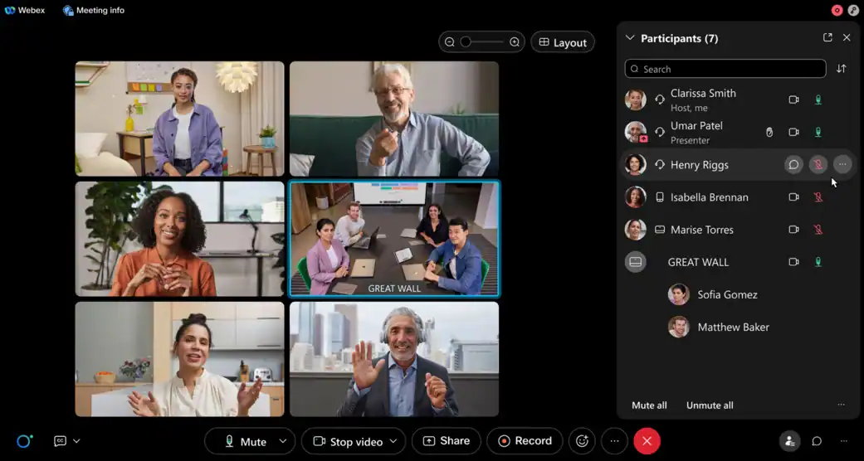

12. Block all remote-control features for users when joining external meetings
With this update, administrators are provided with a button on control hub at organization level to block all remote-control access for users joining external meetings (meetings hosted on sites outside of your company). The block includes desktop remote control, application remote control, and web browser remote control in meetings.
When this feature is blocked, the user and any of their meeting participants trying to initiate remote control see a message window instead.
This block is applicable to users joining meetings from their mobile (iOS) or desktop (Windows and Mac) apps.

13. Receive Webex Webhooks notifications when meeting transcripts are ready
Webhooks are a great way to provide notifications. Customers can use these webhooks to execute specific business logic based on the status provided when the webhooks are received.
In this update, we’re providing the ability to receive a webhook once meetings transcripts are ready. This helps customers to satisfy use cases for sending out emails to meeting participants to inform them about the transcription readiness.
This feature is not available for Webex for Government.

Ignored features from the above list:
- New name for Webex Events (new) (Webex is excited to share its new name for Webex Events (new) - Webex Webinars – will soon be reflected within the product. Along with the name change, we've updated the scheduler to make it easier to select the size and webinar experience for plans that support 3000 or more attendees. For more information, see Webex Webinars.)
- Enhanced recording reports using RESTFul APIs (Meetings RESTful API users are now able to get the following reporting information about who has viewed the recordings: <unordered item> Number of views of a specific recording, <unordered item> Number of downloads of a specific recording, <unordered item> The following information about the viewer: <sub-unordered item> Name, <sub-unordered item> Email, <sub-unordered item> When they viewed the recording, <sub-unordered item> If they downloaded the recording or not. This feature is not available for Webex for Government.)
- End of support for Internet Explorer 11 (In the 42.1 update, Webex will officially end support for Internet Explorer 11. Users may still be able to start or join meetings using this browser. However, we’ll no longer provide bug fixes or updates, and recommend using a supported browser version for the best experience. See our Webex Meetings Suite System Requirements help article.)
- End of support for Windows 7.x and Windows 8.x operating systems (In the 42.1 update, Webex will officially end support for Windows operating systems earlier than Windows 10. Users on Windows 7 and Windows 8/8.1 may continue to be able to start or join meetings. However, for the best experience, we recommend upgrading to the latest version of Windows. We’ll no longer provide bug fixes or updates for operating systems earlier than Windows 10. See our See our Webex Meetings Suite System Requirements help article.)

Webex meetings to support Windows 64-Bit (Starting with the 42.1 update, Webex Meetings supports Windows 64-bit. Specific benefits include: <unordered item> Takes full advantage of 64-bit OS—On Windows 64-bit OS, 32-bit apps aren’t taking full advantage of the 64-bit architecture. <unordered item> More memory—64-bit apps can access more memory than the 4 GB that 32-bit apps can access. <unordered item> Better security—If a program comes under attack, the additional security features applied to 64-bit programs can help 64-bit app. <unordered item> Better performance—Most of the computational logic has better performance on 64-bit architecture than 32-bit architecture. If running a 32-bit app on 64-bit Windows, performance is degraded.)

Slido to support 10,000 Webex Webinars (You can now use Slido in plans for up to 10,000 users in Webex Webinars. Slido polls are available for up to 10,000 attendees, while quizzes are available for up to 5,000 users.)

Rename Meetings to Calendar (We’re renaming the Meetings to Calendar on the left navigation menu. This feature makes it easier for the host to find meetings or webinars in upcoming and completed lists.)
- New keyboard shortcuts for smart audio, chat, closed captions, Mac right-click menu
- Keyboard shortcut changes (CTRL+Shift+K) (We’ve also updated keyboard shortcuts for better platform alignment. Turn on or off the screen reader notification for a new chat message has been changed from CRTL+Shift+C to CRTL+Shift+K.)
- Webex Assistant New Logo (Webex Assistant now has a new logo on all applications. The ring symbolizes 360-degree communication and connections that Webex enables. The dot manifests as an exponent to the ring, augmenting the potential and ease of collaboration itself.)

- Webex media backup port changes (In early January 2022, Webex media streaming for Webex App (one on one calling and space backed meetings) and cloud registered video devices have a change to their backup media port. In this change, we’re deprecating the use of UDP port 33434 and are beginning to use UDP 9000 as the backup media port. If you haven’t already opened UDP 9000, do so to avoid any disruption of media delivery in the event we must failover to the backup media port. It’s advisable to review the Network Requirements for Webex Services (Network Requirements for Webex Services) document periodically to ensure a continuity of service for your users.)
- Apple Airplay external speaker support (Add in-meeting settings to enable Apple Airplay audio support.)
- Administrators can export E.164 format phone numbers from bulk of attributes management (We’ve enhanced the management of the bulk user attributes feature.
The administrators can export the phone numbers with E.164 formatting. Meanwhile, the system is compatible with Webex phone number formats and E1.64 formats. With this enhancement supporting E.164, the end user sees the unified formatted phone numbers with Webex services.)
- Video Mesh Cloud Cascade port changes (In early January 2022, Video Mesh will require open destination port ranges UDP 50,000–53,000 for the Media Cloud Cascades. Make sure that the UDP 50,000–53,000 port ranges are opened up in your firewall configuration. Failure to do so results in service disruption of the Video Mesh solution when the software updates with the new port ranges for cloud cascade are pushed out.

Today, these port ranges are used by the Expressway to Webex Cloud (Webex destination port range): UDP 49152–59999 (Network Requirements for Webex Services). So, these port ranges should already be opened. If that is the case, no action is required. If they aren't, make sure that they’re opened up by January 2022 to avoid any disruption to the proper function of the Video Mesh solution.)
- Webex Meetings VDI supports audio background noise reduction on Windows thin client (Webex Meetings VDI supports background noise reduction on Windows thin client. The user from Windows thin client device can enable or disable the background noise reduction in Webex Meetings VDI.)

Webex for Government updates (We’ve added support for Webex for Government to the following features that are currently available.)
  - End-to-end encryption with identity (Zero-Trust Security from Webex provides end-to-end encryption and strong identity verification in your scheduled and personal room meetings.)

