1. Devices can join webinar as attendees
(It was initially communicated that this feature will be available in the February 43.2 update. However, this feature has been delayed and will be available in the April 43.4 update.)
This update allows attendees to join webinars from a Webex cloud device – perfect for bringing employees together during webinars, such as company All-Hands. Attendees need to enter the webinar ID and password on the cloud device, then they can join the webinar as an attendee from the device.
- This update supports cloud devices that allow keyboard entry. For webinars that require attendees to sign in, the attendees can’t join using a device.
- This update doesn't support webinar with webcast view for attendees.
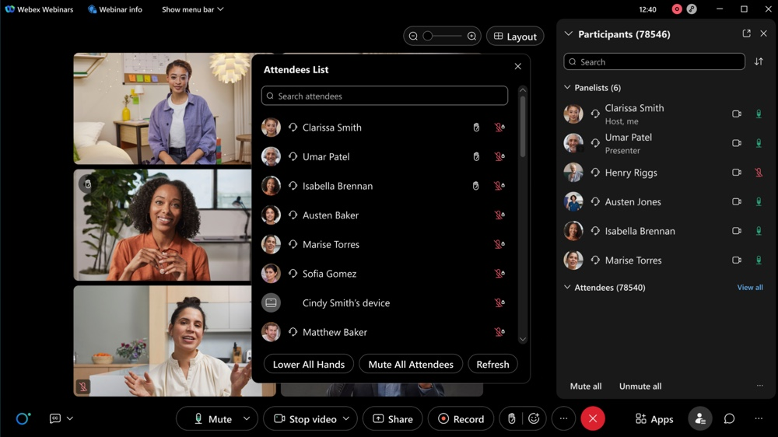

2. Listen to Webex meeting recording on Apple CarPlay
In addition to joining a Webex meeting from the Apple CarPlay dashboard, you can connect your iPhones to the Apple CarPlay dashboard and listen to audio meeting recordings on the go.
You can see a list of your meeting recordings and can tap on the recording title to start listening. You can play and pause the recording and also forward or rewind it by 10 seconds.

3. Dynamically adjust participant video quality
We’ve added a new option to dynamically adjust participant video quality. With this option enabled, the video resolution of meeting participants is increased to better fill the actual window resolution being used. This feature dynamically monitors the system and network performance to limit the improvements to what the system can handle. This setting can be enabled in Meeting Settings in the Layout tab by checking the box to enable. Dynamically adjust participant video quality to the actual video size.
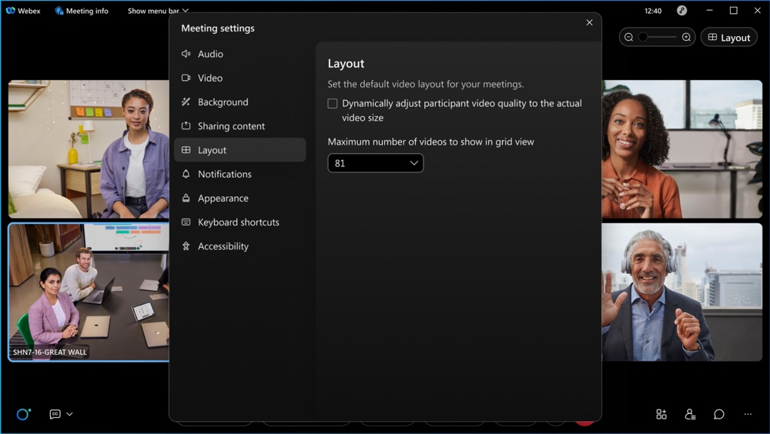

4. Start a meeting from a device
You can now walk into a room and start an instant meeting on a Webex device. Once you start a meeting, you no longer need to struggle to invite guests to a meeting. In the invite pop-up, you can now invite any guests to a meeting. Scan the QR code, and then you can copy and share the meeting information with anyone.
This feature isn’t available for Webex for Government.
This feature is available on a delayed release cycle.

5. Source ID can be tracked before webinar starts
This feature adds a Source ID column to the Manage Registration page, which captures where registered attendees are coming from. This way, hosts can view where their attendees are coming from before the webinar starts to know whether they should increase engagement on certain invitation platforms to attract more attendees.

6. Can change meeting template after a meeting is scheduled
With Webex Scheduler, you can now change your meeting template after you have scheduled a meeting. Previously, your default template was used and you couldn’t change it after the meeting was scheduled.

7. Allow users to turn on or off the floating window when sharing
This enhancement allows users and administrators to hide the floating window with video thumbnails when sharing. While many users find it useful to see reactions from users while sharing, some would rather not show it. This change allows them to do that. To change at Meeting level, go to Settings > Sharing Content. At organization level in Control Hub, go to Meetings settings.
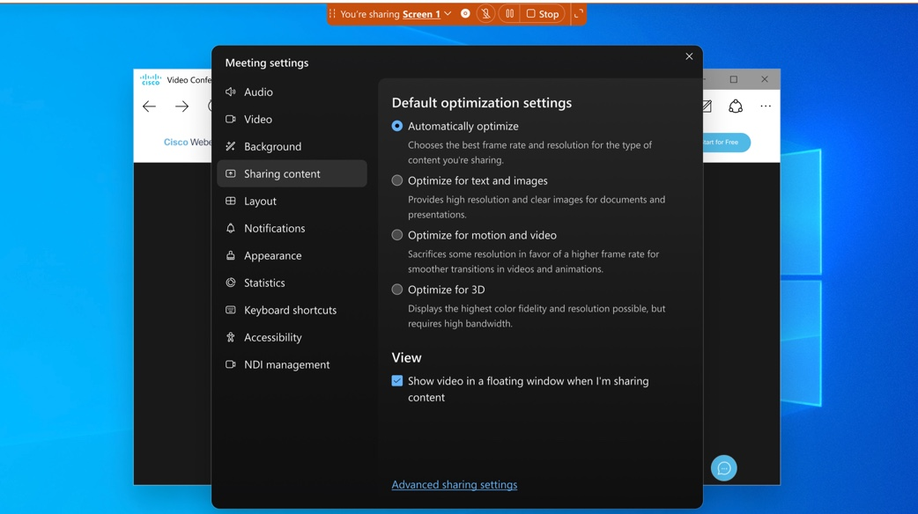

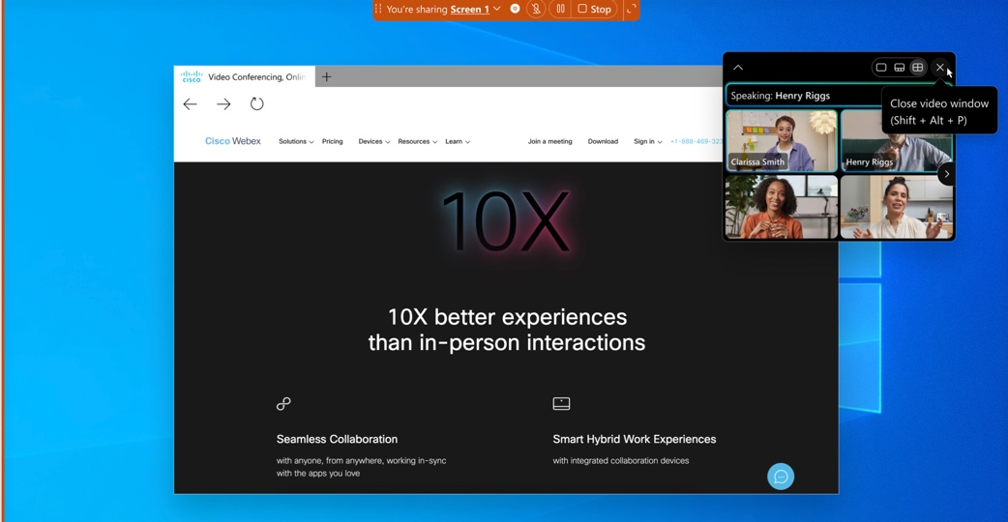

8. New polling activity report that records individual attendee's actions
There is a new polling activity report that records attendees' actions. This provides visibility into who has selected what for each polling question.
This feature is available on a delayed release cycle.

9. First name, Last name, and Role added to attendance report
The webinar attendance report now includes three additional columns - First name, Last name, and Role.
The First name and Last name columns display the names that the attendees first joined the webinar with. If an attendee’s name is edited during the webinar, the edited name doesn’t appear in the report. Additionally, guest attendee’s First name and Last name aren’t reported. The Role column includes the attendee’s roles at the time the webinar ends.
This feature supports webinar with webcast view.
This feature is available on a delayed release cycle.

10. Host knows how many attendees have submitted to a poll
In addition to the number of attendees who have submitted polls, the host also has visibility into how many attendees are actively editing their polls but haven't submitted them yet. The hosts can view the attendee’s editing status for the polls. With this visibility, a host can remind their attendees that they must submit their polls.

11. Simplify VoIP join for attendee in Webinars
We’ve added audio broadcast to Webinars to simplify the join experience for attendees. When a webinar enables VoIP-only (Voice over Internet Protocol) for Audio connection type, attendees joining the event with VoIP are automatically connected and join the webinar directly on desktop (Windows and Mac), mobile (iOS and Android) and the browser app. The attendees don’t need to go through additional confirmation pages before they join.

12. Collaboration restrictions for Webex meetings in Control Hub: Support internal meeting settings at the organization level
Currently, for Control Hub's Collaboration restrictions settings, administrators can only manually apply internal meeting settings using the user or group-level settings templates after the user has been created (it doesn’t automatically apply for new users).
With this new update, the administrators can apply internal meeting settings to users using the organization-level settings, which automatically apply to new users and users with none template.

13. Abilities for IT administrator to custom select virtual background for cross-org policy
Currently, under Control Hub's Organization Settings, there’s an option to Enforce virtual backgrounds require users to have a virtual background) for all external meetings. When administrators enable this option, all required virtual backgrounds are set to Webex's executive office background, and users can't change it when they start video.
With this new update, there’s the Enforce virtual backgrounds setting for all internal meetings, and two suboptions for administrators to allow more backgrounds that users can choose from when they start video:
- Allow all admin-uploaded backgrounds: users can select between Webex's executive office background and admin-uploaded backgrounds.
- Allow selected only: users can select between Webex's executive office background and selected admin-uploaded backgrounds.

Ignored features from the above list:

1. Slido experience

Here are the Slido enhancements coming this month. For more product details, see https://community.sli.do/product-news-23.

Slido releases aren’t dependent on the Webex upgrade cycle.

Theta Lake integration with Slido

Compliance for audience interaction made easy

Theta Lake integration will be available for organizations hosted on US servers in H1FY24.

Theta Lake seamlessly integrates with your Slido platform to provide AI-based compliance and archiving with automated risk detection and review workflow of shared content. Theta Lake makes it easy to efficiently manage compliance while saving time and resources.
Whether your organization’s meetings hosts engage with their audience using Slido at the office or online, Theta Lake is the only purpose-built tool that helps you to securely capture, supervise, and archive Slido’s live polls, Q&A, surveys, quizzes, and more.
Use cases:
- Archiving, retention, and eDiscovery for Slido With Theta Lake, you can customize content retention and disposition policies, apply legal holds, and automate sending a copy of the content and analysis report to your existing third-party archives.
- Connector to Third-party Archive of Records Archive Connector comprehensively captures all Slido content and seamlessly integrates them into an organization’s archive or record-keeping arrangement, retaining the full context of each poll, Q&A, survey, and more.
- Data loss protection Unlock the power of Slido and ensure the privacy of confidential client and company information. With more than 85 built-in classifiers to identify and flag risks within Slido communications, Theta Lake detects the sharing of PII and other sensitive information such as data leakage of sensitive information, misconduct, regulatory compliance and more within any content that was shared.
Benefits
- Improve compliance and reduce risk.
- Save time and money.
- Long-term, secure archiving, and eDiscovery

