1. New virtual backgrounds, both static and animated
Webex is updating its default library of virtual backgrounds. In addition to the most frequently used, we added a few new backgrounds, including two animated ones. Users can still upload their own as desired.
Animated virtual backgrounds are not available when starting or joining a meeting from Webex App.
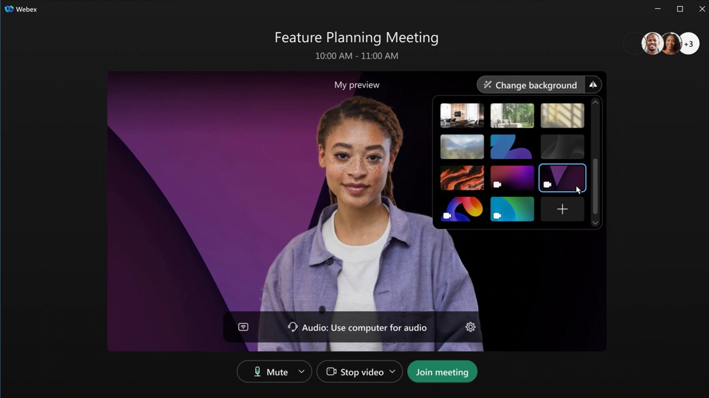

2. Webinar materials support
Hosts can upload webinar materials such as Microsoft PowerPoint presentations, PDF, Microsoft Word documents, JPG, and PNG files in the webinar information page. Attendees can download material in the webinar information page.
When you schedule a webinar, you see separate tabs for panelists, attendees, and hosts, making it easy to copy content and send it to your respective audience.

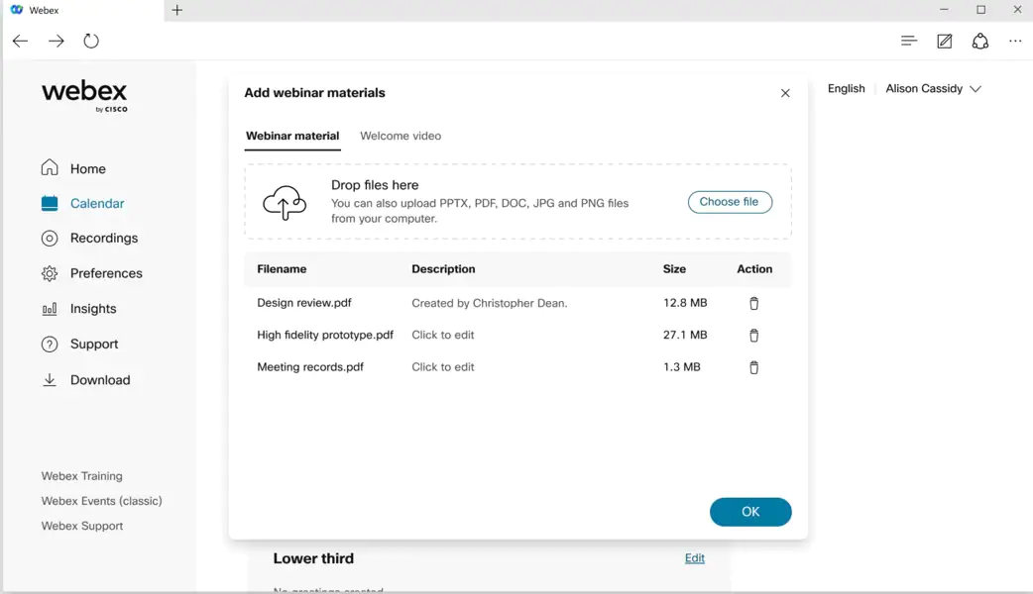

3. Polling support in webinar
In addition to polls using Slido, you can now start polls in webinars from the Polling panel, similar to Webex Meetings. Use polls to engage your participants, even if Slido is not available in your webinar.
To pre-configure the polling questions the host can start any webinar to create questions and save the polling file in .atp format. During the webinar, the host can quickly add the questions by uploading the previously saved file.
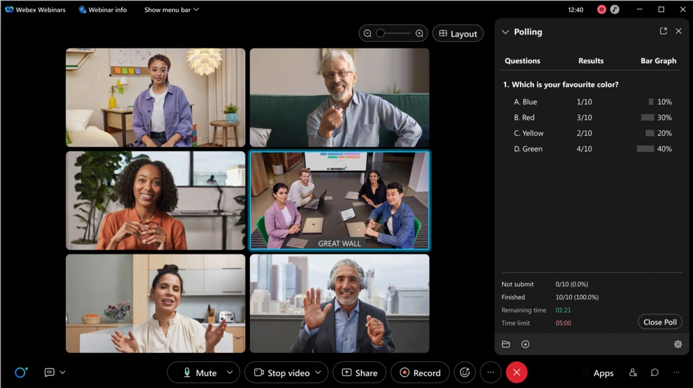

4. Background PiP (picture-in-picture) support for iPad users

The Webex Meetings mobile app now supports background PiP (picture-in-picture) for iPad users.
PiP support shrinks the whole meeting window to a small rectangular window that appears over your iPad home screen and even over other apps.
For example, iPad users can browse their emails or web browser while on their iPad watching a meeting window outside the Meetings app. This is done using the picture-in-picture window that is positioned in one corner of the screen.

5. Meetings VDI to extend maximum video ports from 3x3 to 5x5 in grid view
Webex Meetings VDI to extend the maximum video ports from 3x3 to 5x5 in grid view mode. Your administrator controls the maximum video ports from Webex Control Hub.
To enable the feature, add the following registry key and value to the HVD registry (not thin client):
- Registry path: Computer\HKEY_LOCAL_MACHINE\SOFTWARE\Policies\CiscoWebex
- Key Name: WebexVDIUnlimitVideoPortPolicy
- Type: DWORD
- Value: 1

6. Allow host and cohost to change registration form
Hosts and cohosts can change the registration form - registrant number, registration ID, and approval rules option even after someone has registered for the webinar.
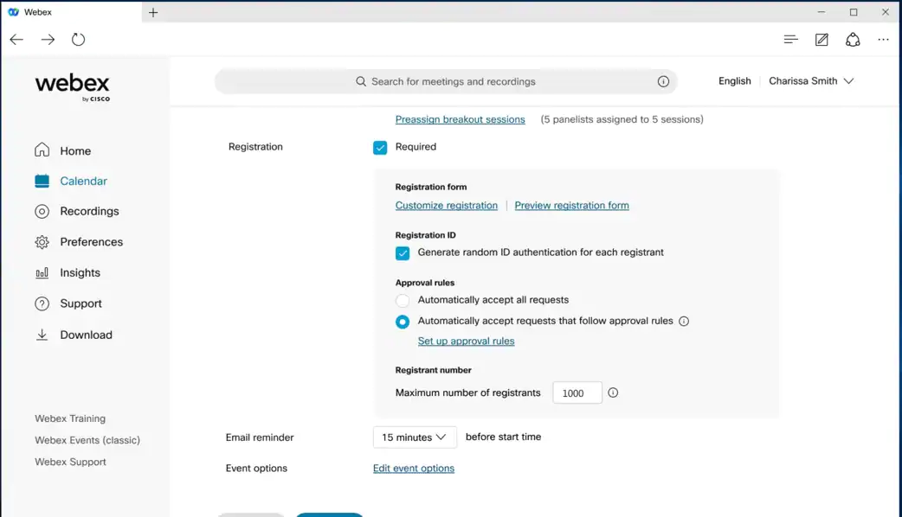

7. Maximum number of webinar registrants and attendees
In this update, users who have the 10,000, 25,000, 50,000, and 100,000 license plans can accept registration more than their current license allows. They now can accept 20 percent more of their maximum attendee numbers. For example, if their license is 10,000, they can accept up to 12,000 registrations.
Users with 1,000, 3,000, and 5,000-license plans remain the same, with a maximum registration of 10,000.

8. New location for opened embedded apps
When a user wants to reopen an embedded app, they can open the Apps panel and find the app at the top of the In Meeting list. Previously, it was in the More (...) menu.
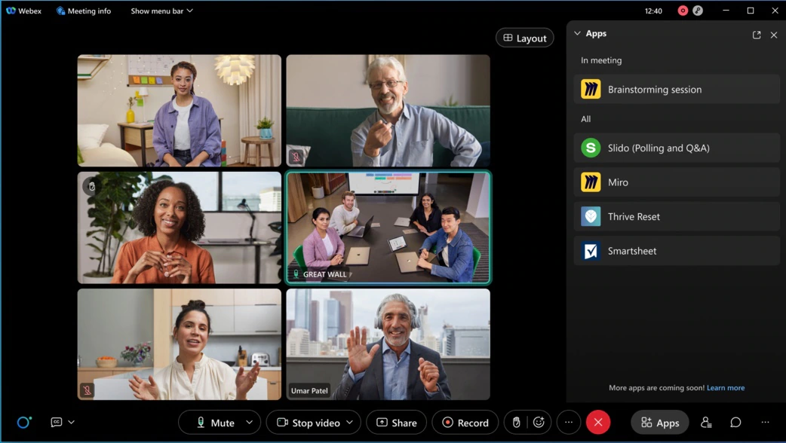

9. Shared Timer app for Webex Meetings and Webex Webinars
Keep people on track using the new Shared Timer app. Hosts and participants can view and interact with a countdown timer during team collaboration or group activities, helping things to stay on schedule. The meeting host can launch the Shared Timer from the Apps panel, set a timer and share it with other meeting participants. Participants can start, pause, and add more time if the host allows.
Administrators enable apps using Webex Control Hub.

10. Google Workspace add-on user interface improvements
Google Workspace add-on users can toggle between Personal Room and one-time meeting links directly from the meeting settings panel. Default settings are used when a user chooses Webex meeting from the Add video conferencing option menu.
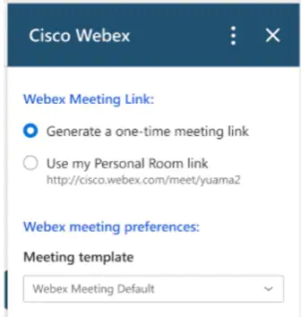

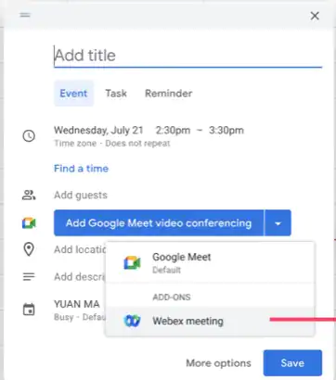

11. Real-time transcription for 13 spoken languages
Previously, only English transcription was supported. Now, the host can select transcription for the meeting and webinar in 13 spoken languages, including English (existing), Chinese Mandarin (Simplified and Traditional), Dutch, French, German, Hindi, Italian, Japanese, Korean, Polish, Portuguese, and Spanish. This feature is part of the real-time translation SKU, so the captions for these languages can also be translated to 100+ other languages. With this feature, users can easily communicate in their own language to be more effective, and experience more inclusive, accessible, and engaging meetings across the globe.
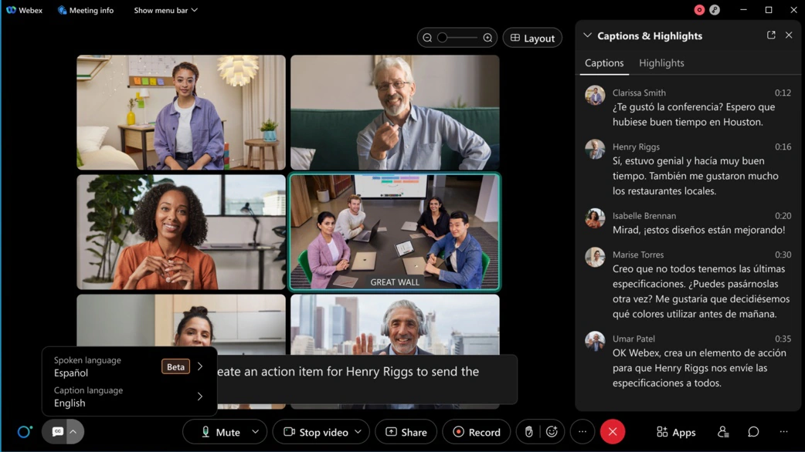

12. Raise hand button has moved to control bar
We’re moving the Raise hand icon out from the Reactions menu to the control bar. This makes it easier to find and faster to use.
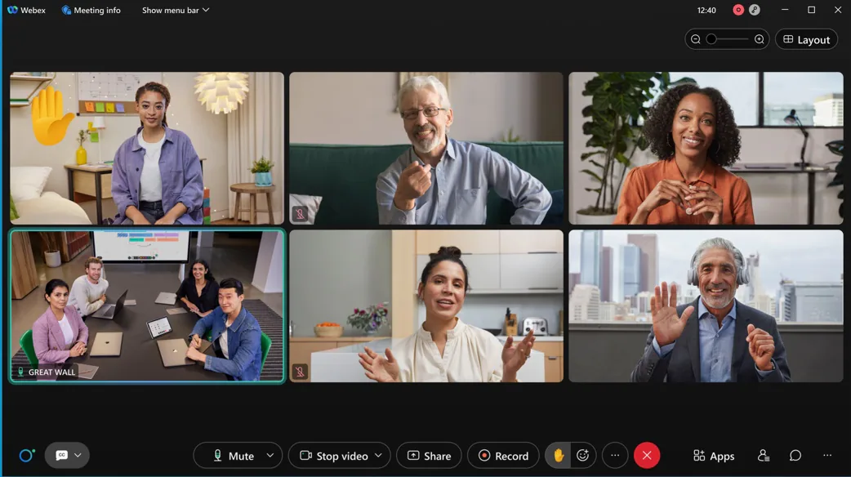

13. Automatically hide self-view when video is off
Now, your self-view will automatically be hidden if you turn off your video. This gives you more screen real-estate to focus on the people you're meeting with.

14. Enable Sync my Stage for everyone
Hosts and cohosts can now sync their exact layout of stage for attendees. Previously, when the host or cohost adjusted the size of the window and then selected Sync my stage, the stage content was synced to the attendees, but the window sizes were not synced. In this update, hosts and cohosts can sync the adjusted size of the content to the attendees and the attendees view is the same as the host’s and cohost's view.
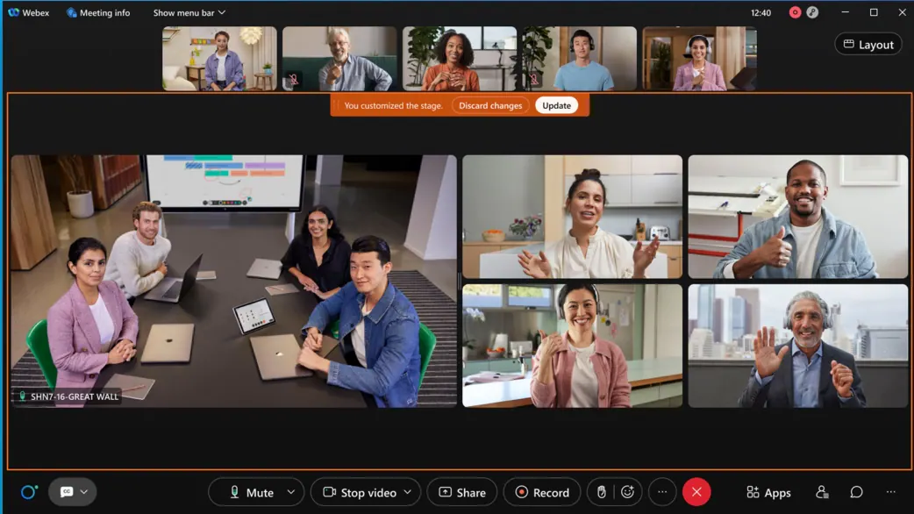

15. End webcast after all content is displayed
When the webcast stops, attendees continue to see the content until all the content is displayed.
This feature is not available for Webex for Government.
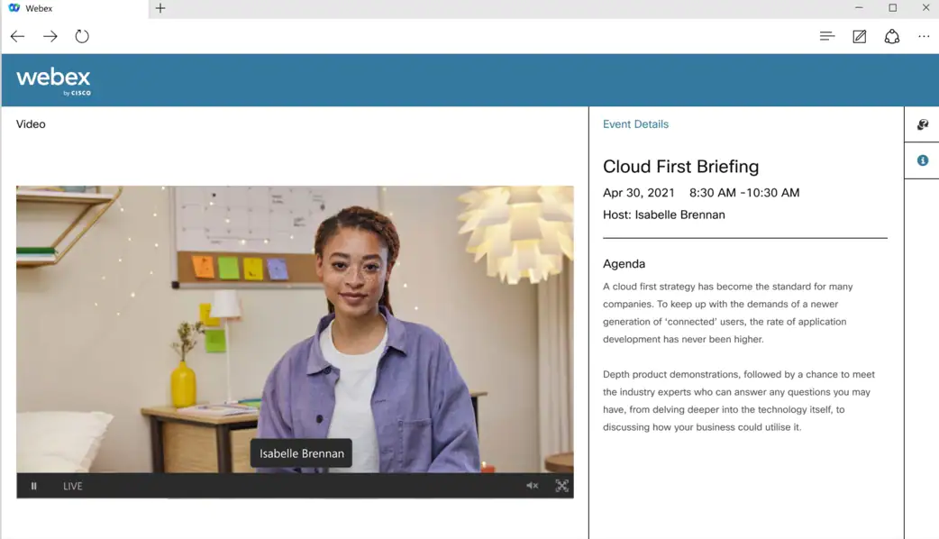

16. Web app: Annotation support
Webex Meetings web app users can now annotate on top of shared content, when the presenter is sharing from the desktop app or the mobile app.

17. Anonymize meeting attendee display names (beta – enabled by request)
When enabled, hosts can use of the Keep attendee names private option in the scheduler. This setting assigns an anonymous display name (Participant 1, Participant 2, and so on) to attendees as they join. Attendees can’t see each other’s real names. Only the host or cohost has access to an attendee’s real name.
This feature is intended for meetings where privacy (anonymity) is required between attendees. For example:
- Holding a meeting with competing vendors
- Support groups
- Consultations
Hosts can request access to these settings.
Beta Limitations:
- Video devices don’t support anonymized display names, and therefore if a user joins from a video device, they can see attendees' real names.
- The calendar tool doesn’t support anonymized names. While invitee names are hidden on the meeting detail page, any users currently using the calendar tool see invitees' real names.
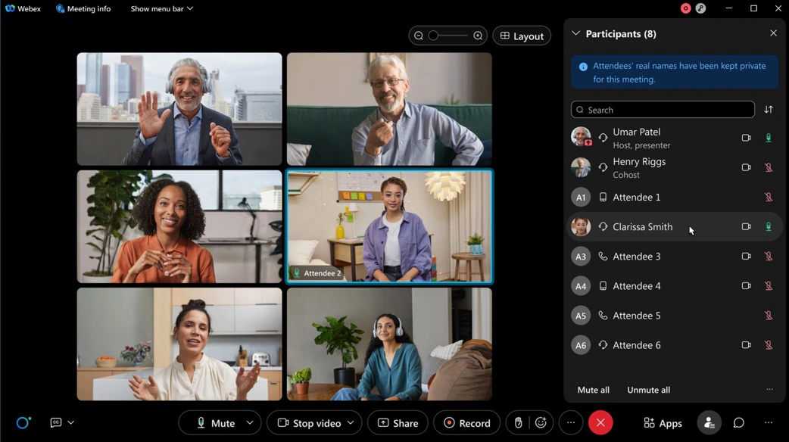

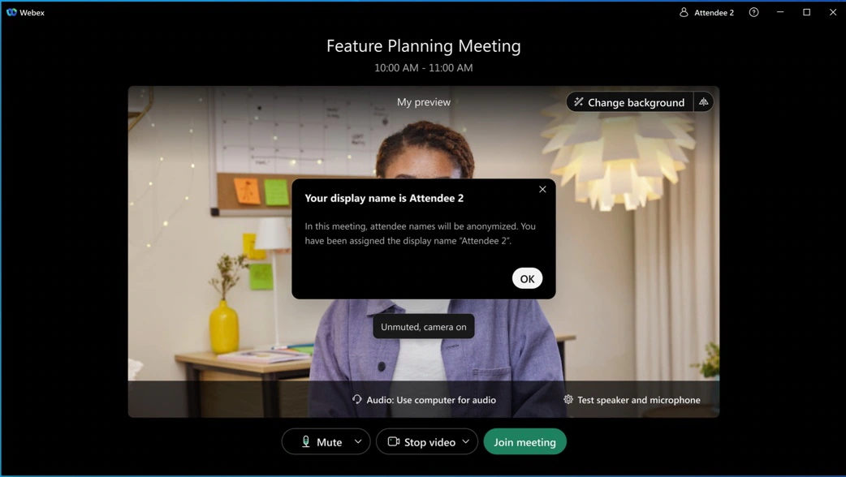

18. Filter for Slido events in Webex panel
In case you missed the updates that came in December, Slido organization owners and administrators can now filter only their Slido events by clicking the filter icon in the Webex sidebar. The default My own option includes their Slido events, and the All option includes Slido events of all users under the organization.
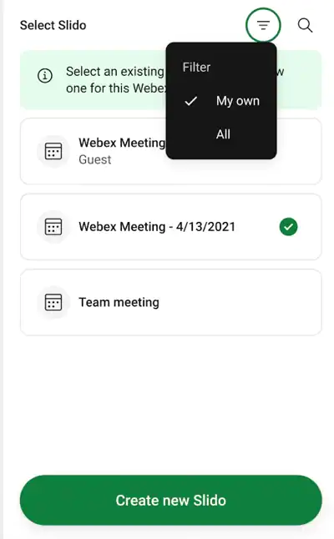

19. Cohosts and panelists can request access to co-administer Slido directly from the Webex sidebar
In case you missed the updates that came in January, if the host added Slido to the Webex Meeting or webinar, cohosts and panelists can request access to the Slido administration panel directly in Webex. Therefore, the host doesn’t have to necessarily invite them as collaborators beforehand using slido.com > Settings > Share access.
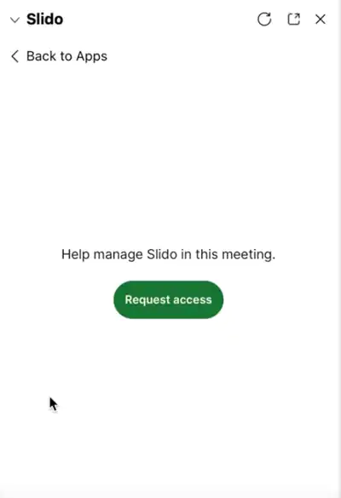

20. No more inappropriate emojis in Q&A and Word-cloud
The profanity filter for Q&A has been announced earlier, and it is now added to the word-cloud poll.

Ignored features from the above list:
- 1080p view only webinar and live streaming (Webex meetings and webinars now support 1080p. Site administrator can enable 1080p support: [i] All attendees can view 1080p contents in view only webinar. [ii] The live stream from Webex meeting and webinars to third parties: IBM Video Streaming, Facebook Live, vBrick, Workplace from Facebook, Other streaming services (for example, YouTube and Periscope) will be 1080p in resolution. [iii] This feature is not available for Webex for Government.)
- *.PDF is the default file format when the shared file content is saved in meetings (*.UCF is an old file format that can only be viewed in a meeting or with Webex Media Player, which is no longer supported. Going forward, *.PDF is the default file format when the shared file content is saved in meetings.)
- Device enhancements: 4K Content share support for on-premises registered video devices (When someone shares 4K high resolution content from their app, users on capable on-premises registered video devices can see the content at their native resolution. Content will be shown at up to 7.5 frame seconds when is is transmitted at 4K resolution.)
- Support viewing 1080P video format for mobile webinar attendees (Similar to desktop, the mobile app also supports viewing 1080P video format for mobile webinar attendees.)
- Administration experience: Administrators can choose to allow users to change their profile in the mobile app (In Webex Control Hub, the administrator can customize whether to allow their users to edit their profile attributes, such as first name, last name, display name, and profile picture.
According to this configuration that is made in Control Hub, the users can see whether they can edit the attributes on the Webex Meetings mobile app.)
- Administration experience: Administrator controls for video device layouts (Users joining your meetings on video devices can now enjoy the default video layout that you set in your meetings configuration. Prior to this update, the layout choice would only be used by the Webex Meetings app. With this update, single screen video devices that are on-premises connected start observing the layout choice that you configure.)

Webex Meetings APIs: Webex RESTful APIs to support approve and reject registration for meetings and webinars (Using Webex Meetings RESTful API you can now approve and reject registration for meetings and webinars and check the number of views of a specific recording. This feature is not available for Webex for Government.)

Webex Meetings APIs: Webex Meetings RESTful API support for webinars (Developers can schedule webinars using the meetings API. The API supports standard CRUD operations in line with the current meetings API endpoint. We're releasing more API features to support webinars so stay tuned here to learn more in the coming months. This feature is not available for Webex for Government.)

Webex Meetings APIs: List recordings APIs (Customers can list recordings based on service type, recording format type, and recording name. This feature is not available for Webex for Government.)
- Webex Meetings APIs: Webinars supports RESTful APIs (In case you missed the APIs that are supported for webinars, you can now find them here.)

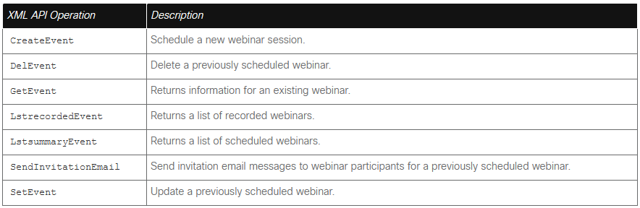

- Webex for Government updates: Collaboration restrictions for your company users joining external meetings now on Webex for Government (Administrators can apply policies to users joining external meetings from a Webex for Government environment. [i] Join Policy: Administrators can now turn on a setting for their organization which prevents all their company users from joining any external meetings. This setting also provides capability for you to add sites to the "approved site" list there by controlling which sites your company users can join or be blocked. [ii] Meetings Setting: Administrators – You can now restrict your company users to use certain “in-meeting” features, that go against your company policies when joining meetings outside of your organization.

The following features can be blocked for your users in this release: File transfer, screen share +Annotation, Chat, Q&A & polling.
You can add your own approved site list where you want these restrictions not to take effect. This setting can be configured using Control Hub site admin page. If turned on for your company, this policy is applied to all users in your organization joining from mobile, desktop, and browser using your company's verified domain email address to join meetings.
- Currently this setting is applicable to ALL users in the organization and users using your company's claimed domain email address to join meetings.
- The join policy setting is applicable for Webex Meetings application only.
//end/right )

- Webex for Government updates: Webex for Government supports RESTful APIs (Webex for Government supports the following APIs: [i] Meetings, [ii] Meeting Preferences, [iii] Meeting Attendees, [iv] Participants, [v] Recordings)

