1. Cohosts can manage invitations and registration in Webex Meetings and Webex Events (New)
Once the Webex Meeting or event is scheduled by the host, assigned cohosts can now help manage invitations and registration from the meeting information page. Here, cohosts can:
- Invite or import attendees and event panelist
- Approve or reject registrants.
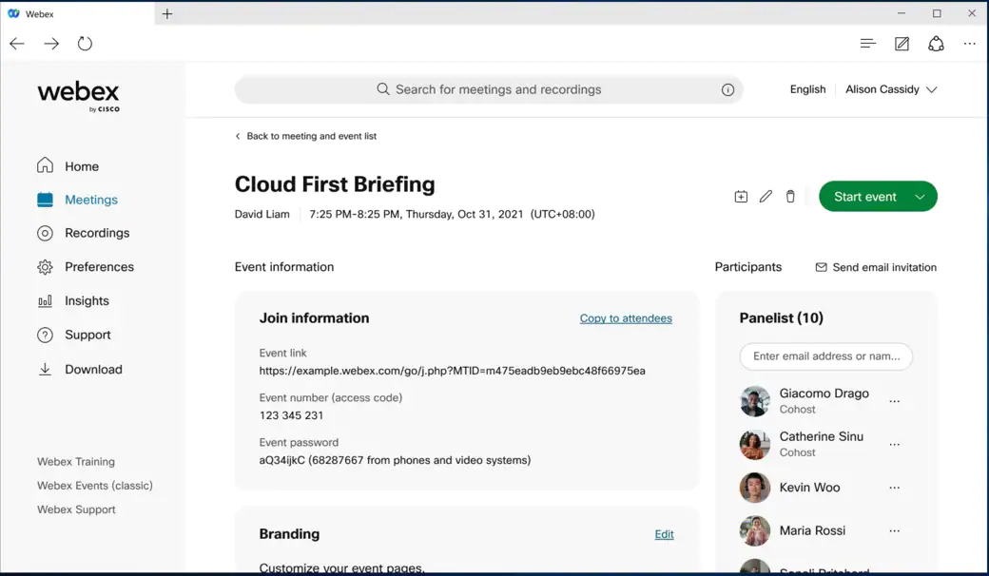

2. Scheduled meetings template using RESTful APIs
Today, on the Webex platform, you can schedule a meeting, and then save the scheduled meeting with its preferences as a template. You can then directly apply this template when scheduling a meeting in the future. We’re adding this feature to our Meetings RESTful APIs to allow you to programmatically save scheduled meeting preferences as a template.
This feature isn’t available for Webex for Government.

3. New skin tones and new reactions (Desktop)
To encourage users to better express themselves non-verbally, we’re adding skin tones to your reactions. The additional five skin tones reflect a range of skin colors. To change the skin tones, go to Meetings > Meeting Settings > Appearance.
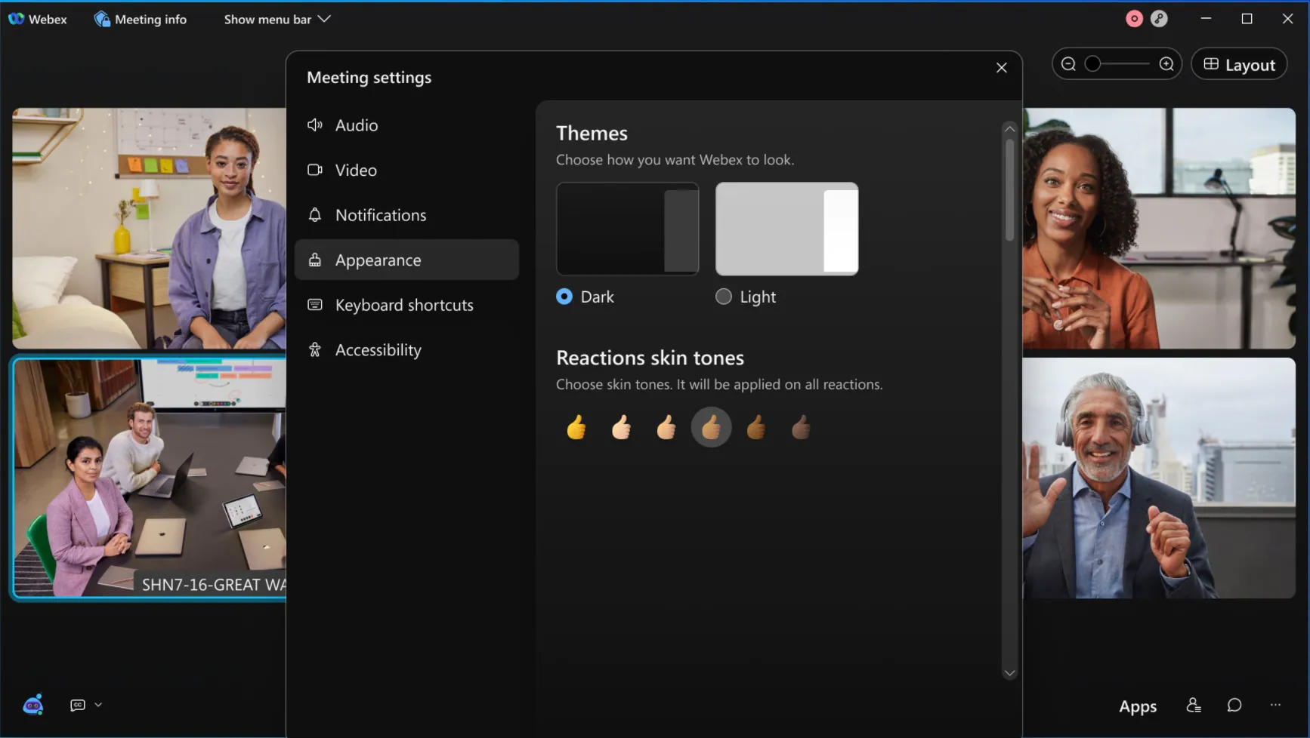
We’re also adding some new reactions to help users express how they’re feeling during a meeting. The new reactions are Thank You, Love, Speed Up, Slow Down, and Fire.
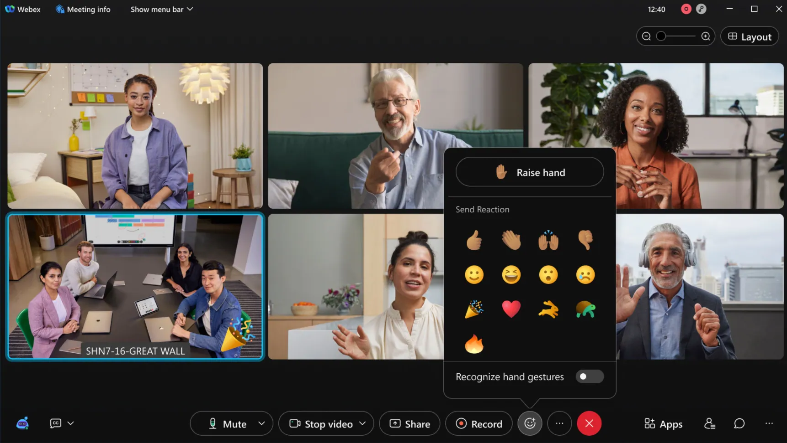

4. New skin tones (Mobile)

Similar to desktop, mobile meetings app users can use five new skin tone reactions during their meetings.

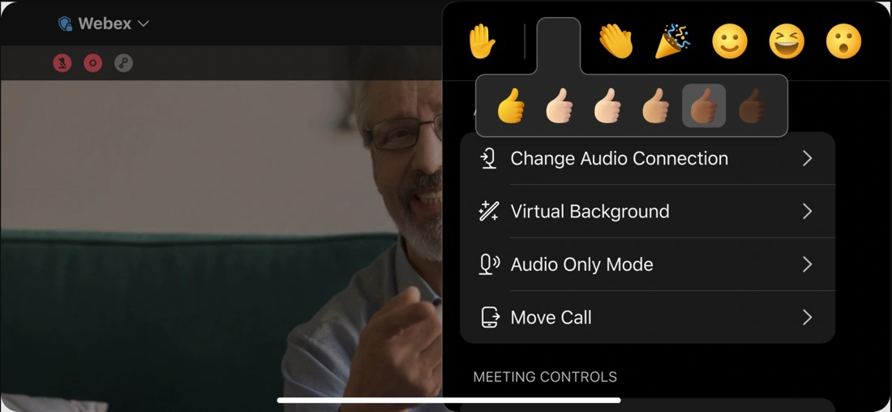
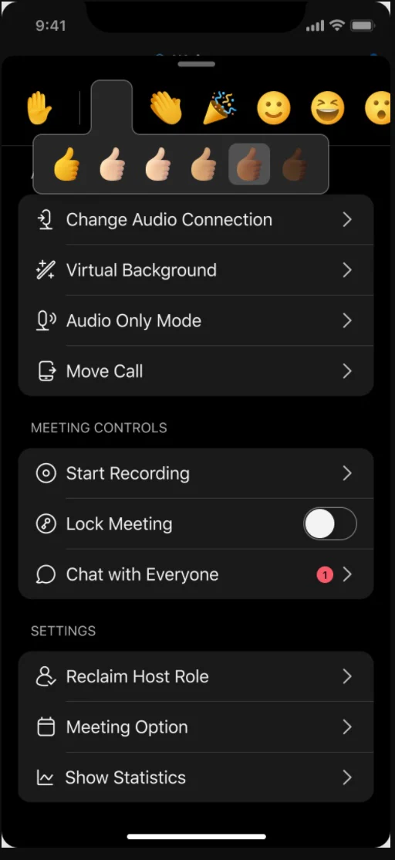

5. Update from Site Administration to Control Hub
In case you missed the update in 41.11.4, administrators can now confidently update their Meetings site management to Webex Control Hub. Previously, meetings data such as upcoming meetings, recordings, site settings, and user preferences are maintained from your Webex site.
The benefits of managing all Webex services in Control Hub include:
- Unified way of licensing across all Webex services (Messaging, Calling, and Meetings)
- Consistent security policies across all Webex services
- Common sign in for users for all Webex services
- Modern administration controls like Directory Connector, System for cross-domain Identity Management (SCIM), Active Directory (AD) groups, and more licensing templates by AD Groups
Review the site conversion doc before updating administration to Control Hub. It’s important to review and follow Prepare your Control Hub Organization before you attempt to update your site.
This update (from Site Administration to Control Hub) is enabled on most sites shortly after this version update. This feature won't require an update of client versions.
Limitations:
- Sites that are managed by partners using CPAC won’t receive this update.
- Sites whose users haven’t been linked to Control Hub aren’t eligible for this update.
This feature is not yet available for Webex for Government and will be available in a future update.

6. Refine the user interface for interpreters in Webex Meetings and Webex Events (New)
Interpreters receive their own email that includes the information to join the meetings or events. When the host adds an interpreter to the invitation list, there’s a new icon to indicate that they are an interpreter. This distinguishes an interpreter from the panelist and other attendees.
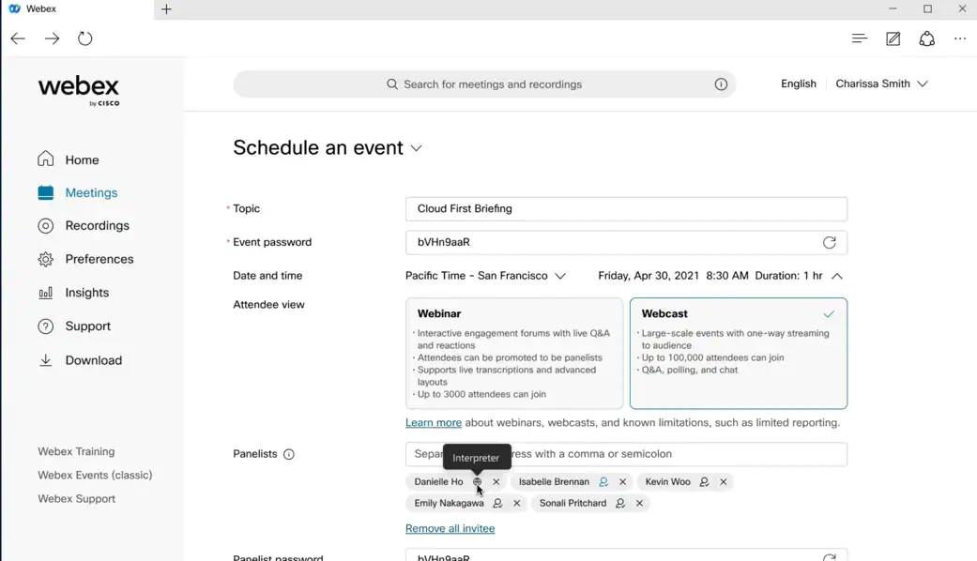

7. Attendee ID changes
To enhance meeting security, we’re changing the length and duration of the Attendee ID used to identify individual meeting participants. Previously, the Attendee ID was a static nine-digit number, in this update we’re changing the Attendee ID to a five-digit number. The new Attendee ID dynamically changes every five minutes.

8. Additional Webex Meetings and Webex Events (New) options
Hosts and cohosts can now set meetings and events options. Presenters without the host or cohost role can't set meetings and events options anymore.
We've added some additional setting to the in-meeting options menu:
- Hosts and cohost can now control whether they want to allow attendees to be able to raise their hands in meetings and events.
- In Webex Events (new), hosts and cohosts can control whether attendees are allowed to see the number of attendees in an event.
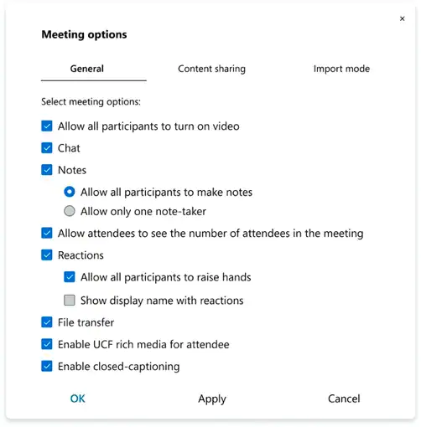

9. Meeting duration clock
We’ve added a meeting duration clock that shows how long the meeting has been running for meetings and events.

10. Speaking while muted prompt for third-party video devices [under the “Device Enhancements” category]
Similar to other Cisco devices, we’re now introducing Speaking while muted prompt for third-party video devices. We’ve all experienced when we mute our line in a meeting, and after a while we start talking, forgetting that the audio was muted. However, people in the meeting can’t hear us.
Say goodbye to these problems, as Webex detects that you’re trying to speak while muted and shows a warning message to remind you to unmute your line.
This capability is for third party standard-based video devices where users mute themselves by using DTMF-*6 command.
When the user has been quiet for more than 60 seconds and has started talking again, the message to unmute themselves is shown on their screen.

11. Respond to host privilege
Webex Meetings and Webex Events (new) desktop hosts can enable or disable participants to from raising their hand. Participants using Android devices can respond to this option.
Webex Meetings and Webex Events (new) desktop hosts can enable or disable attendees from viewing joined attendee’s counts. Participants using Android devices can respond to this option.

12. Notifications to the host when assigning presenter roles to policy restricted users
Starting with the 41.10 update, administrators can set restrictions when their users join external meetings. If an administrator prevents someone from sharing their screen, the restricted users can’t share their screen in the meeting or carry a presenter role.
With this update, the host is also notified when there are restricted users in the meeting and prevents the host from making these restricted users a presenter. The host can also hover over the participants name on the plist which provides the appropriate indication.

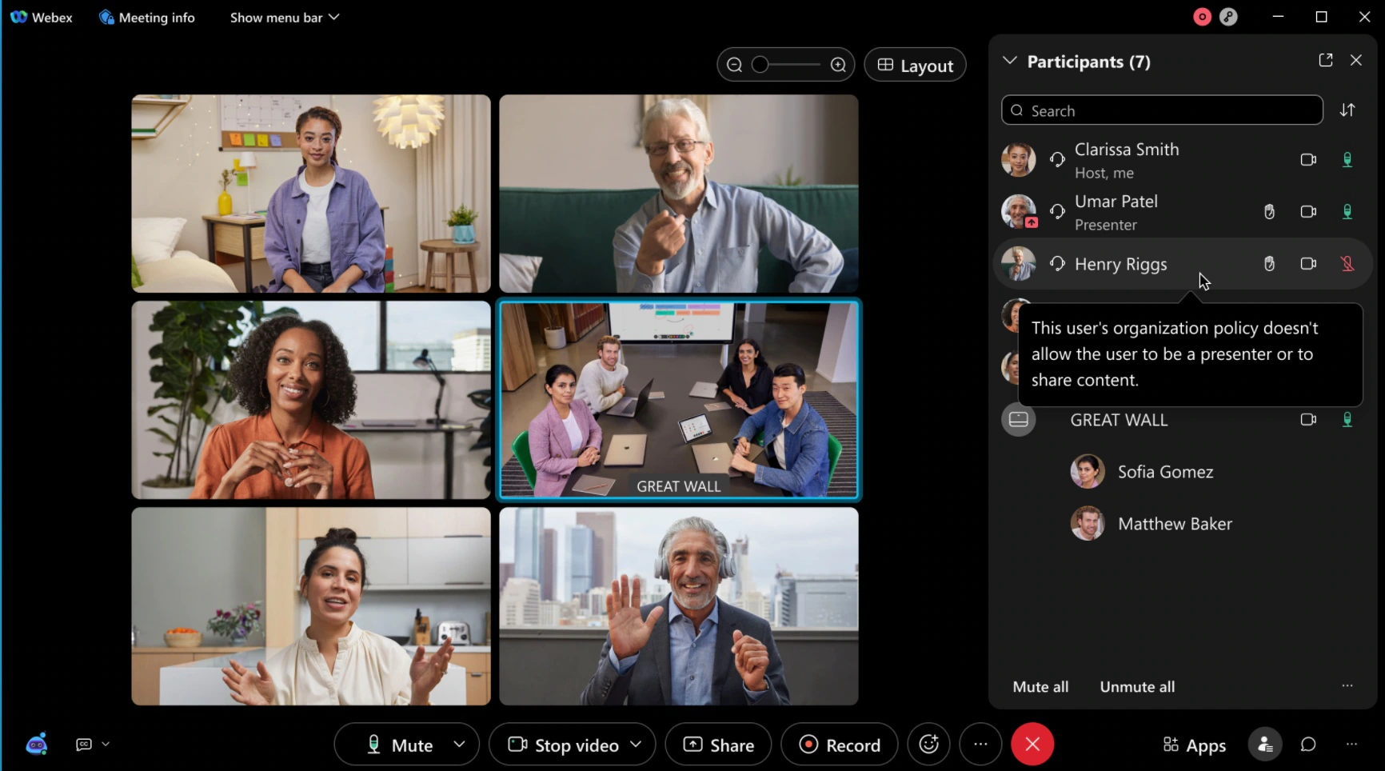

13. Administrator ability to disable Webex Events (Classic)
Administrators now have the ability to disable Webex Events (classic) from their Webex site. This is useful for administrators who’d want their users to use Webex Events (new).
Once disabled, the Webex Events (classic) link is no longer displayed in the left navigation menu. Hosts can still access any of their Webex Events (classic) reports from events they have held in the past.

14. Enable closed captioning and Webex Assistant by default through APIs
This new set of Meetings RESTfulAPIs attributes allow users to set their meeting preference. They can modify such that meetings scheduled by them would enable Webex Assistant or closed captioning by default for all subsequent meetings when the meetings start.

15. Zero Trust security for Webex Meetings and Webex room devices
Superior meeting security is now available using End-to-End (E2EE) Encryption for meetings, including:
- Modern, standards-based cryptography with strong identity verification
- Use Webex room devices (Room Series, DeskPro, and Board)
- Verbal verification of meeting attendees using a new Security Verification Code
- Encryption Key exchange over Message Layer Security (MLS) standard, which uses a nonportable Public Key Infrastructure (PKI) Public-Private Certificate for each user and device
- Media payload encryption using the new SFrame standard
The security icon lets’s you know at a glance, that you’re meeting securely with nobody else being able to connect. The icon also tells you when end-to-end encryption is enabled for the meeting.

Ignored features from the above list:
- Introducing Embedded Apps for Webex Meetings (The Webex Embedded Apps capability enables access to 20+ apps from third-party developers directly within Webex Meetings. In addition, your organization can develop and deploy private apps by registering the apps at the Webex Developer Portal.)
- Rebranding changes and improvements for meeting users on Facebook Portal (Meetings users on Facebook Portal can see changes in icons and button sizes for in-meeting buttons and icons per rebranding changes and Facebook design guidelines.)
- External USB camera support (Webex Meetings Android app now supports external USB camera as another video source.Users can select the video source as front camera, rear camera, and USB camera.)
- Share USB camera video in document sharing mode (Android Meeting app users can now use now use USB camera in content sharing mode and talk to attendees using Android system camera and at same time share USB camera video in content sharing mode like a document camera.)

Webex for Government updates: Webex Events (New) to Support up to 10K Users (Webex Events (new) supports up to 10,000 attendees, dependent on the event's capacity.)

