1. Build your own brand and customization in Webex Events
As a host, you have the option of branding and customizing the attendee Welcome page and Registration page in Webex Events.
For a webinar or webcast, as a host you can customize the attendee landing page and registration page. You can customize the color theme, upload a logo, background, or update the speakers profile with the branding tool.
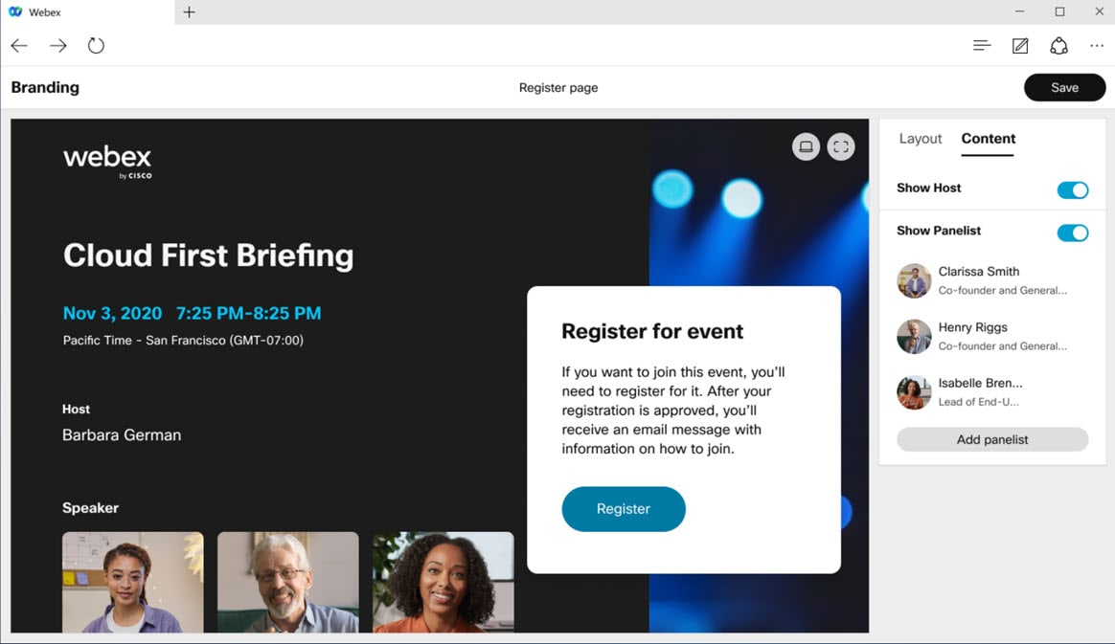

2. Increased number of videos that can be moved to stage

You can now move up to eight additional videos onto the stage (where previous, limit was four). This gives you the ability to keep even more people front and center in your view.
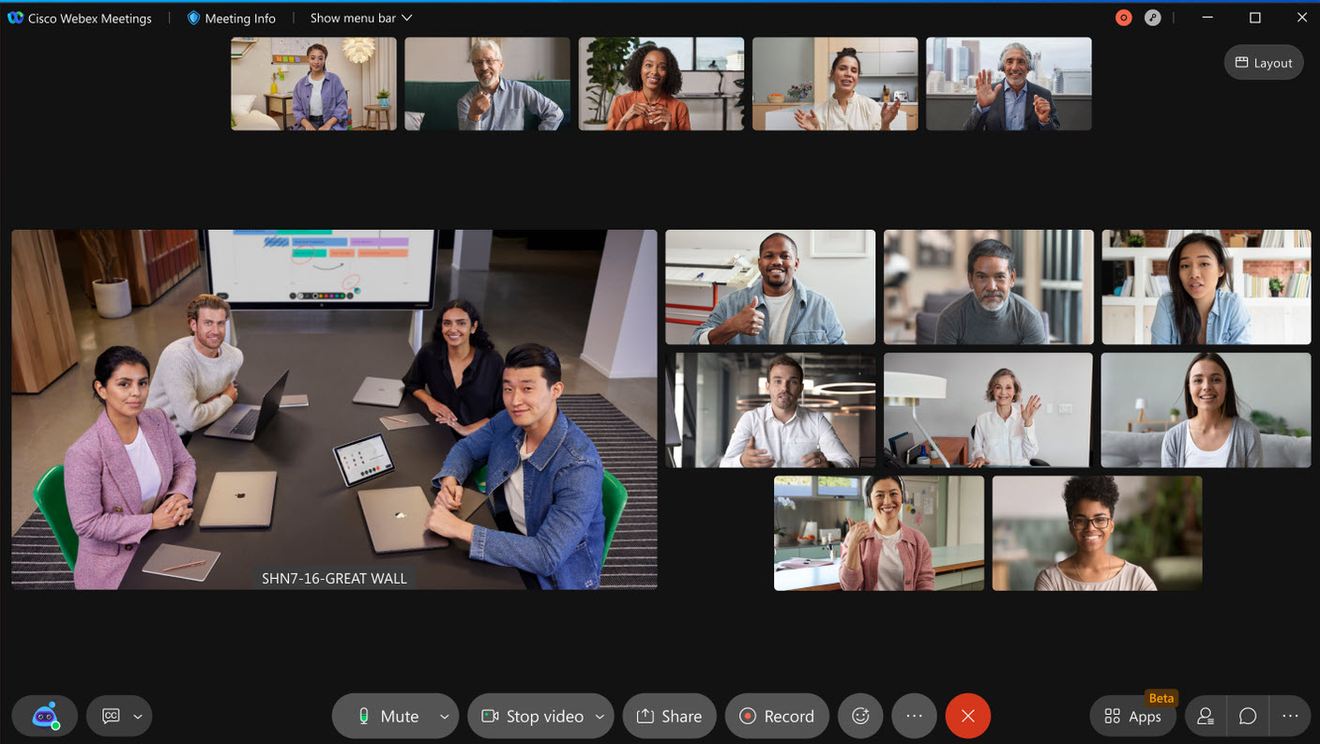
Known Limitations:
  - Web app: Limited to six simultaneous video streams at a time, which means if eight people are on stage, two of them display the profile picture.
  - VDI app: Can show up to eight videos (plus the active speaker) on stage, however the filmstrip is limited to two videos.

3. Pop panels directly from the meeting window
We've made managing panels in the meeting experience even easier! You can now pop out any of the panels directly from the meeting window, without having to go into full-screen view. This makes it easy to float multiple panels, scale them for a closer look, or even move them to another monitor.
Simply click on the pop out icon to float the panel in its own window. Once floating, you can pop panel back into the meeting window at any time, and it snaps right back into place. If you close the panel floating panel, you're able to reopen it from the meeting window. You can even use the panel buttons in the meeting window to close any floating panels.
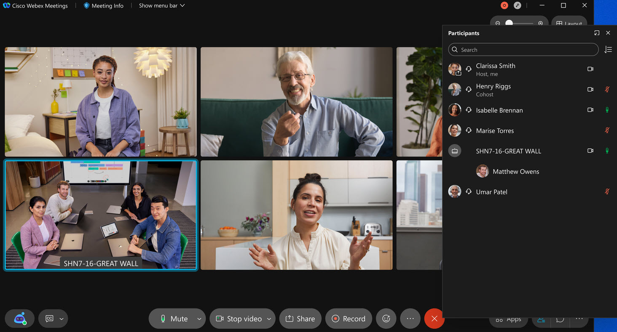

4. Collaboration restrictions for company users joining external meetings

Site administrators, you can now restrict your company users to use certain in-meeting features, that go against your company policies when joining meetings outside of your organization. These features are made read only or blocked for your users:
- File transfer,
- Screen share,
- Annotation,
- Chat, and
- Q&A and Polling.
- You can add your own approved site list to exclude these restrictions. We’ve provided you with a simple toggle in Control Hub to control these features for all users in your organization.
This setting is only applicable to users using your company's claimed domain email address to join meetings. Along with this functionality, site administrators can also control in-meeting experience for any user (including guests) who are using your company laptop (Windows and Mac) and mobile device (iOS and Android) to join external Webex meetings. As a site administrator, you can configure your laptops and mobile devices using registry keys in a way that restricts any user joining meetings using this laptop to adhere to the collaboration restrictions. Simply use registry keys to mass configure and manage your company laptops and mobile devices and use your company's Org ID as a token in the registry key. There are appropriate indication in the meetings to let users know that they are restrictions to use certain features due to their company enforced policy restrictions.

5. Chat with everyone in your Webex webinar

The Chat with everyone option is available in a Webex Events webinar. Hosts, cohosts, panelists, and attendees can view all messages sent to everyone in a webinar. You can disable chat entirely when you schedule an event.
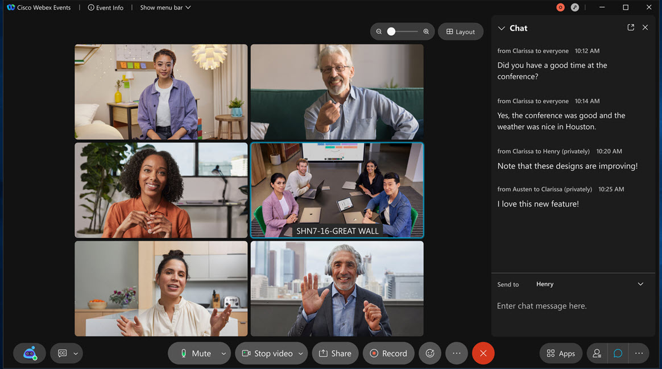

6. Scheduling template available for Webex Events
When scheduling an event as a host, you can choose to save the configuration to a template so that you can reuse it when scheduling future events. The site administrator can also choose to save a template as a standard template for all users on the site.
You can manage your templates in Preferences > Scheduling > Events templates.
As a site administrator, you can manage all standard templates and make any user- created template visible or invisible to everyone for the site in Site Administration > Configurations > Webex Meetings or Control Hub > Configure site > Webex Meetings > Site Options.
Custom registration questions aren’t saved as a part of the template, but they can be saved and reused from My questions when customizing the registration form.
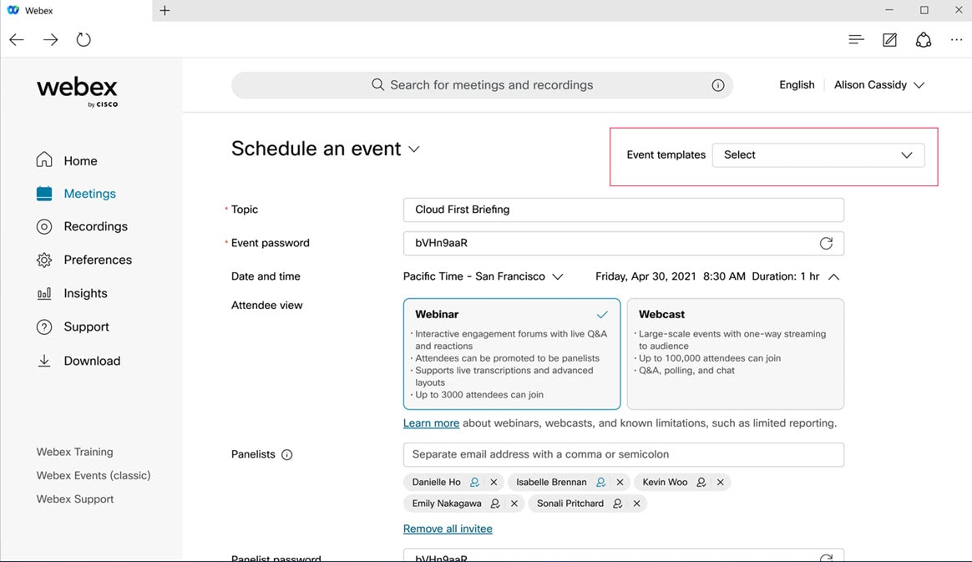
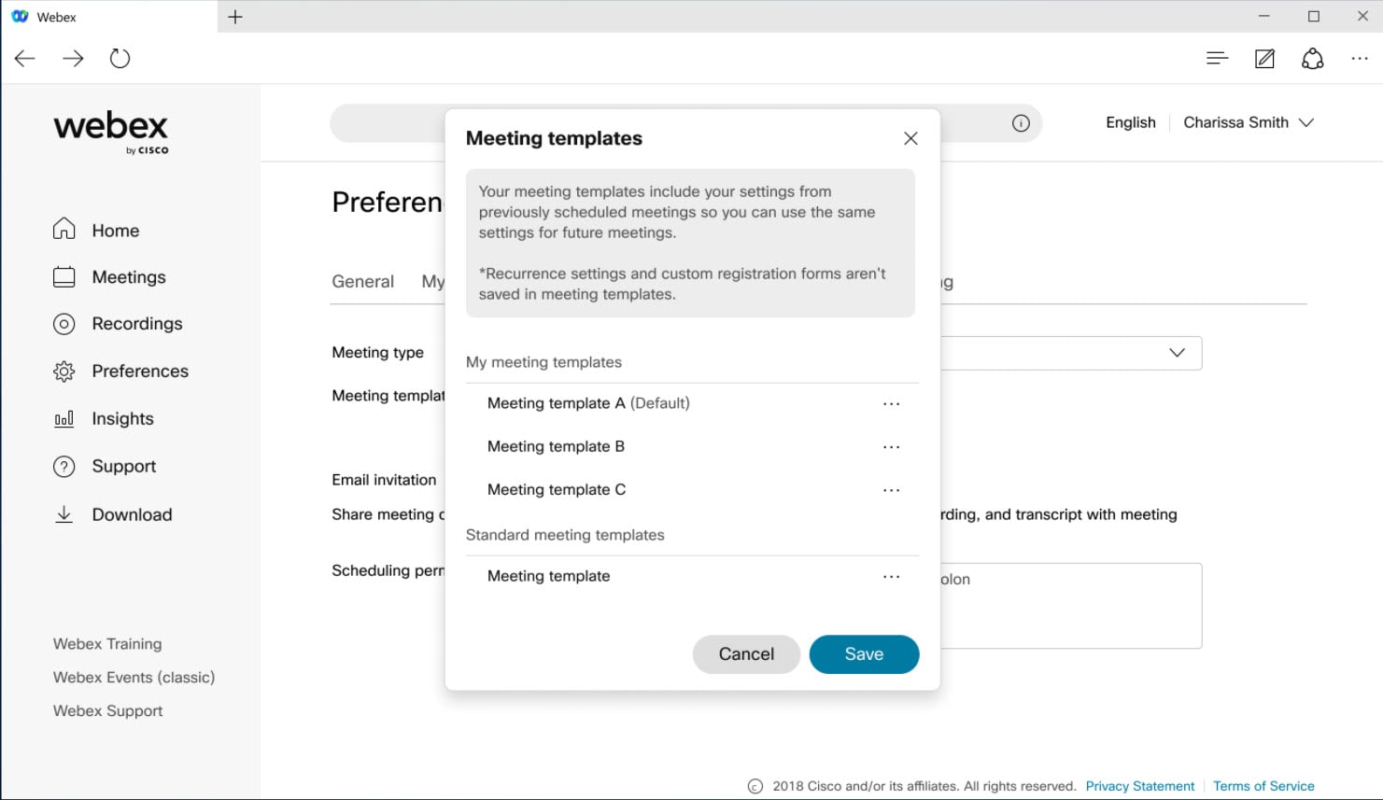

7. Past events report in Webex Control Hub

As an administrator of a site managed by Control Hub, you can export past Webex Events reports in Control Hub > Reports. You have the option to export only the events filtered by date range.

8. Adjust camera brightness
Under the camera settings, there’s a new option to adjust the camera brightness. Enable this feature by checking the box to automatically adjust the camera brightness. This can help with low light or other challenging lighting environments. You can also select Manual in the drop-down menu to enable this feature. This enables a slider control, allowing you to manually adjust the camera brightness level to the desired level.
If the system doesn’t support Hardware Acceleration for video, this option is disabled in the Settings dialog.
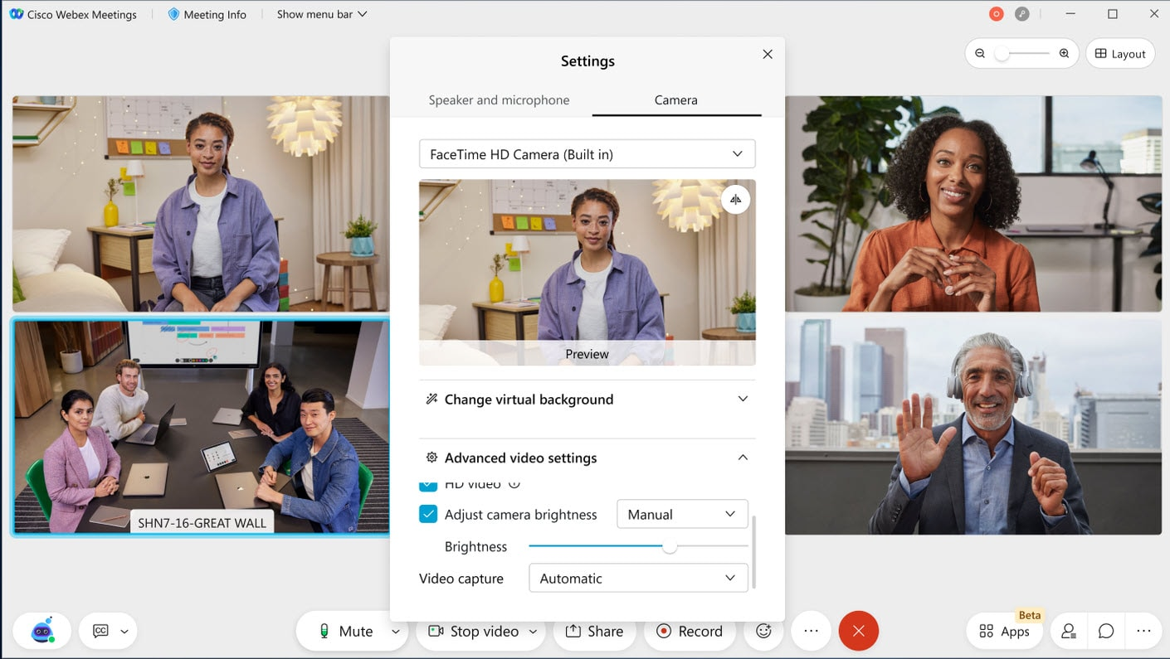

9. Hardware acceleration for video on Mac OS

In the Advanced video settings, there’s a new option to Allow hardware acceleration. This setting is on by default and will use available hardware acceleration for video if available. Requires Mac OS. Disabling this setting forces the use of software-based processing and may have a negative impact on CPU utilization and battery life.

10. Webex scheduled meetings by PSTN host and disable lobby for PSTN host

This feature allows hosts using phone-only to start a Webex scheduled meeting. This capability already exists for Personal Room meetings.
If the site administrator has enabled the following option for Webex scheduled meetings (enabled by default), then the host needs to call from a saved phone number.
For Personal Room meetings, it’s not enabled by default and administrators can enable if needed.
The host can also call from a different phone, but needs to validate the saved phone number by providing the phone number at the time of starting the meeting. This would require the host to have saved a phone number in My phone numbers in Preferences > Audio and Video.
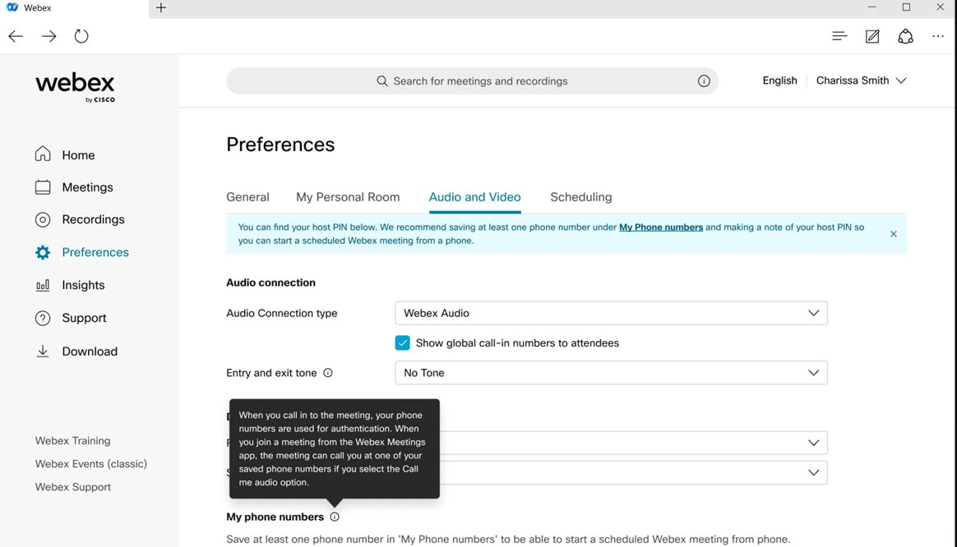
This option provides enhanced security and has been added to Personal Room meetings as well. The Personal Room setting is disabled by default and the site administrator can choose to enable it for Personal Room meetings.
Additionally, the host needs their host PIN to be able to start the meeting.
The host PIN has been moved from Preferences > My Personal Room to the Preferences > Audio and Video
.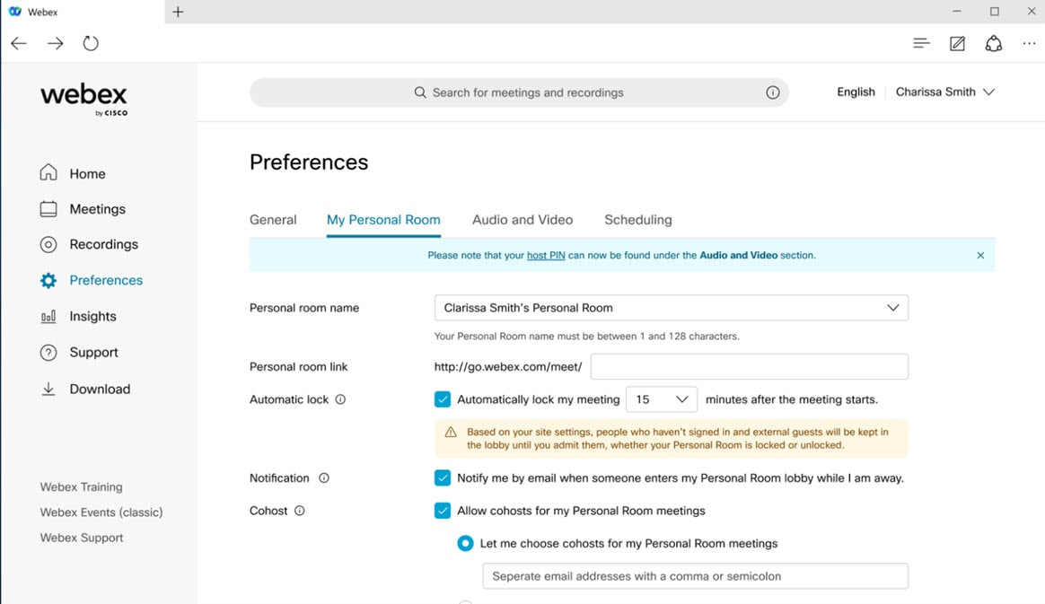
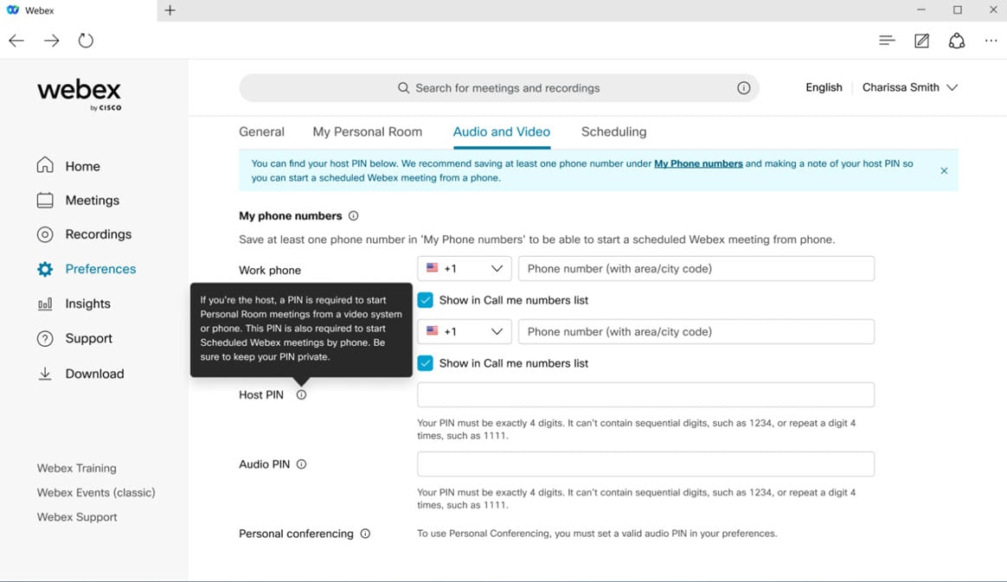
When the host is on phone-only for either Personal Room or Webex scheduled meetings, if the security setting is such that guests can’t get into the meeting directly, then today they are left in the lobby without the ability for phone host to let them in. For a better user experience, the site administrator can now choose if they want to enable the Guests can join without waiting in the lobby when the host starts an unlocked meeting from a phone option to let guests into the meeting directly only when host is on phone. If host is on the app, the guests are still placed in a lobby and the host can view and manage the lobby to let selected attendees in.
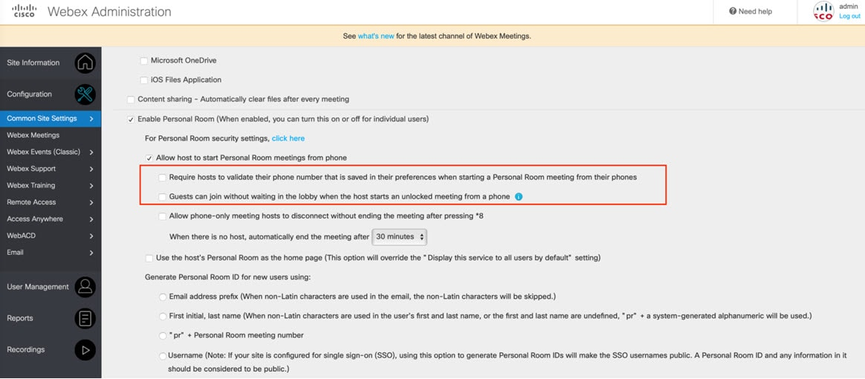
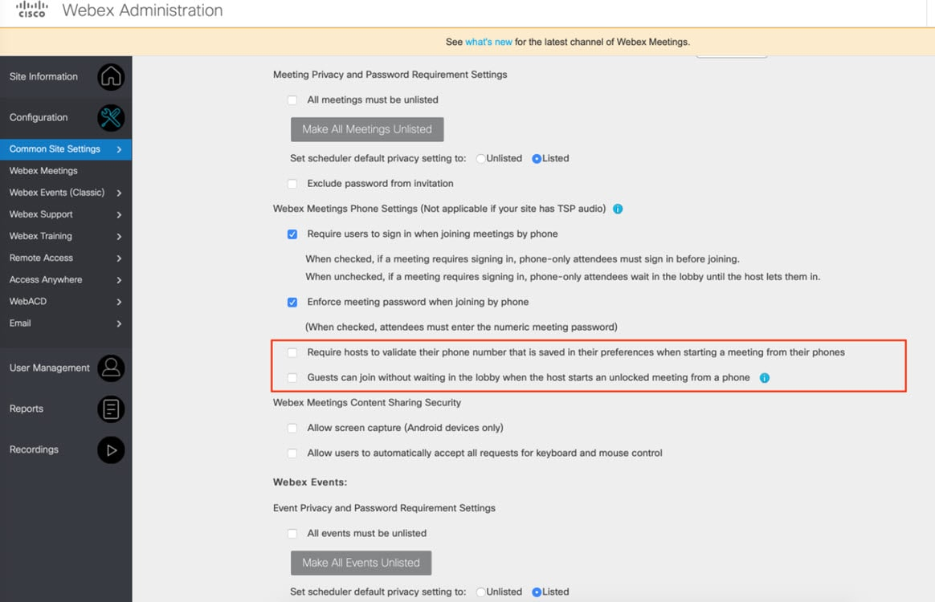
The option can be managed individually for Personal Room and Webex scheduled meetings. By default, this option is disabled and the site administrator can choose to enable it.

11. Start of join a Webex scheduled meeting as a host using your saved phone number
In the 41.8 update, we’ve added the capability for phone only users to be able to start a Webex scheduled meeting from their phone. Users who want to start a Webex scheduled meeting from the phone needs to validate their phone number along with the Host PIN. Save a phone number in Preferences > Audio and Video > My phone numbers to be able to start or join a meeting as a host by phone.

12. Optimized spacing between videos and shared content
We've made some small adjustments to the layout when content is shared to minimize wasted space in between content and video.

13. Improved active speaker switching
We've improved the video response time of the active speaker window on the stage, or when grid view is zoomed in all the way. The active speaker window switches between participant videos more seamlessly as different people in the meeting speak.
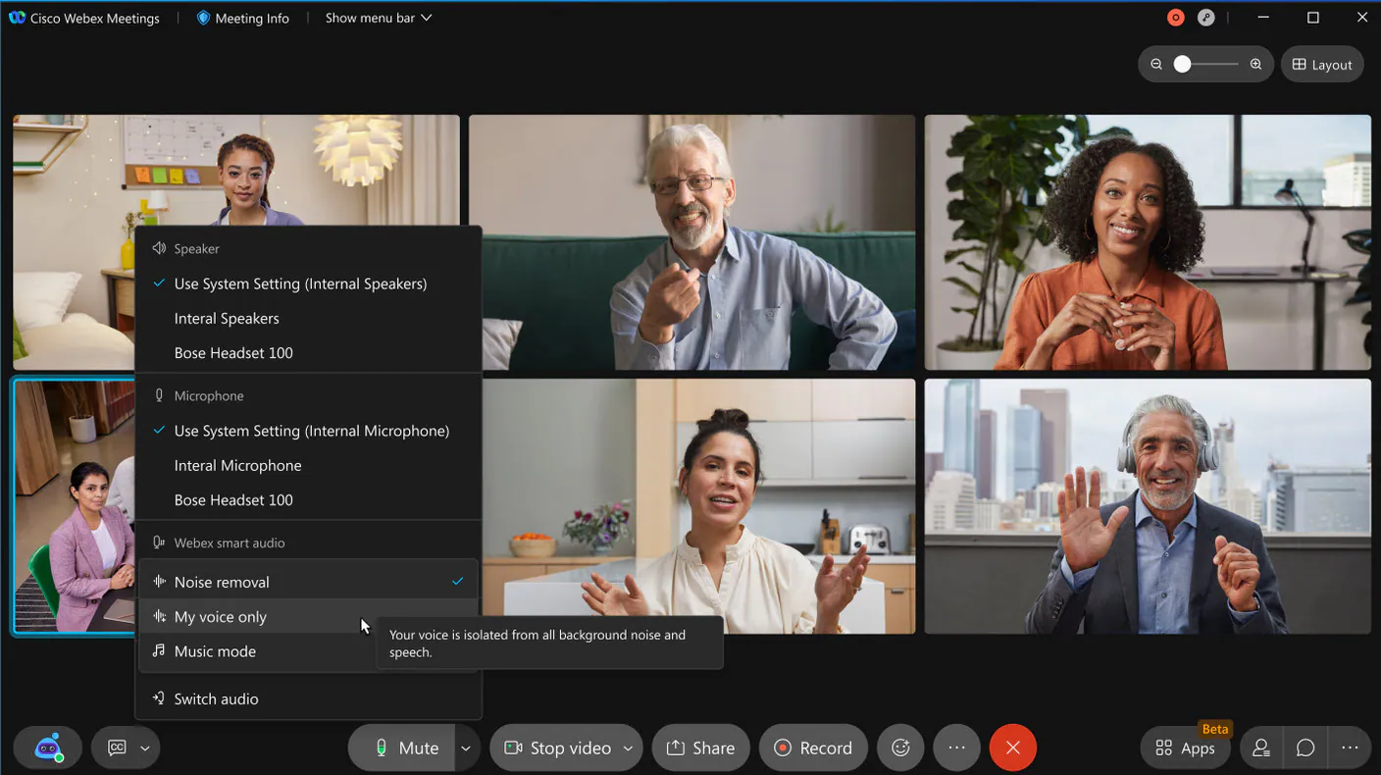

14. Side-by-side mode for dual camera support
Users can share live content through the back camera of their device while remaining a video participant through the front camera of their device. When users use Side-by-Side mode for dual camera, their front and back camera video is combined to one video side by side. The other meeting participants see the participant video that placed the user’s front video and back video side by side at the same time.

Ignored features from the above list:
- Keyboard shortcut optimizations
- Web app: Q&A set priority, mark as answered verbally
- Web App: Q&A Tab Management
- Print friendly format to view usage report
- Display the attendee's actual phone number on the report
- Breakout Session Support for VDI (similar to Webex Meetings desktop app)
- Meetings API support for Webex Events
- Zendesk Integration
- Jira Service Desk Integration
- Name look-up for adding co-workers to a Webex Meeting or Webex Space from Box
- Full mobile support for Webex Outlook add-in
- Enhanced Recording Management (Android users can now rename and delete recordings)
- Resize Stage Video and Content Sharing (Now Android tablet users in 41.5 can resize the video stage and content sharing by dragging the divider horizontally)

