1. Improved toolbar for shared content
We’ve made interacting with shared content easier by moving the tools (from a fade-out side bar) into a dedicated toolbar above the stage so you can access it at any time.
You can now see who's sharing content, zoom in or out, open the annotation tools, and more–without blocking your view of what's being shared.
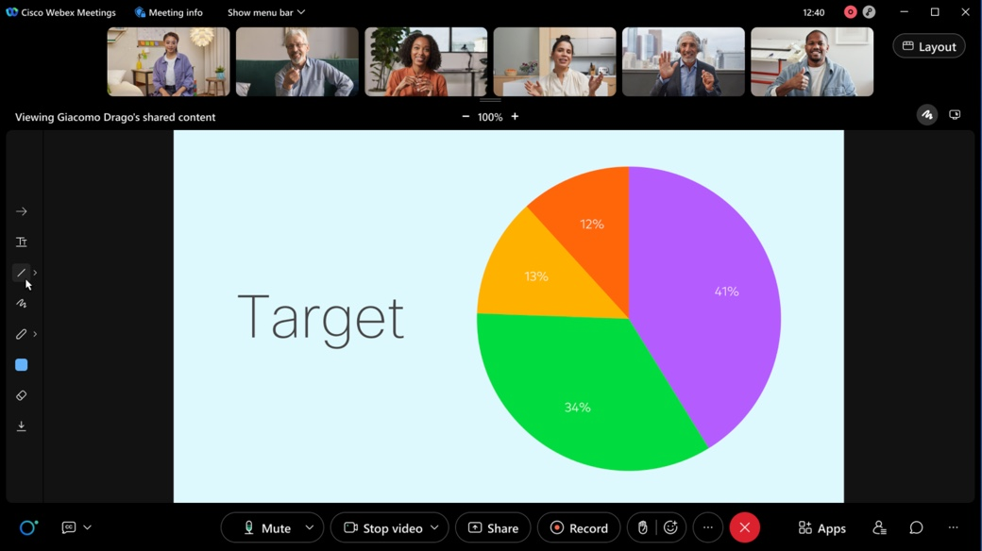

2. Move Webex Meetings from your desktop to mobile app using a QR code
We are introducing the Move Meeting to Mobile feature where users can scan the QR code using their mobile camera and move their meeting to Webex Meetings mobile app without disrupting or disconnecting the meeting.

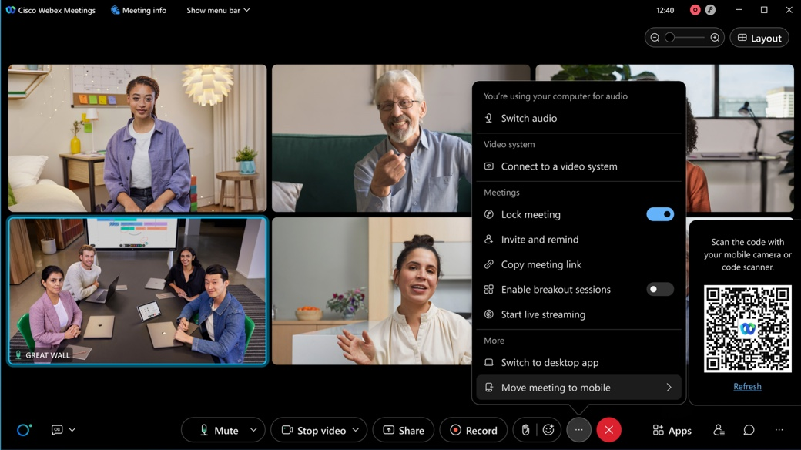

3. Redirect attendee to a URL address after a meeting or webinar
Host can enter a URL address when they set up the meeting or webinar. Attendees can now be forwarded to a landing page after a meeting or webinar ends. This is a way to direct your audience to a survey, invite to next meeting or webinar, a thank you page, or information on event sponsors. This provides the opportunity to keep the attendee engagement going even after the meeting or webinar has ended.
This ability doesn’t apply to webinars with webcast view for attendees.
For security reasons, the domains approved by administrator can be saved here. You can work with your administrator to ensure the domains you need are approved. Otherwise, you'll see an error message when you enter the URL and the URL won’t be saved in your meeting or webinar information page.
Administration experience
As site administrators, for security reasons, make sure that you provide a list of domains so that the users can save the URLs containing the domains. Without the approved domains, the users won't be able to save any URL due to security considerations. For example, here are a few domain types for your consideration, survey domains (qualtrics.com, surveymonkey.com, typeform.com, to name a few), and your company's domain(s).
Site Administration
- Go to Site Administration > Common Site Settings.
- In the Allow the following URL domain names enter the domain names.
The URL containing the domains are considered approved so that the users can save them.

4. New option for high fidelity content sharing

Optimize for 3D is a new sharing optimization that is available to customers upon request to your Customer Success Manager. This feature uses additional bandwidth to reduce color artifacts when sharing high fidelity 3D models. The increased quality can aid in real-time collaboration for other types of content including Computer Aided Design and Medical Imaging.
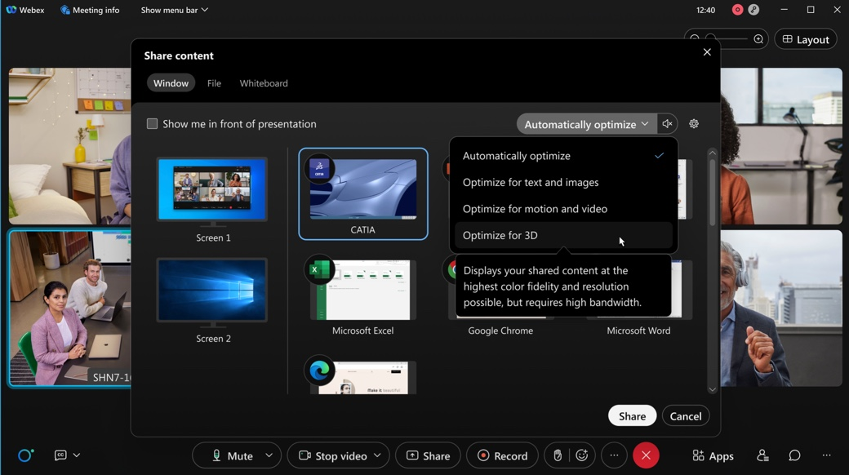
This feature is only supported for Webex Meetings (Windows and Mac) desktop app.
If any other apps or devices join the meeting, the quality is reduced for all participants to normal levels. The quality is also reduced to normal levels if the meeting is recorded.
Once enabled, the Optimize for 3D option appears in the drop-down selection on the Share Content dialog. This optimization is not used when Automatically Optimize is selected.
This feature is turned on by request only.

5. Ability to share application windows instead of the whole desktop
This feature optimizes the Webex Meetings content sharing experience while sharing an application. Previously, when the user shared applications it would share the entire screen and mask areas outside of the application window. With this update, the receiving user sees the individual windows of the shared application and not the entire masked desktop screen.
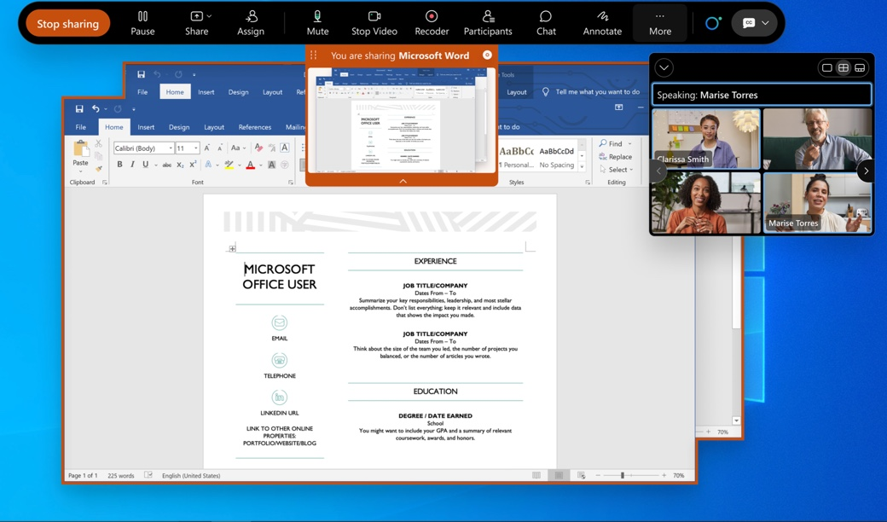

6. A new Share tab added to Meeting Settings
In this update we’ve added a new Share tab to the Meeting Settings dialog. This is the new location for all relevant share-based preferences. One new setting is added for the Optimization for shared content. Currently, the Webex Meetings desktop app defaults to Automatically Optimize each time you share. Updating this preference allows you to control the default optimization that appears when the share dialog is opened.
This feature is to unify fragmented sharing settings into the unified preference to align with the Webex App. It offers a new setting under sharing section to configure the by-default sharing type. This setting could be entered using the new setting icon on the sharing dialog.
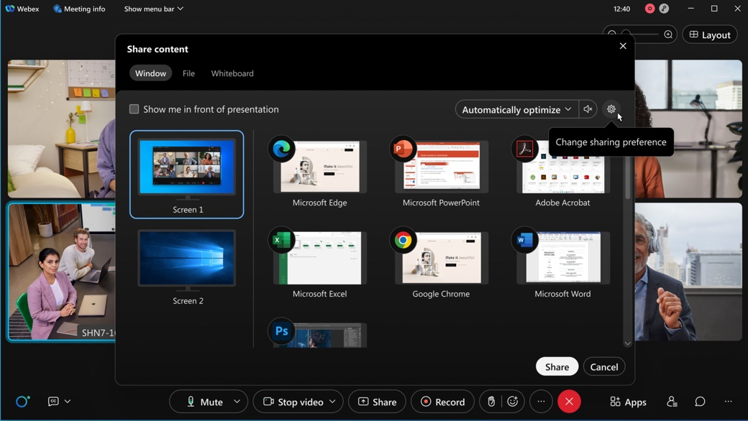

7. Slido open-text polls
A few visual and functional improvements are coming in March/April. As a presenter, you’ll be able to control the flow of incoming open-text responses more seamlessly. Also, we’re adding the option to display respondents’ names attached to their open-text answers. Respondents can decide if they want to submit their name or not, and the Slido administrator can decide if they want to allow the names when setting up the poll.
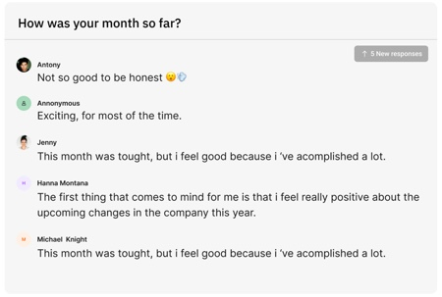

8. New name label style for meetings and devices
We've made some small, but effective changes to the style of the name labels in the video windows. So that they don't cover up as much, particularly in smaller window sizes. Name label styles are being updated to better align better with the rest of the Webex portfolio for users joining from video devices.
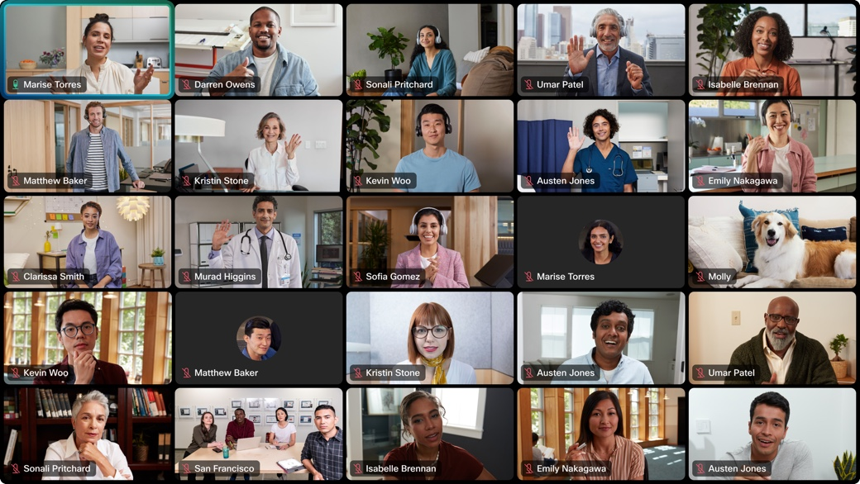
This visual update applies to on-premises registered video devices, older cloud video devices including SX, MX and DX series video devices, as well as meeting recording and streaming.

9. Collaboration restrictions for your company users joining meetings from a Chrome browser
IT administrators can apply all e-compliance controls using templates in Control Hub at user, group, and org level for joining meetings from the Chrome browser.
IT administrators can add the token to the new Chrome extension, then push the extension to all devices in the organization. All the compliance controls that are applicable to the user joining both internal and external meetings using the Webex Meetings desktop app are now applicable when they join meetings from the Chrome browser as well.

10. The administrator can search and delete the obsolete meetings on Control Hub
A host may schedule meetings but for some reason, can’t delete the meetings by themselves. For example, if the host leaves the company, then the administrator should have an ability to find the meetings and delete them. On Control Hub, the administrator can search for the scheduled meetings per the host user's name or meeting number, and then delete them.

11. Remove bot installation from 1:1 conversation
Schedule meetings from the Webex messaging extension in channels, group chats, or private chats without having to install the Webex bot. When you schedule a meeting, the meeting information appears in the conversation or chat message for others to join from.

12. Meetings Quality APIs (Webex for Government updates)
Meetings Qualities API allows an administrator to pull detailed quality and troubleshooting information about a meeting (both recently occurred and currently occurring). This powerful API allows customers to create their own supportability tools and integration for their organization.

Ignored features from the above list:
- Picture-in-Picture support for Webex Meetings iPhone users Similar to iPad, iPhone users can use the iOS picture-in-picture (PiP) feature. With direct PiP support, users can now multitask with other apps on their iPhones while watching the meeting window or shared content.
- Slido updates There are several Slido enhancements coming this month. See the In-meeting experience section for more information.For more product details see https://community.sli.do/product-news-23. Slido releases are not dependent on the Webex upgrade cycle.
- Web App: Send 1080p Video in the Chrome, Firefox, and Edge Browsers Users joining from the Webex Meetings web app from the Chrome, Firefox, and Edge browsers can now send up to 1080p video in meetings and webinars.
- New Slido administrator sidebar in Webex The new side bar was made available in February as a toggle which you can turn on to try the enhanced polling experience. In April, the quiz feature is also supported in the new sidebar, followed by making it the default experience. Details and visuals can be found here: https://community.sli.do/product-news-23/slido-in-webex-has-a-new-look-1527.
- Slido accessibility improvements In the February update, the Slido participant mode was improved in terms of accessibility. Some visual changes were made, as well as support for Voice Over. Additionally, Slido has the VPAT (Voluntary Product Accessibility Template) available now: https://www.cisco.com/c/dam/en_us/about/responsibility/accessibility/downloads/vpats/VPAT_Cisco_Slido-Web-App_Jan2022.pdf.
- GIF and MP4 animation virtual background support Similar to desktop, iOS mobile apps now support GIF and MP4 animation in virtual backgrounds.

Support for scheduling meetings for on-premises hybrid exchange If your Microsoft Teams account uses hybrid Microsoft Exchange, you can now schedule meetings from the Webex tab, a private chat with the Webex bot, or from the messaging extension.

