https://help.webex.com/en-us/article/xcwws1/What's-new-for-the-latest-channel-of-Webex-Meetings#Cisco_Generic_Topic.dita_9ecf7419-110f-4145-a7c0-46d092838110

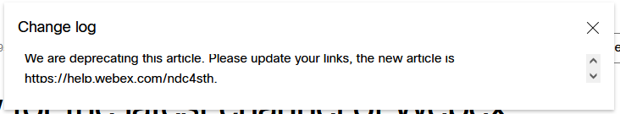

https://help.webex.com/ndc4sth

