Classroom Notes on Neoplatonism and Ontic Order
Aristotle’’.’’’’s square of Opposition
General and species in the world (sets) are ordered by ⊆

A: Ever S is P E: No S is P
S⊆P S∩P=∅
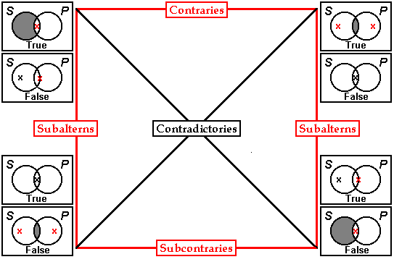
I: Some S is P O: Some S is not P
S∩P≠∅ S−P≠∅
*Properties in red are do not hold in modern logic, holds if term stands for a non-empty set.

Order expressions in natural language that do not conform to the grammar or logic of sets, and that motivate the Neoplatonic conception of order.

(E1) It was not just cool; it was hot.
He was hot, so he was at least warm.
It was certainly hot [enough to …] because it was boiling.
It wasn’t boiling because it wasn’t even hot.
(E2) Logical Truth: something that is warm is at least as hot as something that is cool
a is warm and b is cool logicall implies a is hotter than b
b not as warm a logicall implies a is at least as hot as b to
(E3) It is difficult/*easy for him to admit he was ever wrong.
It is dangerous/*safe for him to do anything like that, ever
(E4) He has eaten more than he is happy /*unhappy to acknowledge.
He has less money than he his willing to be frank/*secretive about.
(E5) no, it’s not cold it’s freezing;
no, he isn’t just thoughtless, he’s immoral;
no it isn’t just boring, it’s unsightly.
(E6) no, it’s not hot, it’s boiling;
no, she isn’t just pretty, she’s ravishing;
no, he wasn’t simply doing his duty, he was heroic.
Quotations from Neoplatonic Philosophers indicating their conception of order.

(Q1):…the higher cause (aitioteron), being the more efficacious (drastikoteron), operates sooner upon the participant (for where the same thing is affected by two causes it is affected first by the more powerful (dunatoteron); and in the activity of the secondary the higher is co-operative, because all the effects of the secondary are concomitantly generated by the more determinative cause (aitioteron). … .All those characters which in the originative causes have higher (huperteran) and more universal (holikoteron) rank become in the resultant beings, through the irradiations which proceed from them, a kind of substratum for the gifts of the more specific principles (merikoteron).

(Q2): Being, after all, is the classic case of assertion whereas Not-Being is of negation…. So then in every class of Being, assertion in general is superior to negation. But since not-Being has a number of senses, one superior to Being, another which is of the same rank as Being, and yet another which is the privation of Being, it is clear, surely that we can postulate also three types of negation, one superior to assertion, another inferior to assertion, and another in some way equally balanced by assertion.

In truth my view is that negations come in three sorts, one sort is for beings of a form more fundamental than affirmations. These are generative and perfective of those things generated in affirmation. Another type is placed at the same level as affirmations, and here affirmation is not in any way more worthy than negation. Finally, there are those with a nature inferior to affirmations, namely privations of affirmations.

(Q3): But contraries in the Heavens naturally coexist. The motion of the Same is contrary to the motion of the Other, but the same thing (the heavens) is moved in both ways, and when it is moving in one way, it does not abandon the other motion.
….
But the contraries in Intellect, being unified to the highest degree, partless and immaterial, and constituted as a single form, are creative in company with one another….In sum the contraries in Matter flee one another, those in the heavens co-exist.

(Q4):…the negations generate the affirmations.

[Explanation: Let ∼ be hyper and ¬ privative negation, let ≤ indicate “causal” or “ontic” order.

All ∼A is ∼B iff All A is B iff All ¬A is ¬B, or

∼A≤∼B iff A≤B iff ¬A≤¬B.

Note on the traditional definition of “privative negation”: Aristotle, Metaphysics (1022^{b}25): [Privation] means such a lack in being of class of beings which normally possesses that property; for example a blind man and a mole are in different ways “deprived” of sight: moles as a whole class and of animals are so deprived, whereas only individual men are. (See Categories 11^{b}15, Topics 109^{b}18, Metaphysics 1022^{b}29.) ]

(Q5): Only this cause [viz. the One], to the extent that it preexists beings [viz. entities caused by the One], we celebrate [i.e. describe] by negations alone [ie. we describe the One only negatively, e.g. ∼A≤1, A≤¬1], while at the same time under the negative mode and under the affirmative mode [i.e. by both positive and negative predicates], we reveal the hights that have proceded [from the One, viz. the effects of the One] in an way analogous to this cause: to the extent that they have a transcendent superiority over inferior beings [to the extent that an effect A of the One is cause of further effects B], we reveal them in a negative mode [in propositions like ∼A≤A, B≤¬B, where B=∼A and A=¬B], but to the extent that they possess part of the beings that procede them [i.e. to the extent that the effect B is a privation or “part” of its cause A], we reveal them in the affirmative mode [in a proposition like A≤B].
…It is necessary that the principal thing [archen] be either one or many, for it is rather from here one must begin. And if many, then sympathetic to one another or scattered from one another, and either completed or limitless [aperious, α-privative]. If one, it will be either a not being (me, intensifier) or a being; and if a being, either that in a body or a non-body [asomaton, α-intensivum, hypernegation], and if a non-body, then either separated from bodies or non-separated [axopiston, α-privative], and if separated, either moved or unmoved [akineton, α-intensivum, hypernegation]; and if not a being [me ousian, intensifier, hypernegation], either weaker with respect to all being or participated beneath being, or unparticipated [amethekton, α-intensivum, hypernegation].

The Principal Thing

One Many

∼Being Being Sympathetic Scattered

∼Participated Participated Weaker ∼Body Body Completed ¬Limited

Separated ¬Separated

∼Moved Moved

(Q6):The One = ∼ (The One in Being)
The One in Being = ∼ (The Intelligible Whole)
The Intelligible Whole = ∼ (The Intelligible Many)
The Intelligible Many = ∼ (The Intelligible Number)
The Intelligible Number = ∼ (The Composite)
The Composite = ∼ Shape
Shape = ∼ (The In-Itself and In-Others)
The In Itself and In Others = ∼ (The In Motion and Rest)
The In Motion and Rest = ∼ (The Same and Different)
The Same and Different = ∼ (The Like and Unlike)
The Like and Unlike = ∼ (The Touching and Not Touching)
The Touching and Not Touching
(Q7). Prop 21. Every order has its beginning in a monad and proceeds to a manifold co-ordinate therewith; and the manifold in any order may be carried back to a single monad.
Prop. 100. Every series of wholes is referable to an unparticipated first principle and cause; and all unparticipated terms are dependent from the one First Principle of things.

(Q8):Prop. 67 Every whole is either a whole-before-the parts, a whole-of-the parts, or a whole-in-the-part.
Prop. 81. All that is participated without loss of separateness is present to the participated through an inseparable potency which it implants.
For if it is itself something from the participant and not contained in it, something which subsists in itself, then they need a mean term to connect them, one which more nearly resembles the participated principle than the participant does, and yet actually resides in the latte… Accordingly a potency or irradiation, proceeding from the participated to the participant, must link the two; and this medium of participation will be distinct from both.

(Q9)

Intelligible-Intellectuals, Book IV,13-20

Being [ousia] Life [zoe] Intellect [nous], 13:9, 14:4 Contact [anaphes]
Super Celestial [huperouranios] Celestial [ouranios] Subcelestial [hupourarios] 18:12-16 40:18-27
∼Color [achromatos] , 41:3 Color [chromatos] Color [chromatos]
(∼∼Figure [aschematistos] ∼Figure [aschematistos] 40:5-10 Figure [schematistos]
∼∼∼Contact [anaphes]) (∼∼Contact [anaphes]) ∼Contact [anaphes], 40:13-17

Intelligible Intermediate Intellectual Being Life Intellectual Permanence Procession Conversion
Science Wisdom Justice 18-22 24-25
22-23,
44:20, 48:18

Figure 1
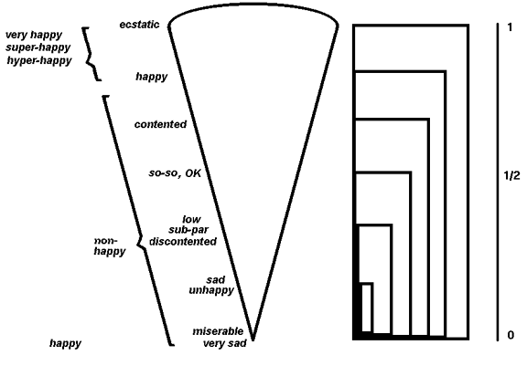

Klenne's Strong ║~║∨│0 ½ 1 ║∧│0 ½ 1 ║→│0 ½ 1
Connectives, ─╫─╫─┼──────╫─┼──────╫─┼──────
∨ is maximum 0║1║ │0 ½ 1 ║ │0 0 0 ║ │1 1 1
∧ is minimum ½║½║ │½ ½ 1 ║ │0 ½ ½ ║ │½ ½ 1
1║0║ │1 1 1 ║ │0 ½ 1 ║ │0 ½ 1

John N. Martin, Themes in Neoplatonic and Arisitotelian Logic (Ashgate, 2004).
Propositions 70 and 71, in Dodds, E. D., ed. and trans., Proclus, The Elements of Theology (Oxford: Clarendon Press, 1963, 2nd ed.).
P. 426, Proclus, Proclus' Commentary on Plato's Parmenides, trans. John M. Dillon Glenn R. Morrow (Princeton, NJ: Princeton University of Press, 1987).
Vol. II:5, 38:18-25, Proclus, Théologie Platonicienne, trans. H.D. Saffrey and L.G. Westerink, vol. I-VI (Paris: Les Belle Lettres, 1968-1997). Author’s translation.
IP 740:6-11and 23-30, M&D 114.
IP 1099:32-35.
PT IV:11, S&W 37, 21-27.
PT II:2; S&W p. 15, author's translation. See note S&W p. 84.
See also PT III:8, S&W 31:20-23, and III:9, S&W 39:20-40:1, and the discussion in Lucan Siorvanes, Proclus: Neo-Platonic Philosophy of Science (New Haven: Yale University Press, 1996)., pp. 102-105.
ET 64 and 76. See also PT III:8, S&W 31:20-23, and III:9, S&W 39:20-40:1, and the discussion pp. 102-105 in Siorvanes (1996).

