 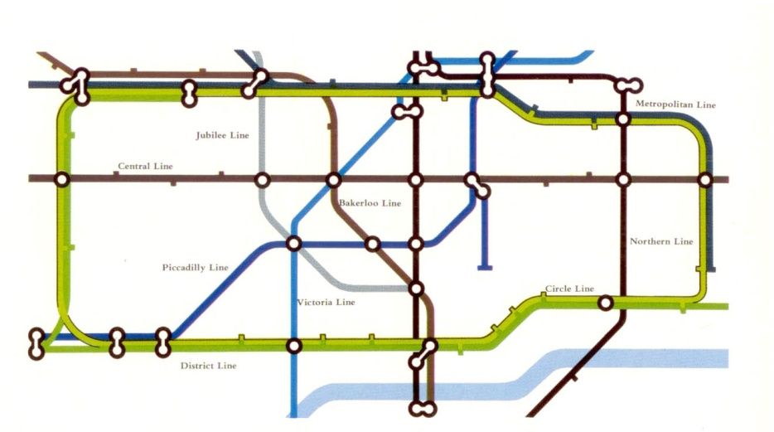

Normal Pantanopes (red defective cones)

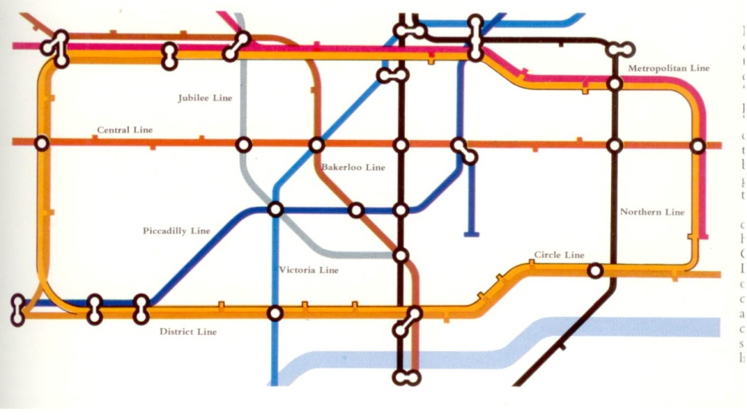 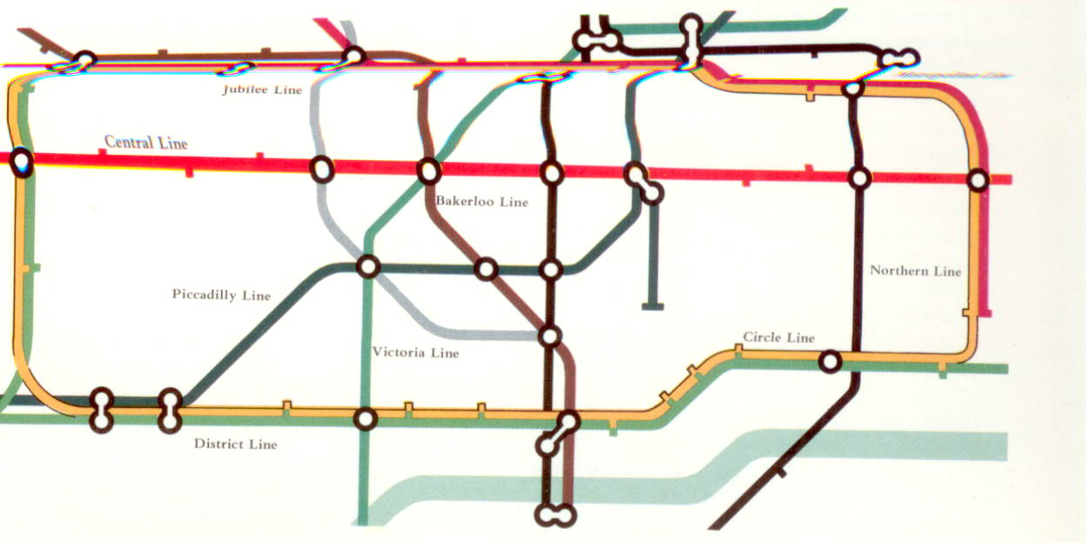

Deuteranopes (green defective cones) Trianopes (blue defective cones)

Helen Varley (ed.), *Colour* (London: Marshall Editions, 1980)