Beauty in Plato and Neoplatonism 5/17/2012

Counter-intuitive Neoplatonic Theses:
There is only one thing in the universe.
Time, space, and change are unreal.
Existence, beauty, goodness, causal power are all the same.
Physical causes are not anterior physical events but ideas in God’s mind.
It is one’s moral obligation is to eschew worldly activity and engage in contemplation of ideas.
Evil is unreal.

History: Plato 427-347 B.C., Plotinus 204/5–270 A.D., Augustine of Hippo 354-430, Proclus 412–485, Pseudo-Dionysius the Areopagite late 5th Cen, John Scotus Eriugena c.815–c.877, Bernard of Clairvaux 1090 –1153, Ficino 1433–99, Pico della Mirandola 1463–94, Cambridge Platonists 1633-1688, Malebranche 1638 –1715, Pope 1688–1744, Schiller 1759–1805, Emerson 1803 –1882, St. Louis Platonists 19th Cen.
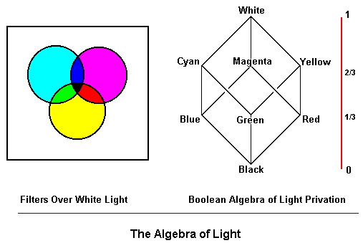
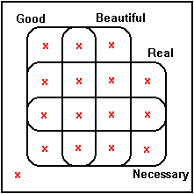

Scalar Families (comparative adjective, adjective series, mass noun)
happier than: ecstatic, happy, content, so-so, down, sad, miserable Happiness
hotter than: boiling, hot, warm, tepid, cool, cold, freezing Heat
taller than: giant, tall, normal, short, tiny Height
adamantine, hard, solid, firm, tangible, soft/weak, wispy/evanescent Hardness
riveted, attentive, awake, wandering, dreamy, asleep Wakefulness
brilliant, smart, pedestrian, dull, stupid Intelligence
absolute, substantial, subsistent, insubstantial, unreal Reality
all, most, some, rare, unheard of Universality
eternal, occasional/intermittent, never Durability
necessary, likely/probable, possible, unlikely/improbable, impossible Necessity
supererogatory, good, neutral, bad, evil Goodness
heroic, brave, dutiful, cowardly, craven Courage

The Happiness Scale

hyper-happy non-happy un-happy
1 …. ecstatic happy content so-so discontent sad miserable…. 0

m n e -n -m

Scalar Negations
Contradictory Negation (Boolean Complementation in set theory)
−A not happy
Contrary Negation (Relative Complementation in set theory)
non-A non-happy
Mirror Negation
un-A unhappy, discontent, illegal
Hyper-negation
hyper-A hyper-active, super-saturated

Privative Negation
sub-A hypo-active, subnormal, subhuman

Linguistic Tests for Scalar Order

Order Tests
for P ≥
P implies x is at least
x is at most implies x is not P

Positivity/Negativity Tests

Only positive adjectives have grammatical mirror negation:
happy, unhappy *unsad, sad
polite, impolite *unrude, rude
modest, immodest *unslutty, slutty
substantial, insubstantial *unrickety, rickety
honest, dishonest *uncrooked, crooked

Negative Polatity Items. Only “negative” adjectives – those interpreted over the negative part of the scale – are grammatically acceptable in contexts that contain so-called negative polarity items. E.g. words like ever, any, at all, still and yet:
It is difficult/*easy for him to admit he was ever wrong.
It is dangerous/*safe for him to do anything like that, ever
Complements of Comparatives. A second test is that only “positive” adjectives are acceptable in complements of some comparatives:,
He has eaten more than he is happy /*unhappy to acknowledge.
He has less money than he his willing to be frank/*secretive about.
An inanimate object possesses too little being to be causally effective/*ineffective
Matter has too little substance to be beautiful/*ugly
The corporeal is less substantial than the truly beautiful/?ugly
Unacceptable “Positive” Modifiers. In the examples below the negative polarity terms have what philosophers would traditionally count as having evaluative readings:
It is really ugly/*beautiful that he is still doing anything like that
It was evil, immoral/*noble, *virtuous that he behaved at all like that
yet he did it
This inanimate thing is only material/*spiritual yet it is still caused by the One
Measure Phrases. If a scalar family describes a quantitative order, positive scalars, but not negative, may be modified by measure phrases.
He is five years old/*young
He is six feet tall/*short

See Plato Symposium, Plotinus Eneads I.6 “On Beauty”, Guy Sircello, A New Theory of Beauty (Princeton, 1975). On Neoplatonism and scalar logic see for example John N. Martin, “The Lover of the Beautiful and the Good: Platonic Foundations of Aesthetic and Moral Value”, Synthese, vol 164:1, November 2008, pp. 31-51.
For an account of this and the test below that uses measure phrases see Pieter A. M. Seuren, “The Structure and Selection of Positive and Negative Gradable Adjectives.”
In general, technical vocabulary, like that of science, tends to neutralize the polarity of adjectives that have “positive” polarity in ordinary usage. The Neoplatonic quasi-technical vocabulary has a similar effect.

