The Four Humors. Derived from Hippocrates, Aristotle and Galen.

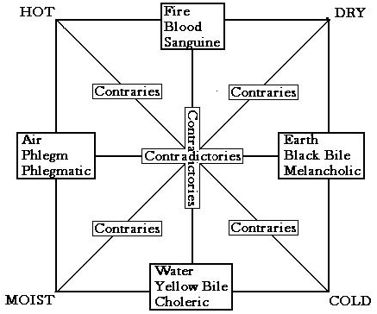

Humour | Body substance | produced by | Element | Qualities | Complexion and Body type | Personality
Sanguine | blood | liver | air | hot and moist | red-cheeked, corpulent | amorous, happy, generous, optimistic, irresponsible
Choleric | yellow bile | spleen | fire | hot and dry | red-haired, thin | violent, vengeful, short-tempered, ambitious
Phlegmatic | phlegm | lungs | water | cold and moist | corpulent | Sluggish, pallid, cowardly
Melancholic | black bile | gall bladder | earth | cold and dry | sallow, thin | Introspective, sentimental, gluttonous

