Neoplatonism Philosophy and Religion 1/15/2013

Counter-intuitive Neoplatonic Theses (which make Neoplatonism implausible):
There is only one thing in the universe.
Time, space, and change are unreal.
Existence, beauty, goodness, causal power are all the same.
Physical causes are not anterior physical events but ideas in God’s mind.
It is one’s moral obligation is to eschew worldly activity and engage in contemplation of ideas.
Evil is unreal.

History: Pythagoras c. 570-495 B.C., Plato 427-347 B.C., Philo Judaeus c. 20 B.C. – 50 A.D., Hermes Trismagistus, 1 cen A.D., Plotinus 204/5–270 A.D., Augustine of Hippo 354-430, Proclus 412–485, Pseudo-Dionysius the Areopagite late 5th Cen, John Scotus Eriugena c. 815–c.877, Bernard of Clairvaux 1090 –1153, Ficino 1433–99, Pico della Mirandola 1463–94, Cambridge Platonists 1633-1688, Malebranche 1638 –1715, Pope 1688–1744, Schiller 1759–1805, Emerson 1803 –1882, St. Louis Platonists 19th Cen.
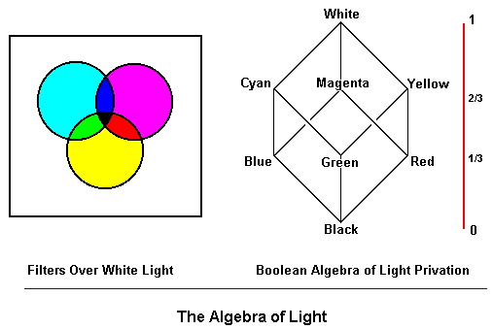
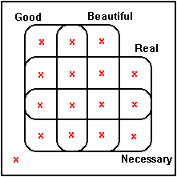

An x indicates cases that count as Light is a “mass” substance that in diminished
counter-examples to Neoplatonism. quantities (privations) exhibits different properties.

Scalar Families (comparative adjective, adjective series, mass noun), Descriptors for Degrees of a “Mass” Substance
happier than: ecstatic, happy, content, so-so, down, sad, miserable Happiness
hotter than: boiling, hot, warm, tepid, cool, cold, freezing Heat
taller than: giant, tall, normal, short, tiny Height
adamantine, hard, solid, firm, tangible, soft/weak, wispy/evanescent Hardness
riveted, attentive, awake, wandering, dreamy, asleep Wakefulness
brilliant, smart, pedestrian, dull, stupid Intelligence
absolute, substantial, subsistent, insubstantial, unreal Reality
all, most, some, rare, unheard of Universality
eternal, occasional/intermittent, never Durability
necessary, likely/probable, possible, unlikely/improbable, impossible Necessity
supererogatory, good, neutral, bad, evil Goodness
heroic, brave, dutiful, cowardly, craven Courage

Happiness Language as Descriptors of Degrees of “Happiness” Understood as a “Mass” Substance Subject to “Privation:”
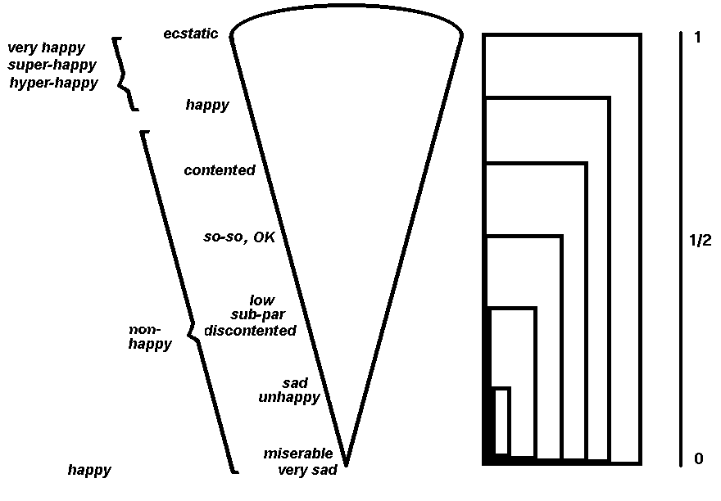

Plotinus’ Hypostases of Being in which Being is Understood as a “Mass” Substance Subject to “Privation:

The One
Being (Ideas)
Soul
Matter
Evil
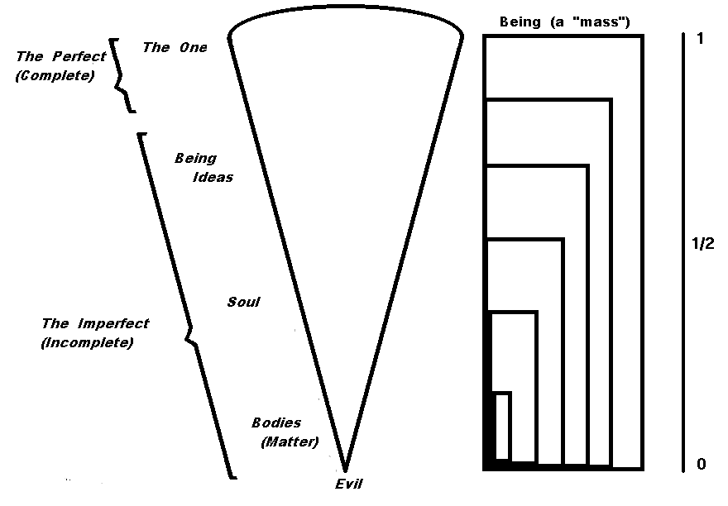

The Happiness Scale and the Hypostases of Being

hyper-happy non-happy un-happy
1 …. ecstatic happy content so-so discontent sad miserable…. 0
The One Being (Ideas) Soul Bodies (Matter) Evil
hyper-real real unreal

m n e -n -m

Scalar Negations
Contradictory Negation (Boolean Complementation in set theory)
−A not happy
Contrary Negation (Relative Complementation in set theory)
non-A non-happy, non-being
Mirror Negation
un-A unhappy, discontent, illegal, unreal
Hyper-negation
hyper-A hyper-active, super-saturated

Privative Negation
sub-A hypo-active, subnormal, subhuman

Linguistic Tests for Scalar Order

Order Tests
for P ≥
P implies x is at least
x is at most implies x is not P

Positivity/Negativity Tests

Only positive adjectives have grammatical mirror negation:
happy, unhappy *unsad, sad
polite, impolite *unrude, rude
modest, immodest *unslutty, slutty
substantial, insubstantial *unrickety, rickety
honest, dishonest *uncrooked, crooked

Only negative adjectives are grammatical in “negative” contexts:
It is difficult/*easy for him to admit he was ever wrong.
It is dangerous/*safe for him to do anything like that, ever
He has eaten more than he is happy /*unhappy to acknowledge.
He has less money than he is willing to be frank/*secretive about.
It is really ugly/*beautiful that he is still doing anything like that
It was evil, immoral/*noble, *virtuous that he behaved at all like that yet he did it.

See Plato, Symposium; Plotinus, Eneads I.6, “On Beauty”; Guy Sircello, A New Theory of Beauty, (Princeton, 1975). On Neoplatonism and scalar logic see for example John N. Martin, "Existence, Negation, and Abstraction in the Neoplatonic Hierarchy," History and Philosophy of Logic, 16 (1995), 169-196, and “The Lover of the Beautiful and the Good: Platonic Foundations of Aesthetic and Moral Value”, Synthese, vol 164:1, November 2008, pp. 31-51.

