**St. Augustine  -  Bishop of Hippo and "Doctor of the Church"**

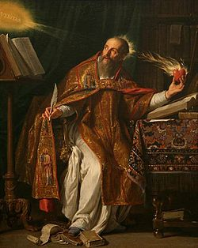

Source: Wikipedia

Accepted by most scholars to be the most important figure in the ancient Western church, St. Augustine was born in Tagaste, Numidia in North Africa. His mother, St. Monica, was a Christian, but his father remained a pagan until late in life. After a rather unremarkable childhood, marred only by a case of stealing pears, Augustine drifted through several philosophical systems before converting to Christianity at the age of thirty-one. At the age of nineteen, Augustine read Cicero's *Hortensius*, an experience that led him into the fascination with philosophical questions and methods that would remain with him throughout his life. After a few years as a Manichean, he became attracted to the more skeptical positions of the Academic philosophers. Although tempted in the direction of Christianity upon his arrival at Milan in 383, he turned first to neoplatonism, During this time, Augustine fathered a child by a mistress. This period of exploration, including its youthful excesses (perhaps somewhat exaggerated) are recorded in Augustine's most widely read work, the [*Confessions*](http://www.ccel.org/ccel/augustine/confess.html).

During his youth, Augustine had studied rhetoric, the legal profession of the time, at Carthage, a discipline that he used to gain employment teaching in Carthage and then in Rome and Milan, where he met Ambrose who is credited with effecting Augustine's conversion and who baptized Augustine in 387. Returning to his homeland soon after his conversion, he was ordained a presbyter in 391, taking the position as bishop of Hippo in 396, a position which he held until his death.

Besides the [*Confessions*](http://www.ccel.org/ccel/augustine/confess.html), Augustine's most celebrated work is his [*De Civitate Dei* (*On the City of God*)](http://www.ccel.org/ccel/schaff/npnf102.html), a study of the relationship between Christianity and secular society, which was inspired by the fall of Rome to the Visigoths in 410. Among his other works, many are polemical attacks on various heresies: *Against Faustus, the Manichean;* *On Baptism; Against the Donatists;* and many attacks on Pelagianism and Semi-Pelagianism. Other works include treatises *On the Trinity;* [*On Faith, Hope, and Love*](http://www.ccel.org/ccel/augustine/enchiridion.html); [*On Christian Doctrine*](http://www.ccel.org/ccel/augustine/doctrine.html); and some early dialogues.