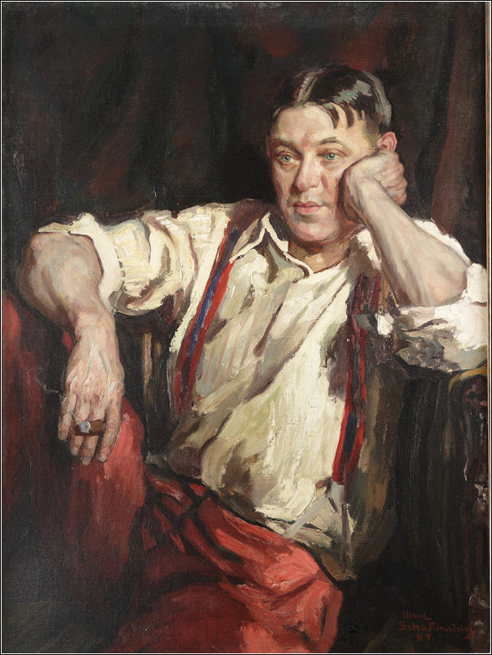

**Memorial Service**

H. L. Mencken

Where is the grave-yard of dead gods? What lingering mourner waters their mounds? There was a day when Jupiter was the king of the gods, and any man who doubted his puissance was ipso facto a barbarian and an ignoramus. But where in all the world is there a man who worships Jupiter to-day? And what of Huitzilopochtli? In one year--and it is no more than five hundred years ago--50,000 youths and maidens were slain in sacrifice to him. Today, if he is remembered

at all, it is only by some vagrant savage in the depths of the Mexican forest. Huitzilopochtli, like many other gods, had no human father; his mother was a virtuous widow; he was born of an apparently innocent flirtation that she carried on with the sun. When he frowned, his father, the sun, stood still. When he roared with rage, earthquakes engulfed whole cities. When he thirsted he was watered with 10,000 gallons of human blood. But today [in 1921] Huitzilopochtli is as magnificently forgotten as Allen G. Thurman. Once the peer of Allah, Buddha, and Wotan, he is now the peer of General Coxey, Richmond P. Hobson, Nan Petterson, Alton B. Parker, Adelina Patti, General Weyler, and Tom Sharkey.

Speaking of Huitzilopochtli recalls his brother, Tezcatilpoca. Tezcatilpoca was almost as powerful: He consumed 25,000 virgins a year. Lead me to his tomb: I would weep, and hang a couronne des perles. But who knows where it is? Or where the grave of Quitzalcontl is? Or Tialoc? Or Chalchihuitlicue? Or Xiehtecutli? Or Centeotl, that sweet one? Or Tlazolteotl, the goddess of love? Or Mictlan? Or Ixtlilton? Or Omacatl? Or Yacatecutli? Or Mixcoatl? Or Xipe? Or all the host of Tzitzimitles? Where are their bones? Where is the willow on which they hung their harps? In what forlorn and unheard of hell do they await the resurrection morn? Who enjoys their residuary estates? Or that of Dis, whom Caesar found to be the chief god of the Celts? Or that of Tarves, the bull? Or that of Moccos, the pig? Or that of Epona, the mare? Or that of Mullo, the celestial jack-ass? There was a time when the Irish revered all these gods as violently as they now hate the English. But today even the drunkest Irishman laughs at them.

But they have company in oblivion: The hell of dead gods is as crowded as the Presbyterian hell for babies. Damona is there, and Esus, and Drunemeton, and Silvana, and Dervones, and Adsalluta, and Deva, and Belisama, and Axona, and Vintios, and Taranuous, and Sulis, and Cocidius, and Adsmerius, and Dumiatis, and Caletos, and Moccus, and Ollovidius, and Albiorix, and Leucitius, and Vitucadrus, and Ogmios, and Uxellimus, and Borvo, and Grannos, and Mogons. All mighty gods in their day, worshiped by millions, full of demands and impositions, able to bind and loose--all gods of the first class, not dilettanti. Men labored for generations to build vast temples to them--temples with stones as large as hay-wagons. The business of interpreting their whims occupied thousands of priests, wizards, archdeacons, evangelists, haruspices, bishops, archbishops. To doubt them was to die, usually at the stake. Armies took to the field to defend them against infidels: Villages were burned, women and children were butchered, cattle were driven off. Yet in the end they all withered and died, and today there is none so poor to do them reverence. Worse, the very tombs in which they lie are lost, and so even a respectful stranger is debarred from paying them the slightest and politest homage.

What has become of Sutekh, once the high god of the whole Nile Valley? What has become of:

|  |  |  |
| --- | --- | --- |
| Resheph Anath Ashtoreth El Nergal Nebo Ninib Melek | Ahijah Isis Ptah Anubis Baal Astarte Hadad Addu | Shalem Dagon Sharrab Yau Amon-Re Osiris Sebek Molech? |

All these were once gods of the highest eminence. Many of them are mentioned with fear and trembling in the Old Testament. They ranked, five or six thousand years ago, with Jahveh himself; the worst of them stood far higher than Thor. Yet they have all gone down the chute, and with them the following:

|  |  |  |
| --- | --- | --- |
| Bilé Ler Arianrod Morrigu Govannon Gunfled Sokk-mimi Memetona Dagda Robigus Pluto Ops Meditrina Vesta Tilmun Ogyrvan Dea Dia Ceros Vaticanus Edulia Adeona Iuno Lucina Saturn Furrina Vediovis Consus Cronos Enki Engurra Belus Dimmer Mu-ul-lil Ubargisi Ubilulu Gasan lil U-dimmer-an-kia Enurestu U-sab-sib | Kerridwen Pwyll Tammuz Venus Bau Mulu-hursang Anu Beltis Nusku U-Mersi Beltu Dumu-zi-abzu Kuski-banda Sin Abil Addu Apsu Dagan Elali Isum Mami Nin-man Zaraqu Suqamunu Zagaga Gwydion Manawyddan Nuada Argetlam Tagd Goibniu Odin Llaw Gyffes Lleu Ogma Mider Rigantona Marzin Mars Kaawanu | Ni-zu Sahi Aa Allatu Jupiter Cunina Potina Statilinus Diana of Ephesus Nin-azu Lugal-Amarada Zer-panitu Merodach U-ki Dauke Gasan-abzu Elum U-Tin-dir-ki Marduk Nin-lil-la Nin Persephone Istar Lagas U-urugal Sirtumu Ea Nirig Nebo Samas Ma-banba-anna En-Mersi Amurru Assur Aku Qarradu Ura-gala Ueras |

You may think I spoof. That I invent the names. I do not. Ask the rector to lend you any good treatise on comparative religion: You will find them all listed. They were gods of the highest standing and dignity--gods of civilized peoples--worshiped and believed in by millions. All were theoretically omnipotent, omniscient, and immortal. And all are dead.

(1922) Reprinted from *A Mencken Crestomathy.*