Consistency of Christianity with Evolution

Definition:
A set of sentences is consistent if it does not logically imply a contradiction.

Law of Concontradiction:
For any proposition P, it is not the case that both P and not-P

Definition:
A miracle is any event P the occurrence of which contradicts some natural law

Definitions:
An axiom system S is a set of sentences of formal language that contains a set of axioms A and is closed under the relation of logical consequence, i.e. if A logically implies P then P is in S.
An axiom system S is consistent if S does not contain a sentence of the form:
P & not-P

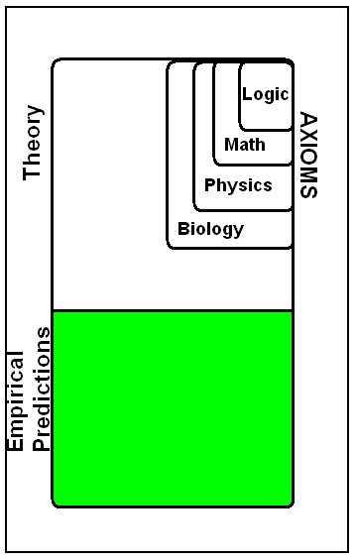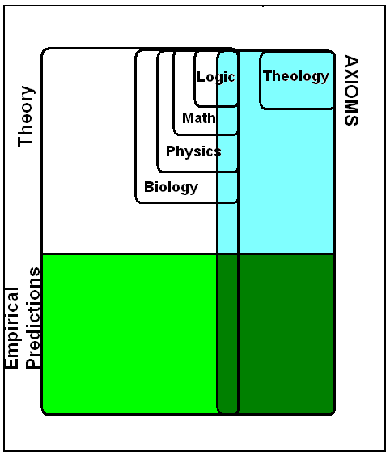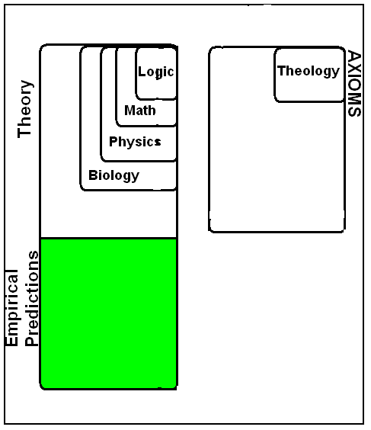

Axiomatic Treadment of Theology
J. M. Bochenski: The Logic of Religion (New York University Press, 1965)
J.M. Bochenski, “The Five Ways,” in A. Garcia de la Sierra, ed., The Rationalisty of Theism, Rodlpi: Atlanta, 2000), 2-11.
J. Salamucha, “The Proof ex mutu for the Existence of God: Logical Analysis of St. Thomas’ Arguments”, The New Scholasticism, 32(1958), 334-372
Jan Wolenski, “Polish Attempts to Modernize Thomism by Logic,” Studies in Eastern European Thought, 55(4), 229-313. Klima, G.: 1990, “On Being and Essence in St. Thomas
Gyula Klima, “Aquinas’s Metaphysics and Philosophy of Science” in Knuuttila et al. (1990) pp. 210-221, and in Klima 1988 pp. 150-164.
Gyula Klima, “Aquinas’ Theory of the Copula and the Analogy of Being,” Logical Analysis and History of Philosophy in (5) 2002
Axiomatic Treatment of Biology
Joseph H. Woodger, Axiomatic Method in Biology …with Appendices by Alfred Tarski and W.F. Floyd (Cambridge: Cambridge Univ. Press, 1937)
Miracles
*David Hume, “On Miracles”

“No Free Lunch Argument” for Intelligent Design in Evolutionary Complexity
William A. Dembski, No Free Lunch: Why Specified Complexity Cannot Be Purchased without Intelligence (Rowman & Littlefield, 2001), ISBN 0742512975.
Michael Ruse, The Evolution-Creation Struggle (Cambridge: Harvard University Press, 2005), ISBN 0674016874.
Phillip E. Johnson, Darwin on Trial (Nw York: InterVarsity Press; 2nd edition, 1993), ISBN 0830813241.
*Robert C. Pennock, The Tower of Babel: The Evidence Against the New Creationism (MIT Press, 2000)
*H. Allen Orr, “Review of William A. Demski No Free Lunch.” Boston Review (Summer 2002)).
*H. Allen Orr, “Devolution,” The New Yorker (May, 2005), pp.40-52.
*David H. Wolbert and William G. Macready, “No Free Lunch Theorems for Search, Technical Report” SFI-TR. Sante Fe, NM, USA: Santa Fe Institute, 1995.
*David H. Wolbert and William G. Macready, “The Mathematics of Search,” SFI-TR-95-02-010. Sante Fe, NM, USA: Santa Fe Institute, 1996.
*David H. Wolbert and William G. Macready, “No Free Lunch Theorems for Optimization,” IEEE Transactions on Evolutionary Computation, 1 (1997), 67-82.
“Devolution” Movie
Idiocracy (2006), staring Luke Wilson, Maya Rudolph, Dax Shepard. A dullard awakens 500 years in the future and finds he is the smartest person alive.
Evolutionary Teleology of Teilhard de Chardin
Pierre Teilhard de Chardin (1881-1955), Phenomenology of Man (1962 [1959]: Harper)
George Barbour (1890-1977), In the Field with Teilhard de Chardin (Herder & Herder, 1965)
*Download Relvant Documents: http://homepages.uc.edu/~martinj/Philosophy%20and%20Religion/

John Martin
Department of Philosophy
University of Cincinnati
john.martin@uc.edu
Sept 30, 2009

