Abelard

Major dates and details

1079 Born
1121 Forced to burn his book Theologia, at Soissons
1121 Accused of treason over the origins of St. Denis and forced to flee to Provins in Champagne.
1140 Accused and found guilty of heresy at Sens .Thence protected in his last years by Peter the Venerable at Cluny.Cluny and Citeaux (S of Dijon) were in some degree of rivalry at thistime [Cistercians (white friars) centred on Citeaux; Cluniacs (blackfriars) on Cluny]. Both sects/cults headed large monastic organisationswith great temporal power. All three locations are in what was Burgundy,the cradle of the great monastic revival.
1142 or 1144 died. Buried now at Père Lachaise, Paris East, alongside Heloise.
Probable locations of Abelard with approximate dates:
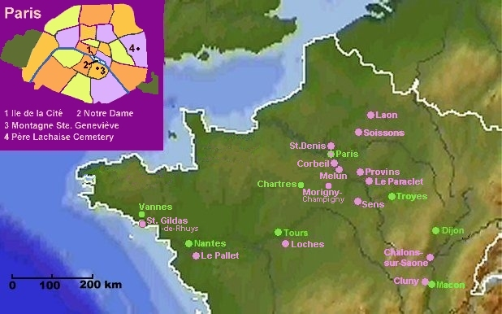
Map showing places in Northern France where Peter (Pierre) Abelard
lived, worked or visited.

Paris,
Le Pallet,
St Gildas-de-Rhuys,
Loches,
Cluny,
Chalons-sur-Saone,
Sens, Morigny-CHampigny,
Melun,
Le Paraclet,
Provins,
Colbeil, Soissons,
Laon.
(Also some locating towns)

1079 Le Pallet, Brittany (20km SE of Nantes), born
1093 Loches (SE of Tours), taught by Roscelin
1100 Paris, taught by William of Champeaux
1102 teaching at Melun followed by Corbeil (both S.E of Paris)
1105 returns to Le Pallet ?exhausted?
1108 Arrives as student in Ile de la Cite, Paris
1112 Teaching at Mont St Genevieve (outside old Paris city walls on the south bank of the Seine),then to Le Pallet (family administration)
1113 Laon (NE of Paris), to learn from Anselm of Laon
1114 Ile de la Cite, Paris - to teach
1118 St-Denis (now North Paris suburbs), as a monk during which time he wasforced to burn Theologia at Soissons
1122 Le Paraclet, SE of Nogent-sur-Seine, near Troyes
1125 St Gildas-de-Rhuys (on coast, SW of Vannes)
1129 returns to Le Paraclet, then possibly back to St Gildas (lost to sight for approx. 4 years)
1131 Morigny-Champigny (east of Chartres, just north of Étampes), then back to St Gildas
1136 Mont St Genevieve (reported by John of Salisbury)
1140 Sens, accused of heresy
1140 Cluny (NW of Macon), under protection of Peter the Venerable
1142? Dies at Cluniac house near Chalons-sur-Saone (south of Dijon). Peter the Venerable then took Abelard?s body for burial at ?Le Paraclet?, a nunnery founded by Abelard and run by Heloise (?Le Paraclet? was 5 miles SE of Nogent-sur-Seine, on the road from Paris to Troyes, close to the village of Quincey and the River Ardusson.). Heloise died in 1163 and was then buried alongside Abelard. In 1497 the bodies were move to a new oratory and placed either side of the high altar. In 1621 they were moved again to the crypt. They were moved again in 1780 to another position in the crypt. The remains then went to Nogent-sur Seine at the time of the revolution (approximately 1789) and then to a museum in Paris and most recently to Mont Louis, now Père Lachaise cemetery. Weird are the ways of humanity.

